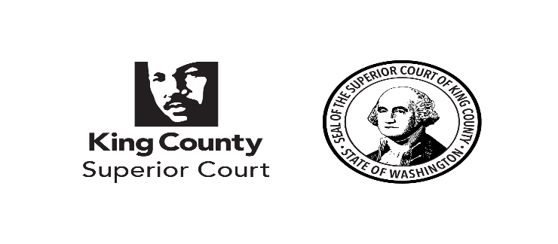
King County Superior Court

Juror Attestation of Eligibility

To Serve as a Juror Under RCW 2.36.100 (2)

I hereby attest that I am eighty (80) years of age or older and am unable to serve due to health reasons.

I hereby state under penalty of perjury under the laws of the state of Washington that the foregoing is true and correct.

________________________________________________
Signature of Juror

Signed this ______ day of _______________, 20____ at ________________, _____________.
(City) (State)

Please print name, address, telephone number and juror number below.

________________________________________________

________________________________________________

________________________________________________

________________________________________________

Signed this ______ day of _______________, 20____

_________________________________.
Juror Coordinator / Court Ops Technician

