King County Human Resources Division (HRD), through a competitive RFQ process, created a talent pool of consultants with proven track records in Organizational Development. The County has entered into master contracts with these consultants. King County departments may use these expert consultants without going through a separate contracting process, saving the county considerable time and money. Project managers must follow these steps to 1) select a consultant, 2) request a contract purchase agreement (CPA), and 3) pay consultant invoices.

Work with a consultant from the consultant pool shall not begin until a contract purchase agreement is approved by Procurement & Contract Services.

Step 1: Selecting a Consultant from the Consultant Roster
The organizational development consultant roster can be found online on the HRD website at: http://www.kingcounty.gov/audience/employees/policy-forms/hr-forms.aspx

The consultants are organized into 4 consulting categories:
- Strategic Planning and Change Management
- Conflict Resolution and Performance Coaching
- Team Development and Team Facilitation
- Facilitation Services

To meet the county's contracting and procurement requirements in Executive Policy CON 7-1-2, any consultant services expected to cost $10,000 or more but less than $50,000 must be solicited from at least 3 consultants in the category. If the consultant services are expected to be $50,000 or more, the agency must solicit all consultants in the category.

If the work is less than $10,000, departments do not need to complete a Consultant Selection Information form, and do not need to request a new CPA through the PCS service request. The invoice may be paid as a direct buy with a purchase order, using the master contract number for the consultant (listed on the Consultant Selection Information Form.) Departments are not required to solicit for single purchases of less than $10,000, but it is advised that they solicit from at least 3 consultants in the event that the work scope expands, the consultant returns for follow up consultation, or substantially similar work causes the eventual amount paid by the department to the consultant to exceed $10,000 in the calendar year.

To solicit from the consultant list, you may email consultants with a summary of the project and request that consultants interested and available to work respond within a reasonable time with requested information to help you evaluate their proposal. This information may include: price, availability and ability to meet the deadline, and the consultant’s work history performing similar work. Please do not use a single consultant repeatedly; although past work at the agency may be criteria for evaluating the consultant’s bid to perform future work, there must be still be a competitive solicitation process. Solicitations may be done by fax or email, and departments may use the attached consultant solicitation and bid form as a template.

Consultant bids may be evaluated by a department project manager (often the same individual who sent the solicitation to consultants.) It is recommended that at least 3 individuals serve as evaluators.

Step 2: Request a Contract Purchase Agreement from Procurement & Contract Services
After selecting a consultant, the department project manager will, complete and sign a Consultant Selection Information form, and send it to the selected consultant for signature. This is your agreement on the timeframe, deliverables, and price. It will also serve as a notice to Procurement & Contract Services that a CPA may be created. The Consultant Selection Information Form may be faxed or scanned, and originals are not required. Next, gather the solicitation email(s), the responsive bids, and any materials used to evaluate the bids. It is suggested that these solicitation materials be packaged with the completed Consultant Selection Information form into a single PDF, which can be attached to the online request for a contract purchase agreement in a single step.

To request a contract purchase agreement, log in to the PCS service request module at
https://procurement.kingcounty.gov/procureadmin/login.aspx?ReturnUrl=/procureadmin/ServiceRequests/SelectService.aspx

To get access, please email procurement.web@kingcounty.gov

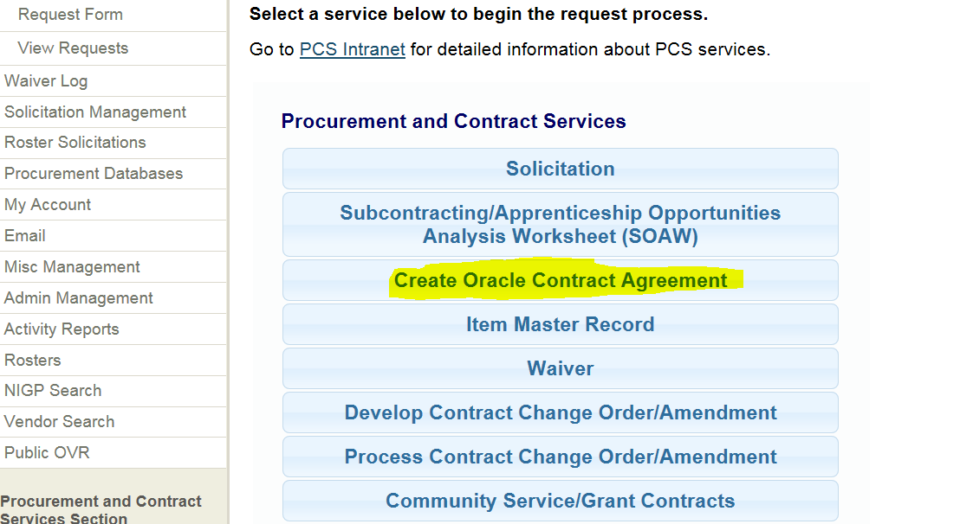

Select “Create Oracle Contract Agreement” and select “Create Technical Services Oracle Contract Agreement” from the drop down. In the Request Description, type in a simple descriptive paragraph that includes the project name, consultant, amount of the project, and the start and end dates of the project.

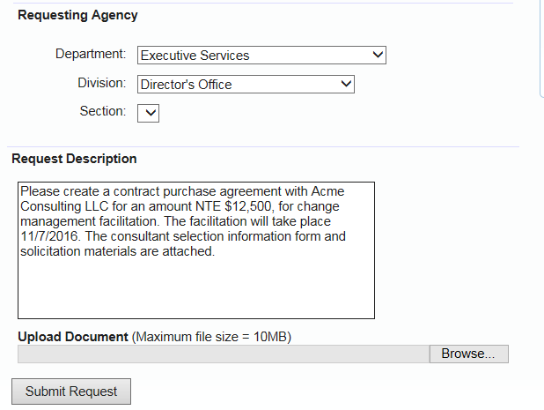

Use the Upload Document link to browse and attach the completed consultant selection information form and solicitation materials. You may only attach one document at a time. Click “Submit Request.” If you have additional materials to attach after submitting, after submitting the request, simply click “Add File” at the top right corner of the page, and repeat as needed.

A buyer in PCS will be assigned to review the materials and issue a CPA number. The submitter will be notified by email. The department will need to use this CPA number to pay invoices from the consultant.

Step 3: Paying Consultant Invoices
Accounts Payable recommends entering a requisition and creating a purchase order for each invoice as it arrives. Agencies may not create a “drawdown” purchase order. You may receive multiple invoices and create multiple purchase orders under the same CPA, so long as the total dollar amount of the CPA is not exceeded.

An online Requisition must be created by the agency in Oracle EBS:

- Choose a “Non Catalog Request.”
- Item Type is “Services Billed by Quantity”
- Enter the CPA number in the Contract Number field. Do not search for the consultant in the Supplier field; the CPA number must be entered, or the Oracle purchase order will not be created.
- Item description – please include the consultant name and the name of the project.
- Suggested NIGP Code is 918.00 “Consulting Services”
- Enter the amount of the invoice. (Quantity = “1”, Unit of Measure = “Each”, and Rate per Unit = dollar amount of the invoice)
- Buyer – Nakamichi, Victoria

Once approved by your agency Oracle Approver, the Buyer will create a Purchase Order. You may then receive the invoice in Oracle EBS, and send the original invoice to Accounts Payable for payment. Remember to write the Purchase Order number on the invoice before sending it to Accounts Payable.

Other Information:

Agencies are not required to use a consultant on the roster; the consultant roster does not restrict agencies from bringing in other consultants for projects. Check with Procurement & Payables to determine whether you will need to create and sign a new services contract and obtain proof of liability insurance from the consultant.

HRD does not need copies of the invoices, or the consultant work product.

In some cases, the agency may request follow-up work beyond the original scope of the work. If additional time and compensation is needed, the CPA may be amended with a request to PCS.

If there are any questions or problems, or if you have any feedback to share about your experience with a consultant, please contact HRD.

