King County Family Treatment Court Cost-Benefit Analysis

Michael Pullmann, PhD
University of Washington School of Medicine February 2019

Executive Summary

The King County Family Treatment Court (KCFTC), like all treatment courts, is based on the premise that short-term investments in supporting clients via intensive court hearing structures, increased access to and support of substance use treatment, and increased support with and accountability for treatment completion, will be associated with greater benefits long-term. These benefits may accrue through less recidivism with child welfare system, fewer criminal behaviors and subsequent costs for victims of criminal behaviors, decreased likelihood of subsequent babies born drug affected, increased housing and employment stability, and increased taxpaying. Other, less tangible benefits may also accrue such as increased quality of life, increased positive community involvement, and more positive parenting.

This report describes cost-benefit analyses comparing 40 parents in the KCFTC who were matched with 40 parents in the regular dependency court, and followed for five years after the index petition date using administrative data collected via child welfare, the court, substance use treatment providers, corrections, and childbirth records. Primary findings include the following:

- When examining costs of the court, child welfare, and substance use treatment, the KCFTC resulted in a net cost-benefit of $5,757 per person five years after entry. For every dollar spent on a parent in the KCFTC, $4.70 was saved.
- Cost savings accrued from less involvement in the child welfare system
- Post-entry into the family court system:
  - The KCFTC cost an average of $1,225 more per parent than the regular dependency court
  - Substance use treatment costs were approximately $9,000 more per KCFTC parent than parents in the regular dependency court
  - Child Welfare costs were approximately $16,000 less per KCFTC parent than parents in the regular dependency court
  - KCFTC parents were less likely to have additional children who were born drug affected

This study reveals that the KCFTC is likely associated with significant cost savings that accrue from decreased child welfare involvement and decreased children born drug affected, which is consistent with the theory that increased investment in supportive court structure and substance use treatment may provide long-term societal and individual benefits.

Methods

This report examines the cost-benefit of the KCFTC using data collected on participants in the KCFTC and the King County regular dependency court from 2005 and 2009. Treatment courts are a more intensive, therapeutic, and supportive approach to jurisprudence. The logic is that the short-term heightened costs associated with increased hearings and staffing of cases comes with the benefit of improved outcomes, which translate to long term cost savings due to lessened system involvement and other negative outcomes.

The current study builds on a quasi-experimental study of the KCFTC conducted by the University of Washington School of Medicine in 2009 that examined the impact of the KCFTC on aspects such as substance use treatment and child welfare services. In this earlier study, we used propensity score matching to identify a group of families served in the dependency court who were similar to KCFTC parents in terms of parent and child age and race, number of prior CPS investigations, whether the parent was in substance use treatment at the time of the index petition, the number of prior substance use treatment episodes, and the caregiver’s primary drug of choice (see Bruns, Pullmann, & Wiggins, 2012, for more information1). Both groups had petitions filed between September 2005 and July 2009. The current study uses the original pool of participants, but narrowed this original sample to 40 KCFTC and 40 dependency parents as a result of using new data to improve the propensity score models that were not available to us in the original study. This improved the closeness of the match between the two groups at the time of index petition, and allows us to draw more precise conclusions about the cost- benefit of the KCFTC. We collected administrative data from multiple systems covering the participants’ lifetimes prior to the index petition, and data for all participants for five years post-index petition. Data was provided by the Research and Data Analysis Division of the Washington State Department of Social and Health Services using their Integrated Client Database. Original data was provided to RDA by the Washington State Health Care Authority, Washington State Department of Health Disease Control and Health Statistics, and the Washington State Children’s Administration (now called the Department of Children, Youth, and Families). Relevant data for this study included substance use service events and costs, criminal charges/convictions and costs, childbirth, substance-exposed childbirth, and Children’s Administration services and costs.

Costs and benefits included in this report. The sections below provide a summary of estimates for each of the major areas of costs/benefits included in this analysis:

- Court costs
- Child welfare costs
- Substance use treatment costs

1 Bruns, E. J., Pullmann, M. D., & Wiggins, E. (2012). Effects of a multidisciplinary family treatment drug court on child and family outcomes: Results of a quasi-experimental study. Child Maltreatment, 17(3), 218-230. DOI: 10.1177/1077559512454216

We also include analyses for additional events and services that likely have significant costs, but do not assign costs to these estimates because precise figures are not known. These include:

- Criminal events
- Law enforcement and corrections events
- Childbirth events
Other costs and benefits. Not included in this report are an array of possible costs and benefits that we do not have data on which to compare the groups. These include but are not limited to the following:

- Hospitalization and emergency room
- Community involvement
- Employment and employment stability
- Educational services and completion
- Housing stability
- Taxpaying
- Quality of life

Results

Overall findings

Parents in the KCFTC had lifetime pre-FTC entry costs in child welfare that were slightly higher than matched parents in the regular dependency court (about $4,000 higher per person). They also had slightly higher substance use treatment costs pre-FTC entry (about $1,500 higher per person). Post- entry, the KCFTC participants had slightly higher court costs ($1,225 per parent) and significantly higher alcohol and drug treatment costs (an average of $10,500 more per parent). However, they also had significantly lower child welfare costs ($12,000 per parent). When statistically adjusting for the higher pre-entry costs of the average KCFTC parent, over the five years after the index petition date, the KCFTC had a net cost-benefit estimate of $5,757 per person in favor of the KCFTC (see Figure 1).
Because the KCFTC cost $1,225 more per parent, this translates to an estimate that for every dollar spent on a parent in the KCFTC, $4.70 was saved within five years, when calculating child welfare and substance use treatment costs.

These data are consistent with the logic model of the FTC: increased spending on treatment and supportive court services are intended to reap benefits of less child welfare involvement and other costly and detrimental outcomes. Based on our comprehensive analyses, and as described below in much greater detail, the KCFTC likely creates significant cost savings above and beyond the amount described above as a result of better outcomes for parents. Primary cost savings likely result from:

- fewer children born after KCFTC entry, which is likely the result of more children returning home and
fewer “replacement children” being born
- fewer children born as possibly drug affected, because KCFTC parents are more likely to be sober, and
  - smaller child welfare costs due to shorter time until permanency for KCFTC parents

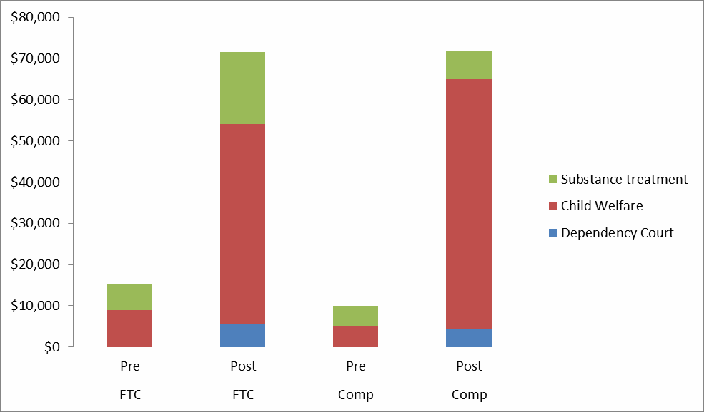

Figure 1. Cost categories, only including categories with the most precise cost estimates

Cost and event categories

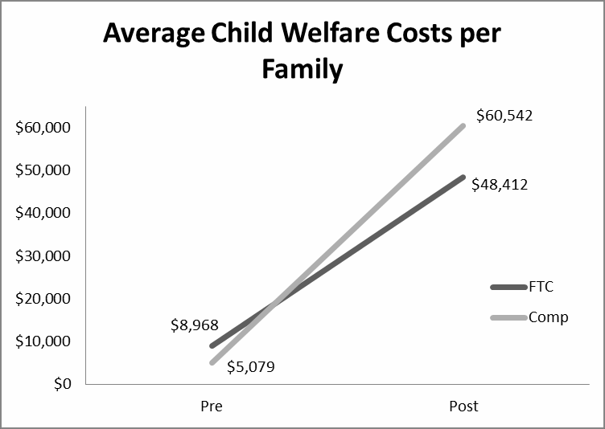
Dependency Court and Family Treatment Court Costs. The KCFTC is designed to have a more intensive court hearing structure than the dependency court. In a study that our research team performed for the KCFTC in 2011, we found that KCFTC parents had 2-3 times more court hearings than parents in the dependency court, nearly entirely due to additional review hearings. This translates to higher costs for the KCFTC parents. Court costs were obtained from the court budgets for 2005 – 2009. We divided these totals by the number of parents served each year and averaged across the years to obtain a per-parent cost. The KCFTC cost an estimated $5,625 per parent served during these years. The dependency court cost an estimated $4,400 per parent. Therefore, the KCFTC cost an estimated $1,225 more per parent served than the dependency court.

Child Welfare Costs. Child welfare costs were obtained from RDA and included costs for all services provided by child welfare, including foster care, transportation, visitations, and other services. Child Welfare costs are the true costs of providing services. Prior to the index petition, there was a small difference in child welfare costs between the groups, with the FTC group costing about $3,900 more, on average, per parent. In the five years after the index
petition, comparison group parents cost over $12,000 more than FTC parents, per parent served. When

statistically controlling for pre-entry differences in costs, in the five years after the index petition, comparison group parents cost over $16,000 more than FTC parents, per parent served. Our prior analyses shed light on why there were lower costs for the FTC group (Bruns, Pullmann, Weathers, Wirschem, & Murphy, 2012): FTC families experienced a greater rate of return home (61% vs. 43%), were more likely to be reunified (55% vs. 29%), had a shorter time in placement (475 days vs. 502 days), and after returning home were less likely to have a subsequent removal from the home (3% vs. 13%).

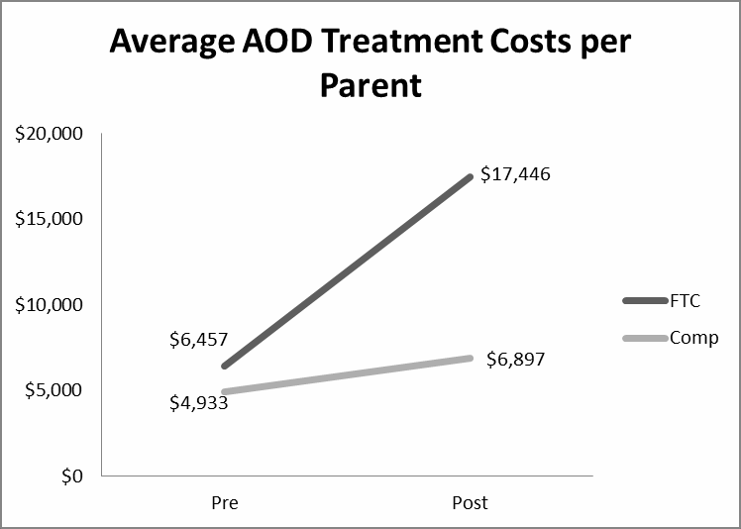
Substance Use Treatment Costs. Substance use treatment costs were provided by RDA. These data only include regular treatment services and do not include hospitalization or crisis service costs. One of the primary goals of the FTC is to encourage and support families to enter and succeed in substance use treatment. However, substance use treatment comes with costs, with the belief that benefits will accrue from improved life outcomes, that will
avoid costs in other areas such as criminal justice and repeated contact with the child welfare system. Our prior analyses, which tracked participants for 1-3 years, found that families in the FTC were much more likely to enroll in substance use treatment (84% vs. 57%), entered treatment faster (63 days vs. 99 days), stayed in treatment longer (142 days vs. 96 days), and were more likely to complete treatment (72% vs. 54%). The cost analysis, which tracked participants for 5 years, reflected these
findings. Substance use treatment for participants in the FTC cost approximately $1,500 more on average prior to their index petition, but post-petition cost approximately $10,500 more on average. When statistically controlling for pre-entry differences, the FTC families cost approximately $9,000 more, on average, per parent.

Childbirth costs. Childbirth carries significant costs to society for parents receiving public health benefits. When children are born drug affected, with fetal alcohol syndrome, or another substance use indication, the estimated cost to society is extremely large (the first year costs of childbirth and hospitalization for a drug exposed infant is nearly $30,000, the first 18 years of the infant’s life is estimated at nearly $1.5 million). Fetal Alcohol Syndrome is especially costly, with estimates ranging from 2 to 3 million dollars of lifetime costs. Additionally, research has indicated that mothers who are involved in child welfare and who lose custody of their child are more likely to become pregnant again and have a subsequent child as compared to mothers involved in child welfare who retain custody of their child, a phenomenon some have referred to as “replacement babies” (Grant et al., 2011). As described earlier, our prior research found that the FTC families experienced a greater rate of return home, were more likely to be reunified, and after returning home were less likely to have a subsequent removal from the home (3% vs. 13%). They were also more likely to enter and successfully substance use treatment, meaning that any subsequent childbirths were less likely to be drug affected. We

obtained data from RDA on the number of births and substance-exposed births. Post-index petition, parents in the FTC had fewer children born overall, and fewer children born substance exposed, than parents in the regular dependency court. These differences are likely associated with significant cost savings resulting from FTC involvement, though cost-benefit amounts were not calculated due to the lack of available direct costs.

 |  | Pre | Post
 |  | Total | Total
Children born with substance use indication | FTC | 45 | 9
 | Comp | 43 | 13
 | FTC | 41 | 6
Children born without substance use indication | Comp | 55 | 11
Total children born | FTC | 86 | 15
 | Comp | 98 | 24
Table 1. Number of children born overall, with, and without a substance use indication.

Justice system costs. Participants in dependency court were likely to have some contact with the criminal justice system. Justice system contact carries significant costs associated with:
- Law enforcement
- Victims—tangible costs and pain/suffering
- Loss of employment/taxes
- Corrections (Jail and Prison time)
- Court
RDA provided data on the per-participant counts of misdemeanor, assault, felony (drug, property, and other), and robbery events,
Total Number of Criminal Charges
150
148
FTC
125
103
Comparison
100
75
50
53
25
36
0
Pre
Post
and whether parents were convicted or not convicted of these criminal charges. We do not have the direct costs of these criminal charges. Parents in the regular dependency court entered the court with more overall charges (a total of 148 charges) as compared to the FTC parents (a total of 103 charges). Within five
years of the index petition, comparison parents accumulated an additional 53 criminal charges, while FTC parents accumulated 36 additional charges. Because of the significant differences at pre-court entry,

which provides more opportunity or room for change for the comparison group, it is difficult to draw conclusions about the association of the FTC with criminal charges.

