Cooperative Purchasing  Agreement | 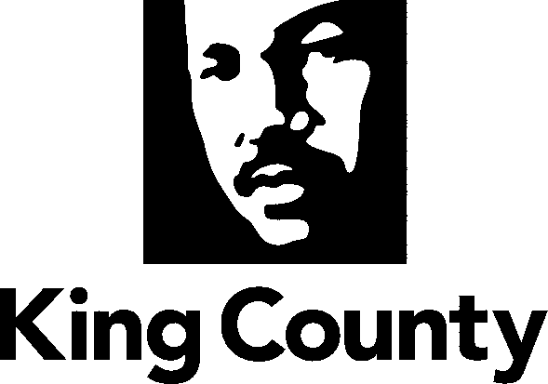 | Department of Executive Services  Finance and Business Operations Division  Procurement and Payables Section  Chinook Building  401 Fifth Avenue, 3rd Floor  206-263-9400 TTY Relay: 711
In accordance with Chapter 39.34 RCW, King County and agree to a cooperative governmental purchasing agreement for various goods and services using each other’s competitively awarded contracts.
King County and , therefore, extend the use of their contracts to each other to the extent provided by law and upon the following terms:
(1) The supplier(s) agree to extend to King County and the terms and conditions of their contract(s).
(2) King County and accept responsibility for compliance with any additional or varying laws and regulations governing its purchases.
(3) King County and accept no responsibility for the performance of any of the purchasing contracts by the supplier.
(4) King County and accept no responsibility for payment of the purchase price by the other entity.

Accepted for King County |  | Accepted for:
Type "Name" here. |  |  | Type "Name" here.
Chief Procurement Officer |  |  | Type "Title" here.
Date: | Type "date" here. |  | Date: | Type "date" here.
King County Procurement & Payables  401 5th Avenue, MS – CNK-ES-0340  Seattle, WA 98104 |  |  | Type "full address" here.
Email | Procurement.Web@kingcounty.gov |  | Email: | "email address"

