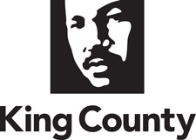

Charter Review Commission Agenda
King County Chinook Building

1st Floor Executive Conference Rooms 121/123
401 5th Ave. Seattle, WA 98104
Wednesday, November 20, 2019 | 6:00 p.m. – 8:00 p.m.

Purpose:
- Review final edits to full report draft.
- Review final steps of CRC process and evaluation

Agenda Topic | Lead | Time | Attachments
- Welcome and Review Agenda | Co-Chairs | 5 min
- Public Comment | Co-Chairs | As needed
- Approve 11-6-19 Meeting Minutes | Co-Chairs | 5 min | 11-6-19 Draft Meeting Minutes
- Review and discuss final edits received to date on report draft | Facilitator | 45 min | Draft report to King County Council
- Review process for post-mortem evaluation of CRC review process | Facilitator | 15 min
- Discuss advice for next Commission | Facilitator | 30 min
- Scheduling and next steps | Facilitator | 15 min | CRC Meeting Calendar
- Adjourn | Co-Chairs

