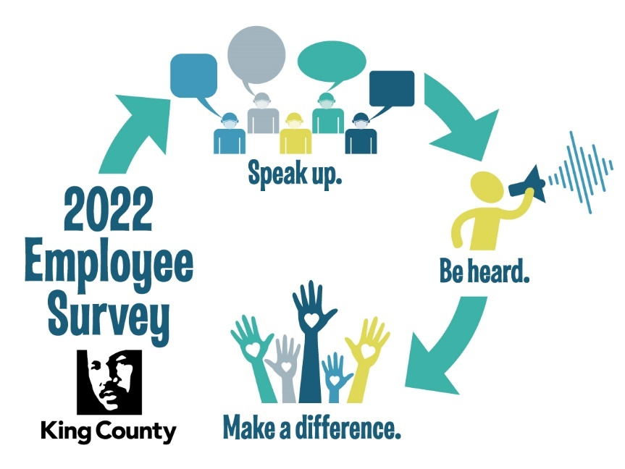

King County Engagement Survey Action Planning
Discussion Guide and Tool Kit
Focus on Wellbeing and Belonging

Table of Contents
Background 3
Timeline and Expectations 5
Sharing the Results with Your Team 6
Survey data discussion sample agenda 7
Leading and Facilitating the Survey Report Discussion 8
The Role of the Leader
The Role of the Team
Do’s and Don’ts 8
Core Practices of a Skilled Facilitator 9
Choose Action Plan Focus and Actions to Take 10
Sample Work Session Agenda 11
Simple, Impactful Behaviors to Support Well-Being and Belonging 12
Communicate Action Taken as A Result of the Survey 16
Our Action Plan 16
Progress Check-in 17
Wrap-Up 17

Background
King County Executive Dow Constantine has a goal of making King County a community where every person feels welcome and can thrive. That includes employees in our work community. In 2015 he launched a new emphasis on employee engagement and soon after wrapped it into a comprehensive people strategy, Investing in You, that prioritizes actions in six goal areas:
- Creating a workplace that embraces your talents and passion for public service
- Providing competitive pay and benefits
- Promoting racial diversity and cultural responsiveness
- Caring about your health and safety, both in and outside of work
- Offering equitable development and advancement opportunities.
Why engagement
Research shows a strong relationship between organizational excellence and employee engagement. With a highly engaged workforce, performance goes up and operational costs go down. The data below is from Gallup and shows the difference between outcomes at organizations with a highly engaged workforce vs. not.

Why Focus on Wellbeing and Belonging
National and King County data shows the growing importance of belonging and wellbeing to the employee experience. For this reason, we are providing resources to support your action planning in these areas. You can still choose to focus on something you feel is more relevant to your team.
As you can see in the chart below, King County employees with high wellbeing are 6 times more likely to be engaged. Employees with a sense of belonging are 9 times more likely to be engaged. Employees with a sense of belonging are 6 times more likely to feel a sense of wellbeing.
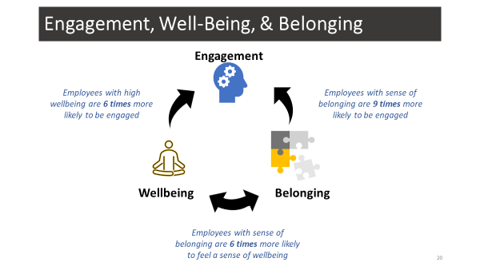

Why action planning
Research shows that doing a survey and not following through on feedback can do more harm than good. Belief that action will be taken as a result of the survey shows up in workgroups across the county as an important influencer of engagement. Following through on feedback is an important way of building trust and demonstrating employee options are valued.

2021 Engagement Timeline and Expectations
The following reflects timing for action steps in the employee engagement action plan process. Each step is an opportunity to include employees and make the survey experience relevant. It is not the survey that matters. It is what we do after.
Steps | Person Responsible | People to Include | Mode | Timing
Share survey results with team | Leader | All team members | Email/In person/Online | Within one week of results being made available to leaders.
Facilitate team discussion about survey results  (See pp. 6-9) | Leader | All team members | In person/Online | Within three weeks of receiving survey report.
Choose action plan focus and identify actions to take  (See pp. 10-12) | Leader | All team members | In Person/Online | Before the end of July.
Communicate actions taken as a result of the survey  (See pp. 16-17) | Leader and employees | Leader and employees | In person, email, newsletter, tier board, action plan tracker or other methods | Ongoing. At least quarterly.

Share Survey Results with Team
The survey is produced from the employee data received. Links will be sent to each team lead. The link will take you to results specific to your team. If you have more teams reporting up through your team, those results will also be available. You are responsible for facilitating action planning with only your immediate team.
Invite your team members to a discussion about the survey results. Schedule this in advance and give them the data in advance so they have time to process and reflect.
Sample invitation email:
Many of you participated in the recent employee engagement survey. What we do with the results, and how we apply the findings is up to us. I would like to schedule time to share and talk about the findings.
Please join me in this discussion. As a later date we will follow up with an action planning work session. This discussion will be to understand our results.

Survey Report Discussion Sample Agenda
Recommended room set up: white board or flip charts, copy of report for everyone or report on a screen
Recommended online tools: Teams, Whiteboard, electronic copy of the report for everyone and screen share report online.
10 mins Leader introduction to the discussion
Why this matters
What you would like to see out of the time (example: shared understanding, idea of next steps)
Agenda overview
Norms (optional)
15 mins Get everyone into the space
Go around the room and have a short ice breaker
Sample: What is engagement to you? Why does it matter to us?
30-60 mins Share high level findings
Ask questions and allow for discussion
Sample questions:
- What are our strengths?
- Do results on any items surprise you?
- What are we doing that makes this a strong or weak result?
- Does a focus on wellbeing and belonging make sense for us?
- What would we want to do to increase belonging and wellbeing?
- What was behind our biggest increases?
- What was behind our biggest decreases?
10 min Next Steps
10-15 min Closing Thoughts
Go around the room and check in with everyone (examples)
    - What matters to you in the findings?
    - One word to describe where you are at

Leading and Facilitating the Survey Report Discussion
Guide the process and the creation of space for the necessary conversations to occur. When a leader facilitates, they assume the role of process guide and step away from participating.
Do | Don’t
- Say thank you a million times for speaking the truth (no matter how bad it is)  - Focus on 1 or 2 issues for the coming year  - Actively Listen  - Ask Questions  - Encourage the group, instead of an individual, to settle on the action plan focus | - Ask who said what  - Ask who participated  - Force people to speak up  - Get defensive  - Speak into silence. Let people thing and process.  - Jump to solutions, take action before really understanding the reports & engaging staff in making meaning of the data

The Role of the Leader: Leading and Facilitating
Presentation of the survey results provides an opportunity for sense making and share understanding. Facilitation is a skillful process that takes practice. As a leader, remind yourself to step back so others can step up. Speak less and seek the observations and insights of others in the room.
The role of the team: Inform and Activate
Team members have the responsibility to make sense of and apply the survey results to creating an action plan.
Core Practices of a Skilled Facilitator

Stay Neutral – Focus on the process role of facilitation. Avoid the temptation of offering opinions. Use questions and suggestions to offer ideas that spring to mind – do not improve opinions on the group. Obtain valid information. Have self-awareness.

Listen Actively and paraphrase – Use attentive body language. Always make eye contact with the person speaking. Prompt quiet members to participate. Summarize key ideas by paraphrasing for understanding and to let others know they’ve been heard. Allow space for quiet.

Summarize periodically and synthesize ideas – listen attentively to everything that is said to include what is unspoken. Offer concise and timely summaries. Summarize when you want to revive a discussion that has ground to a halt. End with a summary as a wrap up. In addition to recording that is said, have the group comment and build on each other’s thoughts. Build consensus and commitment.

Manage Digression – actively listen to make sure digression from the topic is actually happening before trying to redirect. Create group norms around this at the beginning of the meeting. Create a parking lot (holding tank) and post prior to the meeting. Bring digression to the attention of the person or group by asking – I’m noticing that we are starting to move to another topic. Does this need to go on the parking lot at this time?

Manage conflict – always be in the neutral process role. Avoid entering into conflict with group members. Stay calm, speak slowly, maintain neutral body language. If possible, reframe a polarizing conflict as an issue or a need. Then, use a systematic problem solving approach that gets people working together. Provide structure and be assertive. Ask for concerns and facilitate the group to focus on the facts.

Ask Questions

Choose Action Plan Focus and Actions to Take
King County data shows the growing importance of belonging and wellbeing to the employee experience (see p. 4). King County employees with high wellbeing are 6 times more likely to be engaged. Employees with a sense of belonging are 9 times more likely to be engaged. Employees with a sense of belonging are 6 times more likely to feel a sense of wellbeing.

As we move forward into the Future of Work, a focus on well-being and belonging will help us recover and rebuild from the pandemic in a way that centers equity and racial justice.
For this reason, we are providing resources to support your action planning in wellbeing and belonging. You can still choose to focus on something you feel is more relevant to your team. On this page you will find resources to help you develop action plans to improve well-being and belonging:
- Simple, impactful actions to build a culture of well-being and belonging
- Trainings, readings and videos to deepen your knowledge and improve your skills
- Activities that can be incorporated into action plans strengthening belonging and well-being.

Use the following guidance to develop an effective action plan.
Action Plan Tracking
This part will need to be filled in when the action plan tracking plan is developed
Facilitating the Action Plan Work Session
Pick a Focus, Decide What Action to Take
Purpose of the Action Planning Work Session
Create a plan that can be activated, monitored and celebrated that is driven by your team and what they understood about the survey data.
The Action Planning Work Session begins with an invitation to a scheduled work session. You can gauge how much time you and your team will need for this session.
Sample invitation email:
Greetings,
This is an invitation to an Action Planning Work Session to follow our discussion on (DATE) about the employee engagement survey.
As a next step, we will spend time picking an action plan focus for the coming year and deciding what we can do that will have a positive impact. I have scheduled (TIME) for this Work Session. If we need more time, we can add another date.
Before our work session, please think about whether we should focus our action plan on belonging, well-being, both or something else that feels more relevant to our team. I am including information for us to learn more about belonging and well-being (ATTACH BELONGING AND WELL-BEING INFO OR LINK TO PAGE) and how we might incorporate these to our action plan.
See you soon.

Sample Action Plan Work Session Agenda
5 mins Leader introduction to the Work Session
    - What we do with the survey is up to us.
    - Our desired outcome is to create an action plan we think will make a difference: Pick a focus, decide the action we will take
    - Agenda overview
10 mins Get everyone into the space
    - Go around the room and have a short Q&A
    - Samples: What King County value means the most to you?
15 min Pick an Action Plan Focus
    - What bubbles to the top as things we want to focus on? (Write these down)
    - Invite discussion about whether you want to focus on belonging and wellbeing, or if something else feels more relevant to your team
    - Vote with sticky dots, thumbs up or thumbs down or some other way that’s comfortable for your team
    - Welcome discussion about differences of opinion and allow people to change their votes
20 min Do 2 Things About It
    - What two things can we do in the coming year to have an impact?
    - If you are focusing on belonging and well-being identify what will have the biggest impact:
      - What simple, impactful behaviors are most important for you to build a culture of belonging and/or well-being?
        - Use list on the next page and data from your report
      - What actions can we take in the coming year
        - It’s helpful to think of actions that incorporate the impactful behavior the team identified as most impactful.
        - Pick from the the list of suggested activities in the survey or choose your own.
          - Make SMART goals (specific, measurable, attainable, relevant and timely)
          - Assign champions for each thing
5 min Next Steps
- Set expectations for regular check-ins – ask the team how frequently?
5 Min Closing thoughts
- Go around the room and check-in with everyone (samples):
- What do you feel about our Action Plan progress? How can we celebrate our milestones and accomplishments?
Simple, Impactful Behaviors to Support Well-Being and Belonging
In you team action plan discussion, talk about what behaviors that build a culture of well-being and belonging have the biggest impact on team members. Use the list below and data from your report in the discussion.
Well-Being
Things leaders, manager and supervisors can do to improve well-being:
- Know how people are doing. Use the employee survey data to understand how people are feeling about their well-being. Engage employees in discussion about what’s working and what can be improved.
- Model self-care and boundary setting. Encourage work/life balance by modeling the way. Employees will look to you to see what’s okay and what’s not. Consider not sending email outside of work hours, engaging in regular selfcare that rejuvenates and restores you and using vacation leave.
- Be clear about shifting priorities and help people reprioritize to design realistic workloads. When priorities shift, tell employees why and open a dialogue about capacity. Things might need to come of their plates so they can accomplish the new goals. If you are seeing signs of burnout you can support employees adjust workloads to be more manageable by reprioritizing work.
- Empower managers to meet the individual needs of their teams. Each team is different and each person in the team has different needs. Empower managers in their relationships with employees to make decisions that balance the business needs of the organization with the wellbeing needs of the individual.
- Provide Stability. Demonstrate steadiness, resilience and support. In times of chaos, steadiness from leaders is calming to employee.
- Incorporate well-being into work. Create time to connect. Have walking meetings or take time to stretch during meetings.
- Share resources to support well-being. Share information about Balanced You, Making Life Easier and Benefits.
- Support development. Encourage and support employee development through individual development plans, training, stretch opportunities and special duty assignments.
- Take the training Staying Steady for Yourself and Your Team which will teach you how to build a resilient team.

Things individual contributors can do to improve well-being:
- Build opportunities for connection throughout the day. Start meetings with a check in or ice breaker question.
- Recognize people for effort and growth. Use the county’s values cards to recognize employees for accomplishments consistent with the values.
- Value ideas and suggestions of others. Ask people what they think and incorporate their feedback.
- Normalize conversations about mental health. Be authentic in discussing your own challenges and coping skills. Be accepting and supportive when hearing the challenges others are facing. Do not try to solve someone’s problems, offer empathy.
- Build resilience. Psychologists define resilience as the process of adapting well in the face of adversity, trauma, tragedy, threats, or significant sources of stress—such as family and relationship problems, serious health problems, or workplace and financial stressors. As much as resilience involves “bouncing back” from these difficult experiences, it can also involve profound personal growth:
  - Build connections: prioritize relationships, join a group
  - Find purpose: help others, look for opportunities for self-discovery, move toward your goals
  - Embrace healthy thoughts: keep things in perspective, accept change, maintain a hopeful outlook, nurture a positive view of yourself
  - Focus on gratitude: Gratitude practices help you manage these tough times and it reminds you that if you stop and pause, there is still good all around us and it is happening each day.
Belonging
Simple, impactful actions leaders, managers and supervisors can do:
- Know how you are doing. Use the employee survey data to understand how much people feel they belong. Engage employees in discussion about what’s working and together discuss what can be improved.
- Recognize people for effort and growth. Use the county’s values cards to recognize employees for accomplishments consistent with the values.
- Communicate what action has been taken based on the survey so people know their opinions are valued.
- Share information. Ensure all employees have access to the same information by sharing what comes to you via UpFront.
- Use the county’s True North and values to create a shared vision and continually reinforce how work aligns to it. Shared purpose, values, and goals can significantly contribute to a person’s feeling of belonging.
- Model respect for people. Set expectations that people in your department, division and on your team act consistently with the county’s respect for people value.
- Build opportunities for connection throughout the day. Start meetings with a check in or ice breaker question.
- Create psychological safety. See how in trainings and readings below.
- Build trust. Those who have a trusting relationship with a mentor or manager are better able to take advantage of critical feedback and other opportunities to learn. The benefits of these trusting relationships are often greater amongst people from stigmatized groups.
- Be accessible. Delegate so you have time and can be accessible to people for emergent needs.
- Create opportunities for collective problem solving. Ask for input and incorporate suggestions. Be clear about how decisions will be made and don’t make decisions ‘offline’ with a select few team members.
- Support development. Encourage and support employee development through individual development plans, training, stretch opportunities and special duty assignments.

Simple, impactful action individual contributors can do:
- Model respect for people. follow expectations set by department, division or workgroup that people in your department, division and on your team act consistently with the county’s respect for people value.
- Demonstrate compassion. People feel they matter when they are cared about.
- Build opportunities for connection throughout the day. Start meetings with a check in or ice breaker question.
- Recognize people for effort and growth. Use the county’s values cards to recognize employees for accomplishments consistent with the values.
- Value ideas and suggestions of others. Ask people what they think and incorporate their feedback.
- Engage people in decisions affecting them: Ask for input and incorporate suggestions. Be clear about how decisions will be made and don’t make decisions ‘offline’ with a select few team members.
- Demonstrate empathy.
- Listen to understand: seek diverse perspectives, be open to others challenging our assumptions.
- Seek development opportunities: individual development plans, training, stretch opportunities, special duty assignments.
Where to Access Your Teams Drivers of Belonging and Well-Being
- On the summary page of your engagement report, scroll down to the Key Drivers tile.
- Choose well-being or belonging from the drop-down menu. This will give you the question most highly correlated to well-being and belonging. These things are theoretically most influential for employees.
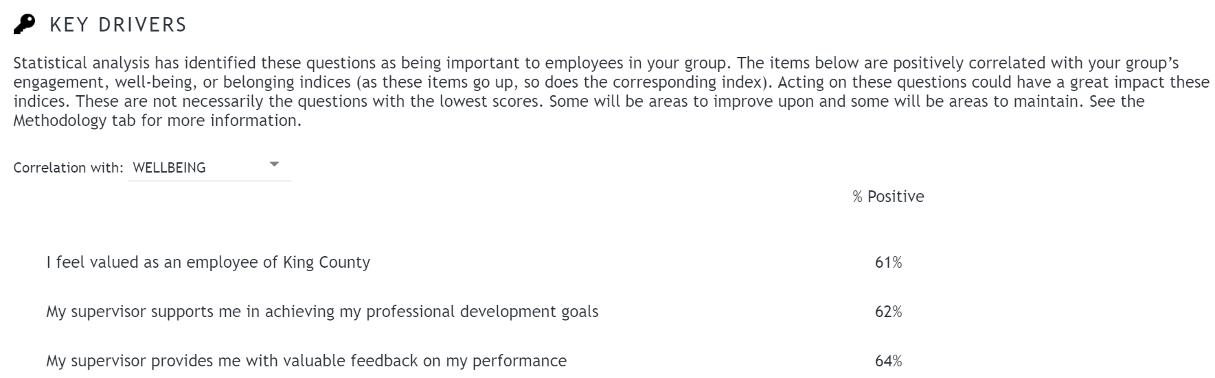

Communicate, Communicate, Communicate: Action Taken As a Result of the Survey
During the course of the action plan, it’s important to check in on progress and celebrate milestones and accomplishments. In the action plan tracker you will be asked to plan three communication to your group and the tracker will remind you a week before these are due.
Communication Timing and Topic

Sample Communication: Our Focus
Dear Team: Thank you coming together to plan what we will focus our engagement efforts on in the coming year. I wanted to recap our decisions and plan.
Focus: Belonging and wellbeing
Do 2 Things About It:
- Team attends resiliency training
  - Steve to identify training by August and send link around for everyone to register
- In team meetings connection before content
  - Each person brings an ice braker activity or question to our team meetings.
Checking in regularly:
- We will check in at our staff meetings in August, November and February about how things are going.
- I commit to communicating to the whole team about those check ins.
Thanks for your energetic participation and your commitment to this! I look forward to the coming year.
Sample Communication: Progress
Dear Team,
At our last meeting we checked in about our progress on our action plan and made some adjustments.
Despite our best efforts, not all of us can attend the resiliency training at the same time, so rather than put it off any longer, we agreed to attend separately when we can and then come back together and process the training as a group. Below is the link with the training dates and registration. Please choose a date before November. We’ll debrief about the training at our December staff meeting.
To support us in this learning, I am going to purchase some books on belonging and at our next team meeting we’re going to watch a video. That way we can start incorporating some of the learning now.
Thanks to everyone for helping us get unstuck. I feel good about how we’re moving forward.

Sample Communication: Wrap-Up
Dear Team,
The engagement survey is coming up in a few weeks so I wanted to take a moment to reflect on the past year.
I am really pleased with what we were able to accomplish. For a while it felt like we were stalled but you had great ideas for how to get us moving forward again. We all agreed the training was a great use of time, even though it was hard to get away from work. The training debrief revealed a lot of learning and a solid commitment to using what was taught.
Erin and her team crated a really fun reward program – practicing hard behavior change has never felt so good! We’ve all agreed that we have more work to do, but we’ve made a great start. I look forward to continuing the journey with you this year.

