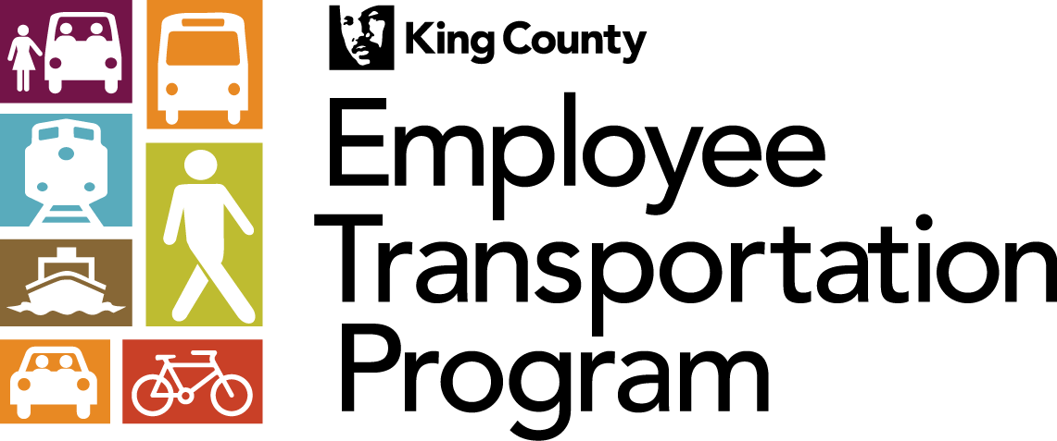

Carpool, Bike, & Walk Program Rules & Standards

Program Eligibility:
- Employees can earn incentives if 1) receive leave and insured benefits from King County and 2) work at a site located outside downtown Seattle.
- Employees must work outside downtown Seattle and must carpool, bike, or walk at least 51 percent of the days they travel to work AND 51 percent of the miles they travel to work in a month to qualify for receiving incentives.
- Employees who travel to their primary worksites fewer than 15 days in any given month must carpool, bike, or walk at least eight days that month to receive incentives.
- Employees who ride ferries and then walk or bike to work are not eligible to receive incentives under this program unless the bike or walk part of their commutes are at least 51 percent of their total commute miles (including the ferry ride).
- Employees who ride the bus and then walk or bike to work are not eligible to receive incentives under this program unless the bike or walk part of their commutes is at least 51 percent of their total commute miles.
- To qualify as a carpool, employees must share a ride with at least one person of driving age. Driving a child to daycare on the way to work does not count as a carpool under this program.
- Employees who are carpool drivers and drop off their partners, then drive alone to work are eligible to receive incentives only if the carpooling part of their commutes (when two or more persons are in the car) is at least 51 percent of the total commute miles.
- Employees who carpool to work in downtown Seattle are not eligible to receive incentives under this program. However, in the case of employees who are carpool drivers and who drop someone off in downtown Seattle before continuing on to a worksite outside of downtown Seattle are eligible if the carpooling part of their commute (when two or more persons are in the car) is at least 51 percent of the total commute miles.
- Bicyclists must use non-motorized bikes to qualify for incentives. Riding a motor scooter to work does not count as biking to work under this program. However, bikes with motor assist (for going uphill) may qualify for incentives.
- Employees who receive vanpool benefits are not eligible to receive incentives under the Carpool, Bike, & Walk incentive program.

Incentives Use and Conditions:
- You must submit a claim form for your incentives to your ETC by the 15th day of the month following each quarter. If you fail to submit your claim form by that time, you could forfeit your right to receive incentives for that quarter. No retroactive payments.
- Incentives are taxable income. You will be taxed quarterly on incentives you receive.
- You will have your choice of an REI gift card or a Union 76 gift card/quarter. You can only choose one type of gift card/quarter.
- You will receive $20, $40, or $60 gift card depending on the number of months you earned an incentive for each quarter.
- If you abuse the program, you will be penalized according to the violation policy listed below.
- Commute modes will be monitored to ensure that you are complying with the program guidelines.

Monitoring and Abuse:
You will be monitored via parking facility checks and other means to ensure that you are complying with program guidelines. If you are found to be in violation of program rules, (e.g., you are not using an alternative commute on the days you claim to be) the ETP Manager or designee will do the following:
- Issue a personal memo to you asking you for documentation or proof to back up commute habits you reported.
- Inform you that you will lose your privilege to participate in the program for six months.
- Inform you that you permanently have lost your privilege to participate in the program.
- Inform your supervisor and/or the HR of the violations and ask them to take appropriate actions.

