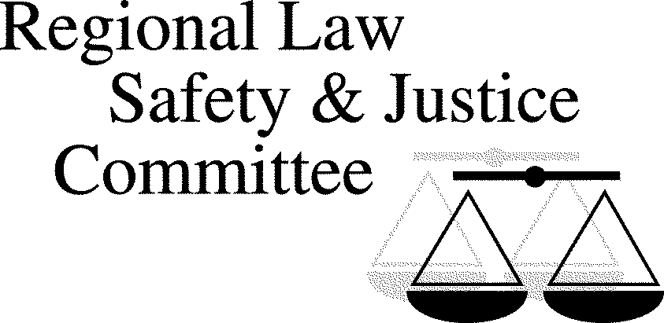
Chair:
James McNeal
Bothell City Councilmember
425-466-2599
james.mcneal@bothellwa.gov

Vice Chair (2019):
Assistant Presiding Judge Willie Gregory
Seattle Municipal Court
willie.gregory@seattle.gov

Staff:
Anna Markee
Executive Analyst
King County Office of Performance, Strategy and Budget
206-263-4176
anna.markee@kingcounty.gov
Thursday, February 28, 2019
7:15 – 9:00 A.M.
Seattle City Hall, Bertha Knight Landes Room
600 4th Ave., Seattle, WA 98104

Agenda
- 7:15 - Coffee and Networking
- 7:30 – SCORE: general update and in-jail programming – David Cline, Devon Schrum, and Lt. Jeffrey Gepner
- 8:00 - King County Jail – information on in-jail programming – Nancy Garcia
- 8:20 - King County Re-Entry Programs Overview – Patty Noble-Desy

Steering Committee Meetings
The RLSJC Steering Committee meetings are held immediately after the full committee meeting from 9:00 a.m. to 10:00 a.m. in the Bertha Knight Landes Room. The Chair, Vice Chair, SCA representatives, committee staff, and interested RLSJC members plan the next meeting topics. All RLSJC members are welcome to attend the Steering Committee meetings. Email anna.markee@kingcounty.gov if you would like to be on the Steering Committee email list.

2019 RLSJC Dates and Tentative* Topics
All meetings (with the exception of the September meeting) will take place at Seattle City Hall in the Bertha Knight Landes Room from 7:30 am to 9:00 am. Coffee and networking begins at 7:15.
- February 28: Reentry and jail updates
- March 28: Inquests and I-940
- April 25 *NEW DATE*: Domestic Violence and Gun Safety
- May 23: Therapeutic Courts, including Community Court
- July 25: Gangs, school safety
- September 26: Homelessness, opiate epidemic update
- December 5: Adult diversion programs: Navigator, LEAD, Familiar Faces
*These topics may change based on speaker availability and other issues that arise.

