Council Meeting Date: May 29, 2013 Agenda Item: IV

GROWTH MANAGEMENT PLANNING COUNCIL AGENDA ITEM
KING COUNTY, WASHINGTON

AGENDA TITLE: Designate Central Issaquah as an Urban Center in the King County Countywide Planning Policies – Appendix 1 Land Use Map

PRESENTED BY: Ava Frisinger, Issaquah Mayor

SUMMARY

Nomination: The City of Issaquah is proposing that Central Issaquah be designated an Urban Center in the Countywide Planning Policies. The Issaquah City Council authorized nomination of the Central Issaquah Urban Core for Urban Center on April 15, 2013 (AB 6586).

Location: The area proposed for Urban Center designation is shown on the attached map. The proposed Center is 461 acres and includes several of Issaquah’s top employers, including Costco’s corporate headquarters.

Growth Targets and Future Land Use: Most of Issaquah’s future housing and job growth (GMA Targets - 5,750 housing units and 20,000 jobs) is planned for Central Issaquah and the proposed Urban Center. This growth will transform the Urban Center from a collection of strip malls and office buildings into a more livable, sustainable and balance mixed use community. Planned densities are 51 jobs and 15.58 housing units per acre.

A Commitment to Urban Center Expectations: The Issaquah City Council has taken the following steps to plan for growth in the proposed Urban Center:

- ADOPTED the Central Issaquah Plan, including a policy calling for Urban Center designation;

- COMPLETED a Planned Action EIS for Central Issaquah and the proposed Urban Center;

- ADOPTED new Development and Design Standards for Central Issaquah;

- ADOPTED a Planned Action Ordinance for the proposed Urban Center; and

- REZONED the proposed Urban Center from primarily Office and Retail zoning to higher density mixed use Urban Core and Urban Village zoning.

APPLICABLE COUNTYWIDE PLANNING POLICIES
The Countywide Planning Policies provide direction about the process for designating Urban Centers.

DP‐29 Concentrate housing and employment growth within designated Urban Centers.

7,185 new residential units and 27,565 new jobs are planned for the 461 acre Urban Center.

DP‐30 Designate Urban Centers in the Countywide Planning Policies where city-nominated location meets the criteria in policies DP-31 and DP-32 and where the city’s commitments will help ensure the success of the center.

The City’s commitment to becoming an Urban Center is summarized above. These actions are the result of six years of community planning.

Urban Centers will be limited in number and located on existing or planned high capacity transit corridors to provide a framework for targeted private and public investments that support regional land use and transportation goals. The Land Use Map in Appendix 1 shows the locations of designated Urban Centers.

Issaquah’s proposed Urban Center is located adjacent to I-90, a designated high capacity transit (HCT) corridor in the 2005 Sound Transit Long Range Plan.

DP‐31 Allow designation on new Urban Centers where the proposed Center:

a) Encompasses an area up to one and a half square miles; and

The proposed Issaquah Center is 461 acres (.72 square miles).

b) Has adopted zoning regulations and infrastructure plans that are adequate to accommodate:

New mixed use urban density zoning districts were adopted for the proposed Urban Center on April 15, 2013. The Central Issaquah Plan EIS identifies specific measures to assure that the City’s infrastructure plans are adequate to accommodate the planned growth.

i) A minimum of 15,000 jobs within one-half mile of an existing or planned high-capacity transit station.

The adopted Central Issaquah Plan includes a conceptual HCT I-90 corridor and four potential light rail stations. Three of the four potential stations meet this criterion.

ii) At a minimum, an average of 50 employees per gross acre within the Urban Center; and,

The Central Issaquah Plan anticipates 23,555 jobs in the proposed center – an average of 51.1 employees per gross acre.

iii) At a minimum, an average of 15 housing units per gross acre within the Urban Center.

The Central Issaquah Plan anticipates 7,185 new residential units in the proposed center – an average of 15.58 units per gross acre.

DP‐32 Adopt a map and housing and employment growth targets in City comprehensive plans for each Urban Center, and adopt policies to promote and maintain quality of life in the Center through:

The Central Issaquah Plan includes a Land Use Map, including the proposed Urban Center and housing and employment targets.

- A broad mix of land uses that foster both daytime and nighttime activities and opportunities for social interaction;

The adopted Development and Design Standards allow a mix of uses vertically and horizontally.

- A range of affordable and healthy housing choices;
The Housing Element of the Central Issaquah Plan includes policies addressing housing choices and affordability. Residential and mixed use residential development in the proposed Urban Center is required to provide not less than ten percent of the residential units for mid-moderate incomes. Affordable housing is also one of the required public benefits to participate in the City’s density bonus program within the Development and Design Standards.

- Historic preservation and adaptive reuse of historic places;

The City’s Comprehensive Plan includes policies to preserve natural, cultural and historic resources.

- Parks and public open spaces that are accessible and beneficial to all residents in the Urban Center;
The proposed Urban Center will be served by a “Green Necklace” of connected urban parks, green space and pedestrian corridors and three new parks. The proposed Urban Center is also adjacent to Lake Sammamish State Park (512 acres) and Issaquah’s 30 acre Tibbetts Valley Park.

- Strategies to increase tree canopy within the Urban Center and incorporate low-impact development measures to minimize stormwater runoff.
The Central Issaquah Development and Design Standards establish minimum tree densities, tree removal standards and tree replacement requirements.

City Codes require redevelopment to be consistent with low impact development measures, including narrow streets and impervious pavement.

- Facilities to meet human service needs;
The Community Food and Clothing Bank is within walking distance from the proposed Center. The City provides financial support to a variety of local and regional human service programs that serve Issaquah.

- Superior Urban Design which reflect the local community vision for compact urban development.
The City adopted new Development and Design Standards for the proposed Urban Center to promote pedestrian oriented development and create a sense of place.

- Pedestrian and bicycle mobility, transit use and linkages between these modes;
The vision for the proposed Urban Center is to create a “connected urban community where pedestrians are priority”. This vision is implemented through related plan policies and the adopted Development and Design Standards.

- Planning for complete streets to provide safe and inviting access to multiple travel modes, especially bicycle and pedestrian travel; and,
Chapter 6.0 Circulation of the Development and Design Standards will “create a complete streets network” for the Urban Center. In addition, the Central Issaquah Plan identifies a number of strategies for Central Issaquah to become bike friendly.

- Parking management and other strategies that minimize trips made by single-occupant vehicles, especially during peak commute periods.
Approximately 75% of the developed land in Central Issaquah is currently used for parking. The new Development and Design Standards replace the City’s current suburban parking standards with new parking requirements and policies to encourage transit use and walking. The Central Issaquah Plan includes a commitment to achieve a 17% transit, transit supportive and nonmotorized mode split.

DP‐33 Form the land use foundation for a regional high-capacity transit system through the designation of a system of Urban Centers. Urban Centers should receive high priority for the location of transit service.

The Sound Transit 2 Plan (ST2) proposal to extend rail service to Issaquah will play an important role in connecting Issaquah to other regional employment and housing centers. The designation of the Central Issaquah Urban Core as an Urban Center will support future transit investment in the I-90 HCT corridor.
Attachment A: Central Issaquah Plan Proposed Regional Growth Center Map

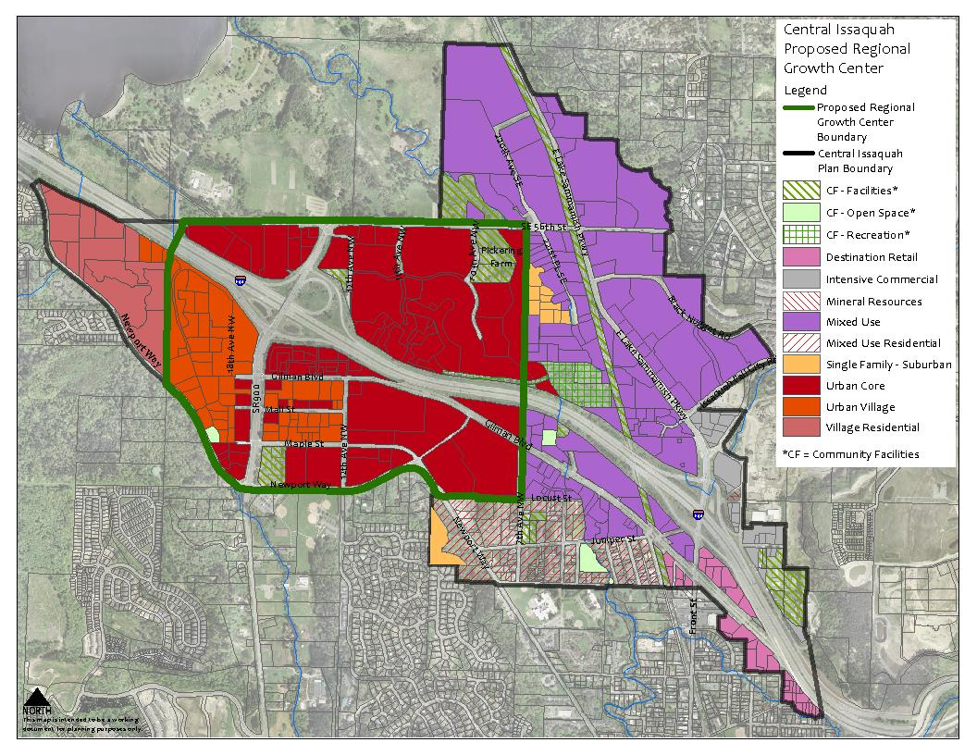
Attachment A

