King County

Public Records Committee Annual Report

February 2015

Prepared by

Records and Licensing Services Division

Approved by the

Public Records Committee

Executive summary

The King County Public Records Committee (PRC) is composed of representatives of all King County Executive departments, as well as independently elected officials, Superior and District Courts. The PRC serves as a collective body of expertise and perspective to consider public records and records management impacts associated with County business. In this role, the PRC promotes employee awareness of public records and records management responsibilities, and advises the King County Council, the King County Executive, King County Information Technology (KCIT), and others, as appropriate, on policy matters associated with management of public records, both electronic and paper-based, including the development and maintenance of a complete countywide records and information management (RIM) solution.

The PRC charter approved and amended by the County Council under Motion 12511 calls for an annual report submitted to both the King County Executive and the King County Council by March 1 of each year. This report summarizes the activities of the committee for calendar year 2014.

The Public Records Committee met seven times in 2014. The committee’s 2014 work addressed each of the six goals set out in its charter. The six goals are:

- Review, comment and provide advice on County documents regarding public records management, including policies, public rules, ordinances, guidelines, best practices, etc.

- Collaborate with County agencies and KCIT on technology-based communication tools as they are deployed to ensure matters associated with records creation and management are known and addressed.

- Provide guidance on the planning and implementation of a countywide records storage management plan and a countywide electronic records management system.

- Provide guidance on the development of policies and guidelines for the permanent preservation of the County’s historical records.

- Provide guidance for the development of policies and guidelines regarding posting records on County websites.

- Provide on-going, two-way communication across the County to ensure employees are aware of issues and responsibilities regarding records creation and management.

Background

On May 21, 2007, the King County Council passed Motion 12511, approving the vision, guiding principles, goals, governance and management structure of the King County Public Records Committee as outlined in the Public Records Committee Charter. The formation of the PRC came in response to King County Council Ordinance 15608, which called for the creation of a public records committee to advise both the Council and the King County Executive on policy recommendations regarding the management of King County’s public records, in all formats. Issues coming under the purview of the PRC include privacy, access to and charges for copies of public records, display of records on County websites, planning and implementation of a countywide records storage management plan, a countywide electronic records management initiative, and the preservation of the County’s historical records.

The officers of the committee for 2014 were Chair Norm Alberg, Director of the Records and Licensing Services Division (RALS); Vice-Chair Stan Roe, Department of Assessments, and Secretary Deborah Kennedy, Archives, Records Management and Mail Services Manager.

The Public Records Committee met seven times in 2014; January, March, April, May, July, September, and November.

- Membership
In 2014, the Department of Executive Services, Records and Licensing Services Division launched the Countywide Records Management Initiative. The Records Management Initiative (RMI) was charged with engaging all County agencies, including the separately elected organizations, in the adoption of the countywide records management policies and establishing a governance and accountability framework. The PRC acts as the governing body for the RMI. As the RMI ramped up, the PRC revisited its membership and processes to maximize the committee’s effectiveness and efficiency. The PRC undertook a review of its membership and asked the departments and agencies named in the PRC charter to identify an agency records officer who would be their PRC representative. In May 2014, Norm Alberg, PRC Chair, sent a memo to the members of the Operations Cabinet asking them to identify their agency’s representative to the PRC. The memo included a list of desirable characteristics for PRC members. Those characteristics are:

- Have decision-making authority for the organization, an understanding of the full range of operational issues faced by the department or agency; and access and credibility sufficient to effect change across the department or organization.

- Be accepted as a department or agency leader.

- Have familiarity with and be supportive of Public Records Act and Records Retention compliance issues.

- Be able to commit to the PRC standing meeting schedule or commit to providing and receiving meaningful backfill or catch-up strategies when meeting attendance isn’t possible.

To formalize the process the King County Records Management Program created a formal process appointing agency records officers. The Agency Records Officer Appointment Form is included as appendix A.

At the April 15, 2014 meeting, the Committee also revised its charter to include the Department of Public Defense. The current membership list is included as Appendix B.

- 2014 Work Plan, activities and accomplishments
The PRC organized its work around the committee’s six goals. The activities and accomplishments associated with each are listed below.

- PRC Goal 1: Review, comment and provide advice on County documents regarding public records management, including policies, public rules, ordinances, guidelines, best practices, etc.

- King County General Records Retention Schedule
At the January 21, 2014, meeting the Public Records Committee approved the King County General Records Retention Schedule. The General Records Retention Schedule sets uniform standard retention periods for County records. The PRC’s approval of this schedule sets the County’s standard retention periods and requires that an agency wishing to deviate from the schedule’s listed retention period would need to argue a business justification for the change and submit it as a unique agency retention schedule for Public Records Committee approval. For records series not on the King County General Records Retention Schedule, agencies will continue to use the Washington State Archives sector specific schedules until the agency participates in the Records Management Initiative and their agency specific unique records retention schedule has been developed and approved.

- INF 15-4 (AEP) Management of King County Public Records
Executive policy INF 15-4 (AEP) Management of King County Public Records went into effect on July 31, 2014. At the September 30, 2014 PRC meeting committee members were instructed to email the Records Management Program to request any appropriate exceptions to the policy. A request for an exception to the policy does require a justification as to why an agency cannot comply with the mandates set for in the policy.

- PRC Goal 2: Collaborate with County agencies and KCIT on technology based communication tools as they are deployed to ensure matters associated with records creation and management are known and addressed.

  - SharePoint
The PRC invited Latasha Battle, SharePoint 2013 Project Manager, to the January 21, 2014 meeting to give an update on the Intranet redesign project. Battle reported that the SharePoint 2013 project will allow users to more easily publish content since it does not require HTML coding. The modern infrastructure of SharePoint replaces the current King County server storage with Cloud computing hosted by Microsoft which will reduce the cost of ownership and provide a more consistent customer experience to search and locate files. Phase I, in progress at the time of Battle’s presentation, involved moving the intranet content of seven pilot agencies: KCIT, HR, DPER, Executive Office, DNRP, and Elections, to Office 365/SharePoint 2013. During the RFP process KCIT was unable to locate a vendor who would integrate SharePoint and Autonomy Records Manager (KC ERMS) within the scope and budget of the project. It is anticipated that this issue can be revisited in the future. In the meantime, Records Management staff will include instructions on managing SharePoint records as part of the training delivered as part of the Records Management Initiative.

  - Lync Conversation history
At the January 21, 2014 meeting, Terra Milles, KCIT Communications Manager, reported that per the 2013 PRC recommendation the Lync conversation history logs were no longer being recorded in individual user’s Outlook accounts. Conversation history logs created before the change and that remain in individual user’s accounts are transitory records with no retention value since KCIT is the office of record for this series.

  - KCIT Conceptual Review Board
KCIT invited PRC membership to comment on projects that were considered by the Conceptual Review Board. The goal of PRC involvement in the Conceptual Review Board process was to make the committee aware of the projects before implementation so that the PRC could communicate with the project team and address any records management concerns. Two PRC members, the County’s Records and Information Manager, and County Archivist reviewed 45 projects using criteria developed for the reviewers to use in their evaluation aimed at identifying projects with records management, archival, and/or public records concerns:
- Data with retention value (such as the Jail house legacy data project)
- Systems that manage documents/records
- Imaging systems or projects that require a Disposition After Digitization (DAD) approval (such as the paperless benefits project)
- Project that would require system integration with KC ERMS or would duplicate the functions of the KC ERMS.
The committee received a report from the two PRC members, the County’s Records and Information Manager, and County Archivist and agreed to the following next steps:
- Ensure that the information/concerns gathered by the PRC are transmitted to KCIT’s Project Management Office so they can be assigned to the correct project manager if the project is funded.
- Determine how to get involved earlier in the process in 2015.

  - .PST file replacement project
The PRC receive a report on the .PST file replacement project at its September 30, 2014 meeting. Several records issues were identified in the discussion that followed the report. The committee agreed that the Records Management Program and KCIT should work together to move forward on the .PST issue.

  - SharePoint-MySite
At the November 19, 2014 meeting the PRC received an update on the conversion of the County’s intranet to SharePoint. SharePoint gives each user a MySite and One Drive – with functionality similar to Facebook and Dropbox. The PRC will include working with KCIT to develop a policy for acceptable use of these technologies and the accompanying records management issues in the 2015 work plan.

- PRC Goal 3: Provide guidance on the planning and implementation of a countywide records storage management plan.

- Guidance documents on Lync voicemail messages
A guidance document, prepared by the Records Management Program, on how to add descriptive metadata to Lync voicemail message to facilitate searching was distributed at the January 21, 2014 meeting. The goal of the advice sheet is to teach users how to add content-specific metadata to the email message so that they can be searched, retrieved and filed into KC ERMS.

- Top down accountability—Quarterly score card
The Records and Licensing Services Division sends a quarterly report to the Operations Cabinet on the status of the Records Management Initiative. PRC members asked that those reports be shared with them prior to the Operations Cabinet presentations.

- KC ERMS Advisory Group
PRC members were invited to join a KC ERMS Advisory Group formed to address various issues and decisions regarding system usage, functionality, and enhancements as well as some very specific issues affecting KC ERMS users. In addition to PRC members, interested employees from the agencies who interact most with the electronic records management system were invited to participate.
- ARC Space Plan Records Storage Survey
PRC members were asked to inventory and send the Archives, Records Management, and Mail Services Section an estimate of the number of boxes of physical records that would be sent to inactive storage within the next two years. This information was then used to inform a space plan and the future storage and space needs for the Archives and Records Center.

- PRC Goal 4: Provide guidance on the development of policies and guidelines for the permanent preservation of the County’s historical records.

- Archives and Records Center Space Plan
See ARC Space Plan Records Storage Survey, number four under C. PRC Goal 3.

- PRC Goal 5: Provide guidance for the development of policies and guidelines regarding posting records on county websites.

  - No activity in 2014

- PRC Goal 6: Provide on-going, two-way communications across the County to ensure employees are aware of issues and responsibilities regarding records creation and management.

- Exiting employee checklist
The Public Records Committee recognized the need for a countywide effort to develop a procedure for exiting employees at its March 4, 2014 meeting. A countywide effort would include HRD, KCIT, FMD, Records Management and possibly other agencies. In the interim the Records Management Program developed and presented to the PRC an Exiting Employees Checklist to provide guidance to both employees who are leaving the County and their supervisors on how to manage records in their custody prior to their departure.

- Open Government Act training
Shelby Miklethun, Executive Branch Public Records Officer, updated the PRC on the requirements of Engrossed Senate Bill 5964, the “Open Government Trainings Act” which was effective July 1, 2014. The law requires that members of governing bodies receive training on the Open Public Meetings Act, elected officials (except the elected officials from the courts) receive Public Records Act (RCW 42.56) and records retention training (RCW 40.14), and that Public Records Officers receive Public Records Act (RCW 42.56) and records retention training (RCW 40.14). The Attorney General’s Office (AGO) made video and PowerPoint trainings available on the AGO’s website that satisfy the requirements of the law. The Office of Civil Rights and Open Government (OCROG) worked with the boards and commission liaisons to schedule times for board and commission members to watch the Attorney General’s Office’s Open Public Meetings Act video and document it for compliance. New board and commission members are required to watch the AGO Open Public Meetings Act video and a KC Executive Branch produced video on the PRA and records retention. The Records Management Program developed three new training classes: a new employee orientation training which will be available online for every new employee to watch, as well as online classes for elected officials and public records officers on retention requirements and the Public Records Act.

- Records and Information Management month
The Records Management Program sponsored several events and activities during April, Records Management Month, designed to encourage and educate employees on records management best practices and to encourage filing records into KC ERMS. The main effort was the “Take-5 and File” contest where users of the electronic records module of KC ERMS were encourage to ‘take 5’ minutes a day to file their records into the system. Three agencies had 100% participation; every eligible employee filed at least one record into the system. There were a total of 102,464 records filed by 211 users during the month of April; in comparison to the 48,440 records filed in March. The filing efforts in April contributed to KC ERMS reaching the milestone of over 3 million records filed. Winners of the “Take-5 and File” contest were awarded a filing certificate and a Take-5 miniature candy bar attached to a postcard of email management tips. Other activities included a scavenger hunt where users looked for records management related information and resources on the section’s Intranet page and a crossword puzzle with records management related clues. There were eight scavenger hunt entries and seven crossword puzzle entries. The Records Management program promoted records management month by producing and posting in county buildings, two posters where staff represented a Records Management Mishap and A Records Management Rock Star. The posters were also distributed via email and posted to the intranet site and can be used as inspiration all year as they are not specific to Records Management Month.

- Records Management Activity Report
The Records Management Program began distributing an Agency Records Management Activity Report to provide the PRC members with information that can used to increase awareness of records management in their agencies. These reports include filing reports showing the Department, Division, Section offices in each agency that are filing electronic records in KC ERMS consistently and a listing of delinquent Records Center box (physical records) disposition sessions. Delinquent sessions are those disposition authorization reports that have been sent to the Disposition Authorities but have not been reviewed and approved.

- Officers
Chair: Norm Alberg, Director, Department of Executive Services, Records and Licensing Services Division
Vice-Chair: Stan Roe, Public Information and Disclosure Coordinator, Department of Assessments
Secretary: Deborah Kennedy, Archives, Records Management and Mail Services Manager, Department of Executive Services, Records and Licensing Services Division

Minutes and agendas along with the meeting schedule is available on the PRC website, http://kcweb.metrokc.gov/archives/prc.aspx

Appendix A

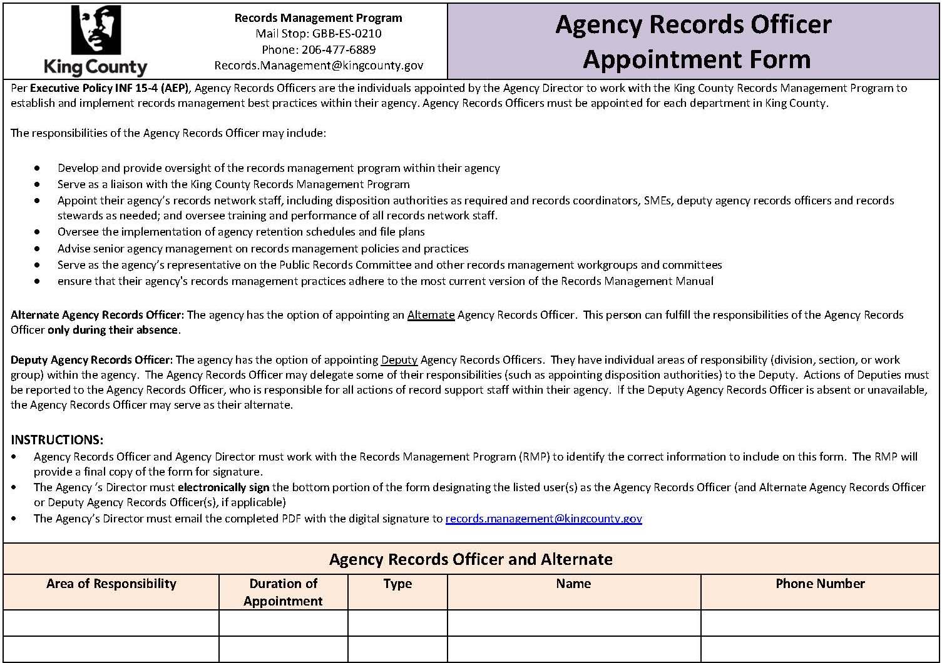

Appendix A (continued)

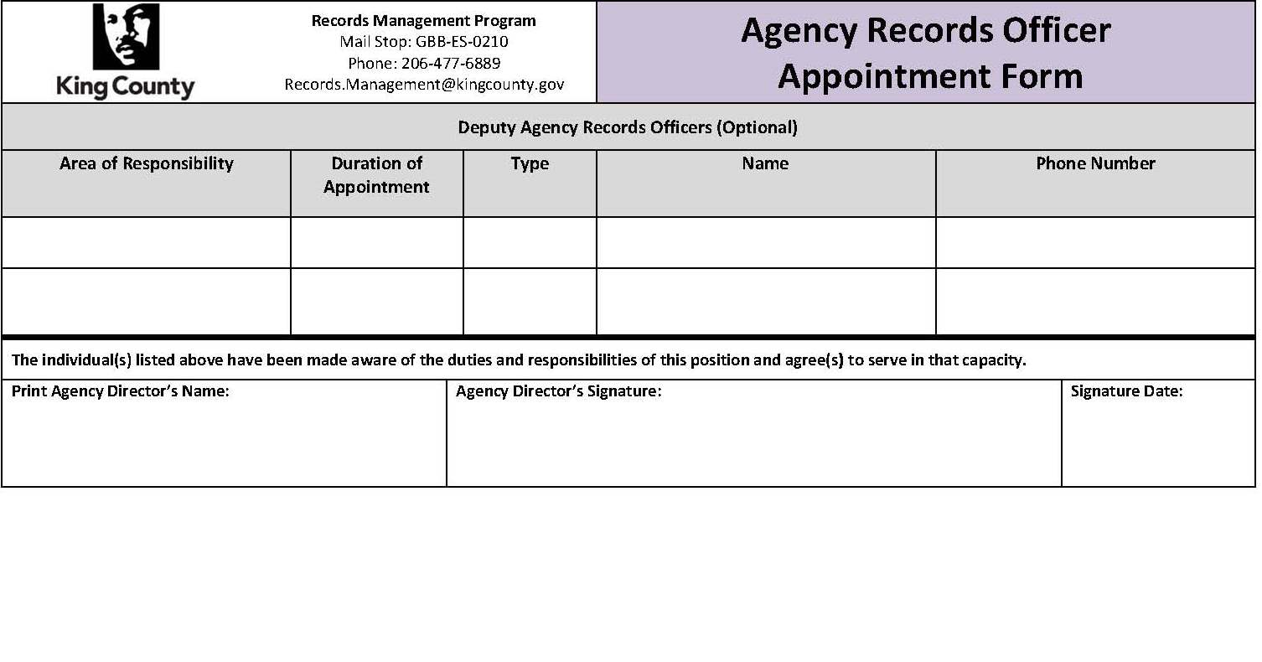

Appendix B
Public Records Committee
Membership List

First name | Last name | Charter Named Agency | Appointed Agency Records Officer
Andrea | Williams | Adult & Juvenile Detention | ⊠
Stan | Roe (Vice-chair) | Assessor’s Office | ⊠
 |  | Community & Human Services | ⊠
Kimberly | Hamm | District Court | ⊠
Nathan | Valderas | Elections | ⊠
Nicholas | Lee | Executive Services | ⊠
Norm | Alberg (Chair) | Executive Services: Records & Licensing Services
Deborah | Kennedy (Secretary) | Executive Services: Records and Licensing Services: Archives, Records Management and Mail Services Manager
Rosa | Orams | Executive’s Office/Performance Strategy & Budget | ⊠
Shelley | Harrison | Executive’s Office/Performance Strategy & Budget
Terra | Milles | Information Technology (KCIT)
Joel | McAllister | Judicial Administration | ⊠
Denise | Millard | Judicial Administration
Anne | Noris | KC Council | ⊠
Cynthia | Hernandez | Natural Resources & Parks | ⊠
Benita | Lamp | Permitting & Environmental Review
Kim | Laymen | Permitting & Environmental Review
Monique | Cohen | Prosecuting Attorney
David | Hocraffer | Public Defense | ⊠
Tyler | Entrekin | Public Health | ⊠
Shelby | Miklethun | Public Records Officer, Executive Branch
Kimberly | Petty | Sheriff’s Office | ⊠
Linda | Ridge | Superior Court | ⊠
Laura | Federighi | Transportation | ⊠

