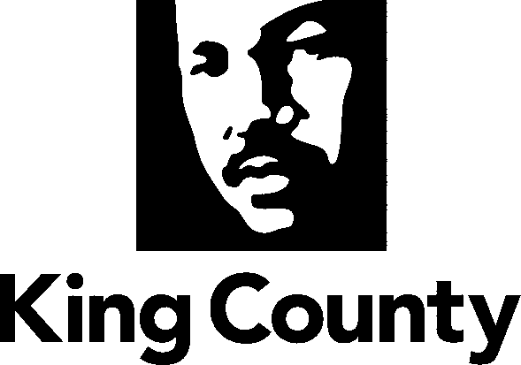
Adult Services Division
Women’s Advisory Board
Department of Community and Human Services
401 Fifth Avenue, Suite 510
Seattle, WA 98104
206 263-9069 FAX: 206-205-6565
TTY Relay: 711

WOMEN’S ADVISORY BOARD
MINUTES FROM THE September 13, 2023, MEETING

Meeting Type:  Regular: X  Special: _ | Location: Chinook Building- 401 5th Ave., Seattle, WA  Join Zoom Meeting: Join Zoom Meeting  https://kingcounty.zoom.us/j/84312053856  Meeting ID: 843 1205 3856  Passcode: KCWAB |  |  | Called to Order:  4:00 PM |  | By:  Tanya Matthews
Members Present:
Roxanne Thayer- po.8  Councilmember McDermott |  |  | Po. 1 Vacant  Councilmember Dembowski |  | Po. 13 Vacant  Council At-Large
Sarah Reyneveld- po.4 Councilmember Kohl-Welles |  |  | Po. 5 Vacant  Councilmember Upthegrove |  | Po. 14 Vacant  Council At-Large
Karol Brown- po.6  Councilmember Balducci |  |  | Po. 9 Vacant  Councilmember Dunn |  | Po. 15 Vacant  Council At-Large
Tanya Matthews- po.2  Councilmember Zahilay |  |  | Po. 10 Vacant  Council At-Large
Po. 11 Vacant
Council At-Large
Po. 12 Vacant
Council At-Large
Excused/Absent: |  | Melissa Margain- King County Staff Liaison
Speakers: | N/A
Staff: | Marjan Didra- King County Staff Liaison
Guests: | Tana Yasu (former Seattle Women’s Commission), Mary Williams (Ways Forward Washington Against Sexual Exploitation).
Approval of Agenda: N/A |  |  |  | Vote: N/A
Approval of Minutes: N/A |  |  |  | Vote: N/A

AGENDA ITEMS:

Agenda Item 1: | Welcome & Introductions
 | Tana Yasu (former Seattle Women’s Commission), Mary Williams (Ways Forward Washington Against Sexual Exploitation).
Action Items: |  | Person(s) Responsible: | Deadline/Due Date
In this meeting, the WAB members discussed various topics and action plans in moving forward with their current project of older adults and healthy aging, specifically related to women in King County.  WAB members worked on new member orientation planning.  WAB members planned to cosponsor an event on October 29th with former Seattle Women’s Commission members and advocates for the month of October (Domestic Violence Awareness Month). |  | WAB members | September 13, 2023

Agenda Item 2: | Public Comment
 | Tana Yasu: announced their event for the Domestic Awareness Month (DV) and invited the King County WAB members to cosponsor the event with them.
Action Items: |  |  |  | Person Responsible | Deadline/Due Date
Domestic Awareness Month on October 29th Event |  |  |  | Tana Yasu | ASAP
Agenda Item 3: | Announcements
Boardmember Updates: Roxanne Thayer announced: the need for women in King County (KC) to access healthcare and emphasizing that through writing a resolution.

Marjan Didra announced: the Website is updated with the current WAB members information.
Action Items: |  |  |  | Person Responsible | Deadline/Due Date
Agenda Item: Future Focus | Older Adults and Healthy Aging (OAHA)
 | WAB members are interested in presentations from various organizations that provide services to Seniors to discuss issues such as transportation. Specifically, WAB members want to hear from those with lived experiences or those living in poverty.
Action Items:
Future Agenda |  |  |  | Person Responsible | Deadline/Due Date
WAB members to write a draft resolution and share with others to edit. |  |  |  | Karol Brown | ASAP
Find ways to reach out to the media in KC and share WAB work and events. |  |  |  | Karol Brown | ASAP
Members to reach out to their Councilmembers to share the existing vacant positions. |  |  |  | WAB members | ASAP
WAB members are to review the mission statement at their next meeting on October 11, 2023. |  |  |  | WAB members | ASAP
WAB members to start building a list of the organizations to present. |  |  |  | WAB members | ASAP
Reach out to Councilmembers and learn what they are doing for the October DV Awareness month. |  |  |  | WAB members | ASAP
Reach out to the Seattle Women’s Commission and invite them to the October 29th event. |  |  |  | Roxanne Thayer | ASAP
Roxanne Thayer to send their completed member re-appointment form to Marjan Didra. |  |  |  | Roxanne Thayer | ASAP
Reach out to KC organizations leading DV work and invite them to the October 29th event. |  |  |  | WAB members  Marjan Didra | ASAP
Recap of the orientation as it will be in person for everyone to get to know each other.  - Create group norms and values  - Provide new members with the big picture  - The kind of work that King County WAB does  - The recommendations writing process  - Share the Bylaws of the WAB  - The expectation setting and division of responsibilities  - All-inclusive space  - Hear from everyone on the issues that are most important to women in King County |  |  |  | WAB members | ASAP
Staff liaison to share the October awareness month event on KC blogs. |  |  |  | Marjan Didra | ASAP
Can WAB members have KC-WAB logo |  |  |  | Marjan Didra | ASAP
GBV recommendation and updates on the transmittal. |  |  |  | Melissa Margain | ASAP

AJOURNMENT

Time: 5:45 p.m.

NEXT MEETING

Date: October 11, 2023, Vice Chair: Tanya Matthews Time: 4:00-6:00 p.m. Location: Chinook Building- 401 5th Ave., Room 115, Seattle, WA OR Zoom/Call-In

