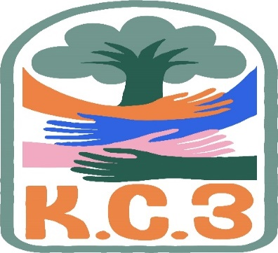
King County Community Collaborative- KC3
Voices of Change and Empowerment
Aug 23rd,2022 5:30– 7:30 pm
Introduction and welcome Melody first time in her role as the meeting facilitator.
There was a discuss on the peer workforce; How our community providers are doing with it? Are peer’s getting the training needed to be hired? What is HCA doing to help with peers getting into the Certified Peer Counseling classes?
- Discussion outcome- send out question to network to get more input. We will put on the next month agenda.
Presentation on the King County September Recovery Month Campaign “King County Go Purple” and how can KC3 participate.
- The group agree to support the campaign, some of the idea’s 1. where to encourage folks to wear purple at the Sept meeting. 2. To post on social media platforms take pictures in purple if they would like and post them 3. To share with your networks. 4. A word cloud of words that share what recovery means to you. We will share it at the next meeting. 5. Check out the KC website for more information and ideas on getting families and the community involved.
Sharing Announcements, Updates:
- GPs shared upcoming class and event (Melody will send out the flyers), GPs is looking for youth and family member to for an advisory committee. (Information will be set out.)
- WSCC shared upcoming meetings and events Parent Weekend Yakima Sept 16-18th 2022
Workgroups
- Cole provided an update on the last youth engagement meeting. He also put out an ask for other to attend and to invite a youth and or young adult that they may be working with or know to attend alongside of them. Next meeting Sept
- No update on the membership committee they are looking for folks to join. Still have not gotten any one to join the membership.
Announcements there were a few people that shared community meeting and event.
- King county Leg. Day Nov 11th
- WA DADS father Camp
- Jones Solution Fishing & Camp trip Oct 7-8th,2022
- WSCC Parent weekend Sept 16-18th
- So. King CWPI meeting
- Zero Suicide Academy Trainings (email with dates will be sent to LaTonya to be shared out to network.)
KC3 engagement Activity Time; Scavenger Hunt
Next meeting Virtual - Sept.27th,2022 5:30pm

