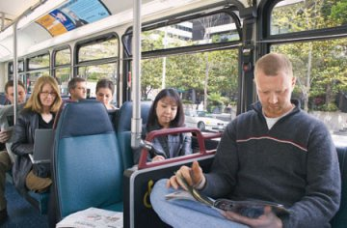 | We’re reducing our carbon footprint!  How about you? | 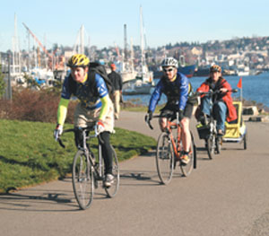
Find out how simple it is to help save the planet and save commuting costs at the same time. | 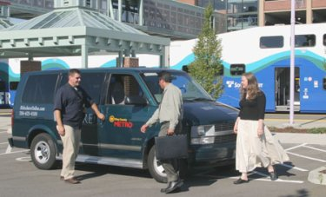
Come learn about commuting options: riding the bus or train, vanpooling, vansharing, carpooling, biking and walking. We’ll help you find an option that works for you!  When:  Time:  Where:  For more information contact: |  | 