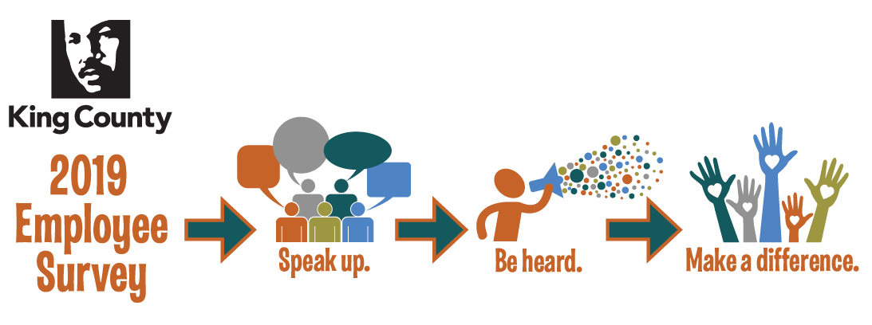
1-2-3 Action Plan Template
Pick 1 Thing – Do 2 Things About it – Communicate 3 Times

Team Information
Action Plan Point Person Name

Action Plan Point Person E-Mail

Action Plan Team

Workgroup (Department, Division, Section, Unit)

Pick 1 Thing
Pick something that your team agrees is important and that you can impact in the coming year.
Description of the Action

Background for this Action

Related Survey Question

Engagement Dimension (Peer Culture, Personal Influence, Growth and Development, On the Job, Relationship With Supervisor, Division Leadership, Department Leadership, Strategic Alignment, Equity and Social Justice, Well-being)

Do 2 Things About It
Pick two concrete things that your group will need to do in order to compete your action plan. This should be specific and action oriented. For example: “Have the entire office complete Strengthsfinders Assessment” or “Create new telecommuting policy.” It’s okay if these actions are long term – just make sure you’re actively working on it and communicating. Where possible, try to find alignment with existing activities in your work such as ESJ or continuous improvement.
Action 1

Action 2

(Over)
Communicate 3 Times
Communication 1
Theme:

This should be a summary of your action plan: What you chose to focus on, what your planned actions are and who is on point to do what.
Due Date: (June – August 2019)

Communication 2
Theme:

This should be a check in about the progress on your action plan.
Due Date: (September – November 2019)

Communication 3
Theme:

This should be a wrap up of what you were able to accomplish and what you learned along the way.
Due Date: (December 2019 – February 2020)

