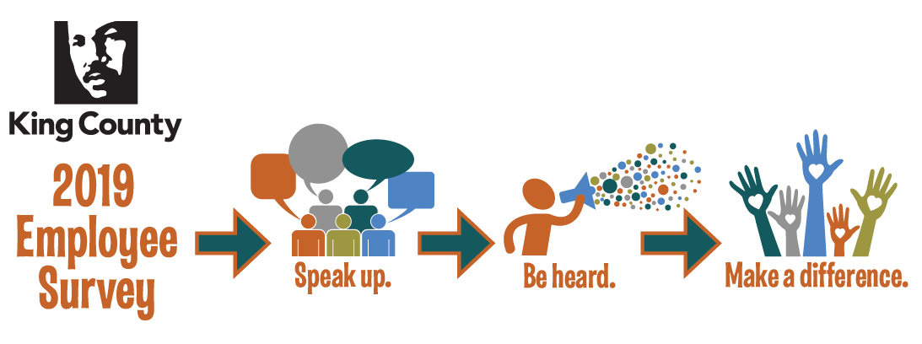
Use the Action Plan Tracker
Introduction
This document has step-by-step instructions on how to enter your engagement action plan into the tracker and how to use it to see what others are doing.
As much as possible, we recommend that you use the Google Chrome or Microsoft Edge browser when accessing both the Action Plan Tracker and the Engagement Report.

Step-by-Step Instructions
- The action plan tracker is available from the same platform as the engagement survey results. Single Sign On is enabled so you can access the tracker using your King County Credentials. Use this link to access the platform https://sso.us.confirmit.com/kingcounty/

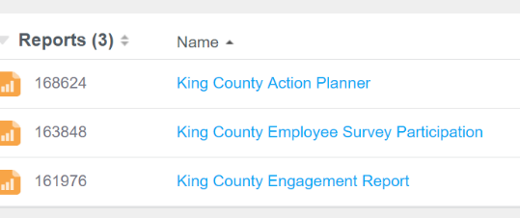
- Upon successful login you will see the Confirmit homepage and the resources you have access to. Click on King County Action Planner.

- To enter your action plan, first choose an engagement driver from the pull down menu by clicking the down arrow under “Pick an Engagement Driver.” The engagement driver can be found by looking at the section of the survey that contains the question you are addressing.

- Once you have chosen an engagement driver, choose a survey question your action is most related to by clicking on the down arrow under “Pick a survey question.” This drop down menu will appear after you have chosen an engagement driver. Only the survey questions pertaining to your engagement driver will appear in the drop down menu.
Click the plus sign to continue entering your action plan.
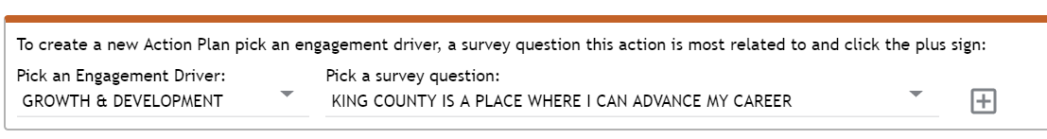

- Enter your:
  - Team information
  - Action Plan point person email (so you can get reminders)
  - Workgroup
  - Description of the action (Make this succinct like “create development plans for all staff” or “create work life balance by prioritizing existing tasks”)
  - First action – What’s the first thing you’re going to do to address your action? For example: “Schedule an all-staff to discuss development plans.”
  - Second action – What’s the second thing you’re going to do to address your action? For example: “Host workshops on how to create development plans.”

- Set goals for when you would like to send three communications to your team. You are asked to send at least 3 communications to your team, each spurred by action you take together.
  - Before August 31: Enter your action plan into the tracker and communicate to your team what you have agreed to do and who will do what.
  - September 1 – November 30: Meet with your team to check on your progress and make any adjustments needed. Communicate to your team how things are going, celebrate any accomplishments and clarify any adjustments being made.
  - December 1 – February 20: Do a wrap up of your action plan with your team. Communicate wins, share lessons learned and carry forward anything you weren’t able to get to.
Note: You will get a reminder email a week before the date you choose.

To set the date click on the down arrow and choose a date in the range specified.

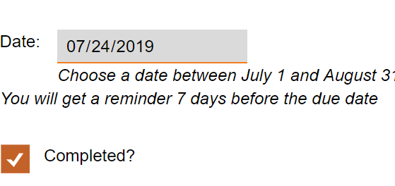
After meeting with your team and followed up with communication, make sure to go back into the tracker and mark that you have completed your communication.

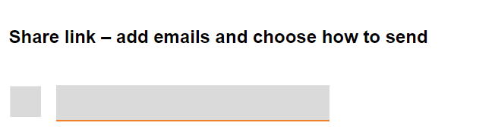
- You can share a link to the action plan with members of your team or your supervisor by entering their email under “Share link.” Use commas to separate emails.

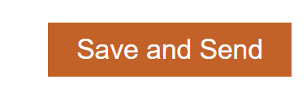
- Finally, click “Save” to save your action plan in the tracker.
You will see a pop up box letting you know that all changes were saved

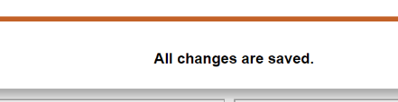

- To check your progress close out of the form and go back to the tracker.
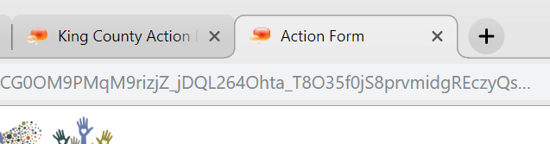

- To update your progress or edit your plan, use the filter in the Action Plans pane to search on point person by entering your name.

Click on the arrow in the square to access the action plan form to update your progress.
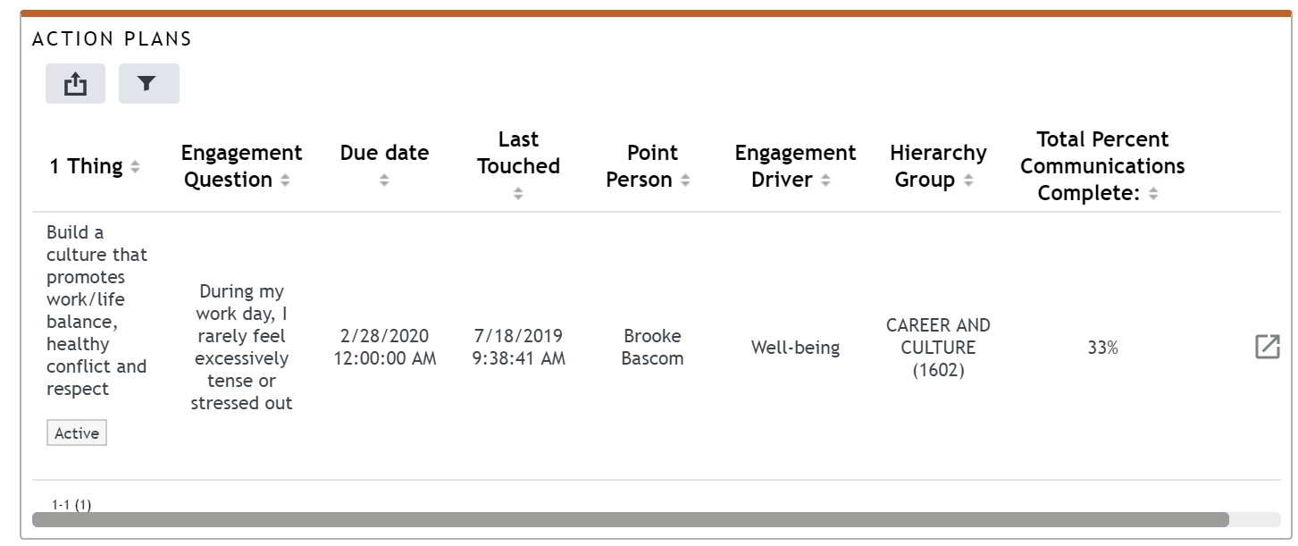

- We encourage you to explore the action plans others are doing so you can learn from them and get ideas! Use the filter to explore action plans by engagement driver, organization or survey question it’s focused on.
Engagement Tier Board Measures Proposal

Engagement “Change Theory” or “Logic Model”
Outcomes:
Increased employee confidence that action will be taken.
Higher employee engagement.
Improved organizational performance: fewer safety incidents, fewer grievances, lower sick leave usage, higher productivity
Goal: Better, more effective, public service
Strategy:
Increasing employee engagement will improve public service by improving organizational performance.
Activities:
Action Planning at the workgroup, division and department levels.
Enterprise-wide response (ex: leadership training, development plans, etc.)
Leadership Action Plans

Outputs:
Action Plans.
Communication about how action plans respond to data.
Investing in You enterprise-wide initiatives that address engagement drivers.
Leadership Action Plans.

Tier Board Measures
 | Tier 5 | Tier 4
Outputs: Action plans | - Action Plan Progress: Percent of action plan communication completed | - Action plan progress: Percent of action plan communication complete  - Leadership action plan completion vs. target  - Percent of Enterprise-wide strategy completed (DHR tier 4)
Outcomes: Engagement, trust, action plan impact | - Employee engagement index  - Belief in action pulse  - Action having a positive impact pulse | - Employee engagement index

Flow
Engagement Action Planning Reporting

People Rounding Schedule

