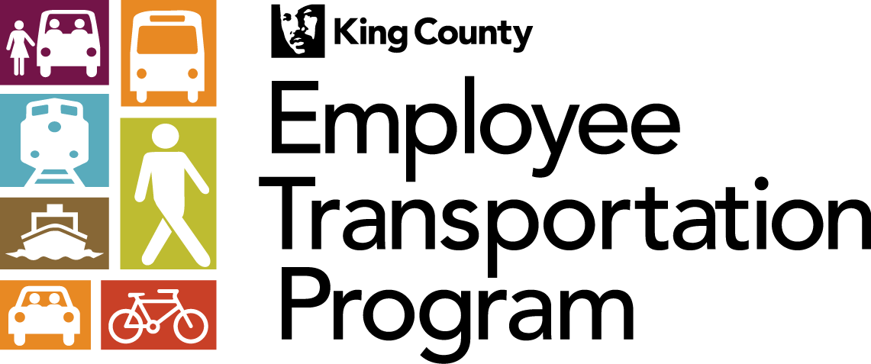

King County Employees Vanpool Benefits Rules of Use and Policy
Effective October 2019 unless or until revised

Starting October 1st, the King County Employee Transportation Program (ETP) will cover the full cost of the Metro Vanpool or Vanshare program for all King County employees who choose to form a new group or participant in an existing vanpool or vanshare group.
Also, when you vanpool to work, you are eligible for up to 14 free taxi rides home (under two different programs) when you have personal emergencies or unexpected requests to work overtime.
The KC Employee Transportation Program (ETP) website and other materials explain Vanpool program and Home Free Guarantee (HFG) program rules and policies. These rules have been communicated to KC employees in brochures, emails, posters and videos as well as online at http://www.kingcounty.gov/employees/ETP.
It is your responsibility to understand the program rules and you are expected to follow all ETP and Vanpool rules. If you do not follow the program rules or abuse the program, you will be penalized according to the program’s violation policy listed below.
The rules state that:
A. Vanpool and Vanshare Programs:

- You can receive the 100% vanpool or vanshare benefit if you are an employee who receives leave and insured benefits from King County.
- To receive benefits for any month, you must vanpool or vanshare at least 51 percent of the days. You may count vacation and sick leave days as regular commute days.
- If you vanpool or vanshare less than eight days per month, you do not qualify for the 100% per month benefit.
- To receive your 100% per month benefit, you are required to read this document, complete the ETP Acknowledgement Form, and submit the form to ETP.
- The ETP must receive your completed and signed Acknowledgement Form by the 1st day of the month. If you fail to submit a completed and signed form to the ETP by the 1st day of the month, you could forfeit your right to receive incentives for that month.

Vanpool and Vanshare Program Benefits and Conditions:
- You will receive 100% of the cost of your monthly vanpool or vanshare when you vanpool or vanshare to work.
- You may choose two vanpool groups in a given month. However, your maximum benefits remain at 100% per month on one vanpool.
- If you choose two vanpool groups in a given month, you may ask your vanpool bookkeepers to split your benefit between your vanpool groups.
- Every year, ETP may send you this document asking you to read it, complete the form in the bottom, sign the form, and send it to ETP. You are required to comply with this request in order to continue receiving the 100% per month benefit.
- All new vanpoolers or vanshare users are required to read this document, complete the form at the bottom, and submit the signed form to ETP.
- You are required to give the ETP and your bookkeeper a two week notice when you plan to leave your vanpool group.
- After you notify your bookkeeper that you will no longer vanpool, your bookkeeper shall not include you in his/her “Ridership Report”.
- ETP may request that you complete short surveys. Upon request, you are expected to complete these surveys.
- ETP and Vanpool program administrators will monitor your vanpool or vanshare activity to ensure that you are complying with the program guidelines.

Vanpool and Vanshare Program Monitoring and Abuse:

- ETP and Vanpool program administrators will monitor information you and your bookkeeper provide to the program to ensure that you are complying with program guidelines and policies. If ETP or Vanpool program administrators determine that you are in violation of program rules, (e.g., you are not vanpooling to commute as you claim to be) the following may occur:

- You will be issued a personal memo/email from the ETP or the Vanpool program administrator reminding you of the program rules and ask you to report accurately.
- The ETP manager will inform your supervisor of the violations and ask your supervisor to speak to you.
- You may lose your privileges of receiving full benefit towards your vanpool fare.
- ETP will report the issue to the KC Human Resources (HR) office and/or your department for investigation and appropriate actions.

B. Home Free Guarantee:
- Your ETP provides you with up to eight free taxi rides home each year, on days that you come to work via bus, rail, streetcar, carpool, vanpool, bicycle, or on foot and have personal emergencies or unexpected requests to work overtime. These eight Home Free Guarantee (HFG) taxi rides are subject to ETP and HFG rules.
- After you exhausted the eight HFG taxi rides provided to you by your ETP, as a vanpooler, under a different program, you are eligible for up to six “Courtesy Cab” rides home each year. These six “Courtesy Cab” rides are provided to you by the Vanpool program and are in addition to the eight HFG rides provided to you by your ETP. The additional six “Courtesy Cab” rides are subject to the Vanpool program rules.
Home Free Guarantee Monitoring and Abuse:

- ETP and HFG administrators will monitor the number of times you use the HFG program every month. If ETP or HFG administrators determine that you are in violation of program rules, the following may occur:

- You will be issued a personal memo/email from the ETP reminding you of the program rules and ask you to stop misusing the program.
- The ETP manager will inform your supervisor of the violations and ask your supervisor to speak to you.
- ETP will ask you to reimburse the County for unauthorized trips taken.
- ETP will report the issue to the KC Human Resources (HR) office and/or your department for investigation and appropriate actions.

Vanpool Benefits Rules of Use and Policy Acknowledgement
Employee Name: Department:

Work (or home) email: Worksite:

Contact Number (cell, home, or work phone number):

Employee ID/ORCA # (All numbers in front of your ID):

Vanpool #: Average # of days scheduled to work/week:

Home address: City: Zip Code:

Vanpool Program: King Snohomish Kitsap Pierce

(Please make sure you have provided all the information, above.)

I acknowledge that I have read and understand the King County Employees Vanpool Benefits Rules of Use and Policy.

Employee Signature: ______________________________________Date: __________

Please note: You may send this form to ETP electronically as an attachment to an email ETP@kingcounty.gov, mail the form to ETP via interoffice mail: KSC – TR – 0411, or mail the form to Employee Transportation Program, KSC – TR – 0411, 201 South Jackson Street, Seattle, WA 98104.

