Computer Workstation Ergonomics: Self-Assessment Checklist

The goal of this self-assessment instrument (adapted from National Institute of Health) is to help you set up your workstation for optimal comfort and performance.

Item | The Office Chair | Yes | No | N/A | Suggested Actions
1. | Can the height, seat and back of the chair be adjusted to achieve the posture outlined below? |  |  |  | • Obtain a fully adjustable chair
2. | Are your feet fully supported by the floor when you are seated? |  |  |  | - Lower the chair  - Use a footrest
3. | Does your chair provide support for your lower back? |  |  |  | - Adjust chair back  - Obtain proper chair  - Obtain lumbar roll
4. | When your back is supported, are you able to sit without feeling pressure from the chair seat on the back of your knees? |  |  |  | - Adjust seat pan  - Add a back support
5. | Do your armrests allow you to get close to your workstation? |  |  |  | - Adjust armrests  - Remove armrests
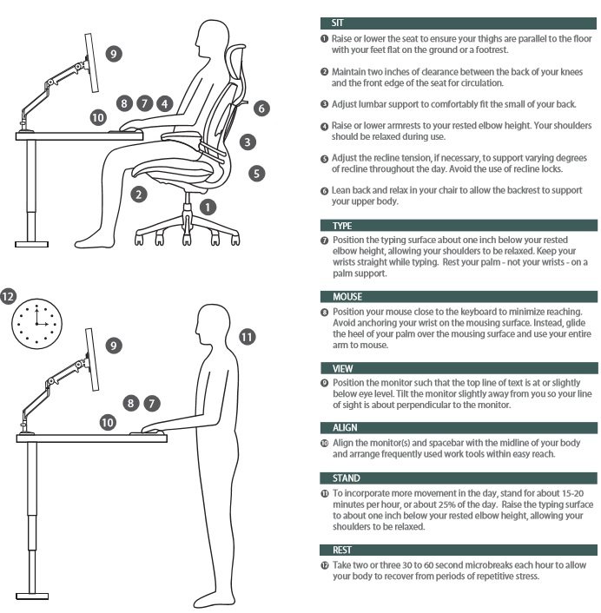  Adapted from Humanscale Corporation brochure with permission 2020 | 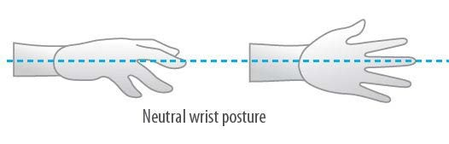
Item | Keyboard and Mouse | Yes | No | N/A | Suggested Actions
6. | Are your keyboard, mouse and work surface at or slightly below your elbow height? |  |  |  | - Raise / lower workstation  - Raise or lower keyboard  - Raise or lower chair
7. | Is the keyboard close to the front edge of the desk allowing space for the wrist to rest on the desk surface? |  |  |  | • Move keyboard to correct position
8. | When using your keyboard and mouse, are your wrists straight and your upper arms relaxed? The keyboard should be flat and not propped up on keyboard legs as an angled keyboard may place the wrist in an awkward posture when keying. |  |  |  | - Re-check chair, raise or lower as needed  - Check posture  - Check keyboard and mouse height
9. | Is your mouse at the same level and as close as possible to your keyboard? |  |  |  | - Move mouse closer to keyboard  - Obtain larger keyboard tray if necessary
10. | Is the mouse comfortable to use? |  |  |  | • Rest your dominant hand by using the mouse with your non-dominant hand
Item | Keyboard and Mouse | Yes | No | N/A | Suggested Actions
for brief periods (mouse buttons can be changed within the computer control panel)
• Investigate alternate mouse options.

Item | Work Surface | Yes | No | N/A | Suggested Actions
11. | Is your monitor positioned directly in front of you? |  |  |  | • Reposition monitor
12. | Is your monitor positioned at least an arm’s length away?  Note: the monitor’s location is dependent on the size of the monitor, the font, screen resolution and the individual user e.g. vision/use of bifocal spectacles etc. |  |  |  | - Reposition monitor  - Seek an alternative monitor if necessary, e.g. flat screen that uses less space
13. | Is your monitor height slightly below eye level? |  |  |  | - Add or remove monitor stand  - Adjust monitor height
14. | Is your monitor and work surface free from glare? |  |  |  | - Place monitor(s) parallel (side by side) to windows, not behind or in front of.  - Adjust overhead lighting  - Cover windows  - Obtain antiglare screen
15. | Do you have appropriate light for reading or writing documents? |  |  |  | - Obtain desk lamp  - Place on left if righthanded – place on right if left-handed
16. | Are frequently used items within easy reach: commonly used items located within the repetitive tasks work area and occasionally used items located in the occasional work area? |  |  |  | • Rearrange workstation
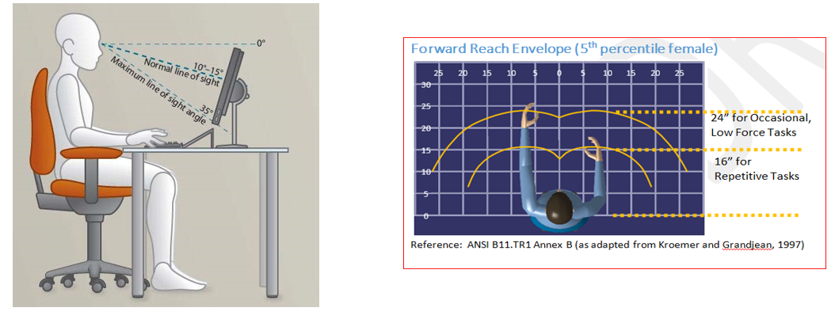

Item | Stand | Yes | No | N/A | Suggested Actions
17. | Do you change posture every 20-30 minutes: switch between sitting and standing if equipped with sit-stand desk for 15-20 minutes per hour, otherwise, stand, walk to printer, etc.? |  |  |  | • Set reminders to switch between sitting and standing
Item | Rest Breaks | Yes | No | N/A | Suggested Actions
18 | Do you take two or three 30 to 60 second microbreaks each hour to allow your body to recover from periods of repetitive stress. |  |  |  | • Set reminders to take breaks
19. | Do you follow the 20-20-20 rule for your eyes: for every 20 minutes spent staring at a screen, look away at an object that is 20 feet away for a minimum of 20 seconds? |  |  |  | • Refocus on an object 20’ away for 20 seconds every 20 minutes
Item | Accessories | Yes | No | N/A | Suggested Actions
20. | Is there a sloped desk surface or angle board for reading and writing tasks if required? |  |  |  | • Obtain an angle board
21. | Is there a document holder either beside the screen or between the screen and keyboard if required? |  |  |  | • Obtain document holder
22. | Are you using a headset or speakerphone if you are writing or keying while talking on the phone? |  |  |  | • Obtain a headset if using the phone and keyboard
Item | Laptop | Yes | No | N/A | Suggested Actions
23. | When using a laptop computer for a prolonged period, are you using:  - A full-sized external keyboard and mouse;  - Docking station with full sized monitor or a laptop stand? |  |  |  | • Obtain appropriate laptop accessories
Item | “Hot Desking” (when applicable) | Yes | No | N/A | Suggested Actions
24. | Are you provided time, support and supervision to make above adjustments?

Upon completion of this checklist, please submit it to your Safety and Health Administrator or Ergonomist and discuss any concerns or requirements with them.

Person Completing Assessment
Name |  | Position
Signature |  | Date

Safety and Health Administrator or Ergonomist
Name |  | Position
Signature |  | Date
Comments/ Recommendations

