Superior Court of Washington, County of King
Petitioner DOB  vs.  Respondent DOB | No.  NOTICE OF HEARING  (NTHG)  (Optional Use)  (Clerk’s Action Required)

TO:

(Name of Moving Party)
has filed a motion for the following relief (name of Petition/Motion):

A hearing will be held on (date) , at ☐ a.m. ☐ p.m. to determine whether the requested relief should be granted. IF YOU DO NOT APPEAR, THE COURT MAY ENTER AN ORDER GRANTING THE RELIEF REQUESTED.

SEE THE INSTRUCTIONS INCLUDED WITH THIS NOTICE ON HOW TO ATTEND YOUR PROTECTION ORDER HEARING.

Dated:
COUNTY CLERK

By:
Deputy Clerk

This document must be served on the other party, and
proof of service must be in the court file prior to the hearing.

How to Attend your Protection Order Hearing
Use Only the information below the checked box to connect to your hearing
☐ VULNERABLE ADULT PROTECTION ORDERS
Online | Hearings occur on Zoom. The Zoom link for your hearing is:  Link: https://kingcounty.zoom.us/j/95589486575
Phone | Call: 253-215-8782  Enter the meeting ID number: 95589486575 followed by the # sign
In Person | Kent Cases:  401 Fourth Avenue, Room 1J  Kent, Washington 98032 | Seattle Cases:  516 Third Avenue, Room W-325  Seattle, Washington 98104
Trouble Connecting? | Call: 206-477-2517  Email: SCExparteOrders@kingcounty.gov
☐ ANTIHARASSMENT, STALKING, OR SEXUAL ASSAULT PROTECTION ORDERS:
Online | Hearings occur on Zoom. The Zoom link for your hearing will be posted three days before the hearing at.  https://www.kingcounty.gov/courts/superior-court/civil.aspx  You can also access the link using the QR code below:  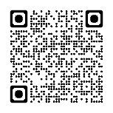
Phone | The phone number to appear at your hearing can be found at: https://www.kingcounty.gov/courts/superior-court/civil.aspx  If you do not have internet access, you can call the number in the “Trouble Connecting” box below to get the Zoom call-in number for your hearing.
In Person | Kent Cases:  401 Fourth Avenue  Kent, Washington 98032 | Seattle Cases:  516 Third Avenue, Room  Seattle, Washington 98104
Trouble Connecting? | Kent Cases: Call 206-477-2600  Seattle cases: Call 206-477-1400

☐ DOMESTIC VIOLENCE PROTECTION ORDERS:
Online | Hearings occur on Zoom. The Zoom link for your hearing will be posted three days before the hearing at:  https://kingcounty.gov/courts/superior-court/family/virtual-hearings.aspx  You can also access the link using the QR code below:  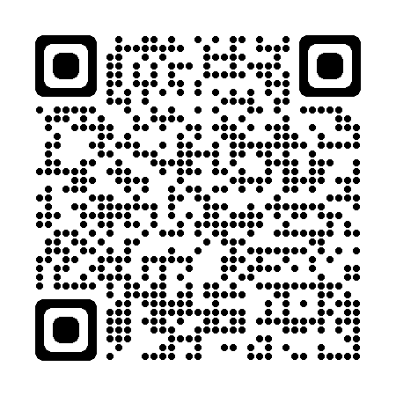
Phone | The phone number to appear will be posted three days before the hearing at:  https://kingcounty.gov/courts/superior-court/family/virtual-hearings.aspx  If you do not have internet access, you can call the number in the “Trouble Connecting” box below to get the phone number for your hearing.
In Person | Kent Cases:  401 Fourth Avenue  Kent, Washington 98032  Review the reader-board outside 1E for your courtroom | Seattle Cases:  516 Third Avenue, Room  Seattle, Washington 98104  Review the reader-board outside W-291 for your courtroom
Trouble Connecting? | Kent Cases: Email FamilyLawStaffMRJC@kingcounty.gov  or call 206-477-2750  Seattle cases: Email FamilyLawStaffSeattle@kingcounty.gov  or call 206-477-1523

OTHER IMPORTANT INFORMATION:
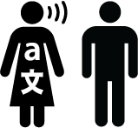 | Ask for an interpreter, if needed.  Call: For Kent: (206) 477-2547  For Seattle: (206) 477-1415  Or go to:  https://blue.kingcounty.gov/courts/superiorcourt/interpreters/default.aspx |  | Ask for disability accommodation, if needed  Call: (206) 477-5694  Or go to:  https://kingcounty.gov/courts/superior-court/get-help/accommodation-requests.aspx
Ask for an interpreter or accommodation as soon as you can. Do not wait until the hearing!

