Relapse Prevention

Relapse can happen for people who have 30 days clean or 30 years. One way to help avoid it is to know your relapse triggers and learn new ways to react to them. This packet will help you identify your triggers, learn new ways of dealing with them and help your team know how to support you. Learning new ways to react to triggers can help you maintain your recovery and save you from a lot of heartache.

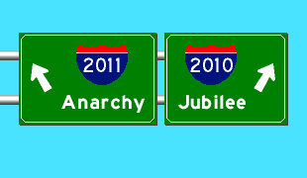

Danger Signs

It is said that relapse begins at least 6 weeks before a person actually picks up. That means, we have lots of warning right? You do if you know your signs. An early sign could be falling back into old behaviors, feeling out sorts, avoiding folks who you know will call you out on things, not sleeping, avoiding groups, self-talk like “I got this down-I don’t need meetings!” Other signs could be getting the funky mumps, isolating, feeling like others are full of it, etc.

Think of a time when you may have relapsed. Create a timeline below that starts with you picking up. Work your way backwards on the time line and describe things that were happening before hand. For example:

couldn’t sleep __________stopped groups_______fight with SO________Relapse

2 weeks prior 2 weeks prior Day before

Now do yours:

Looking at this now, where could you have possibly stopped the process? What would you have done? Who would you have called?

What are your triggers?

Knowing your triggers can help you avoiding relapse. The following is a list of triggers:

**My neighborhood**

**My family**

**Using friends**

**I can’t sleep**

**I feel like crap**

**I’m in pain**

**I feel lonely**

**I feel like people look down on me**

**I don’t know how to have fun in recovery**

**I’m worried all the time**

**Trauma**

**Seeing someone high anywhere**

**Untreated depression/mental health**

**I don’t have any spirituality**

**I feel like I have no support**

**The smell of weed**

**I don’t know what I like to do sober**

**Anger**

**Remembering the good but forgetting the bad**

**I’m overwhelmed and have no time for myself**

What are your triggers? Make a list below. Be honest and write as many as you can think of. Revisit this list a few times to make sure you have included as much as you can.

Recovery Tools

A good way to maintain recovery is by finding new ways to deal with triggers. Think of this as building your own toolbox of things you can use to keep from relapsing. Treatment, meetings, your Treatment Specialist, your mother and many others will bombard you with tools. Some will sound ridiculous and some will sound impossible to do. Others will help you. What will you put in to your tool box?

Remember, to keep what you have earned, you will have to put the same amount of effort as you put into using.



Recovery tools can include:

Mediation

Yoga

Exercise

Sponsor

List of others who will be hurt or harmed if you use

Eating right

Journaling

Working the steps

Meetings

Service work

Going to clean and sober campouts, game night, dances, Seaside, etc.

HALT-Never let youself get too hungry, angry, lonely or tired.

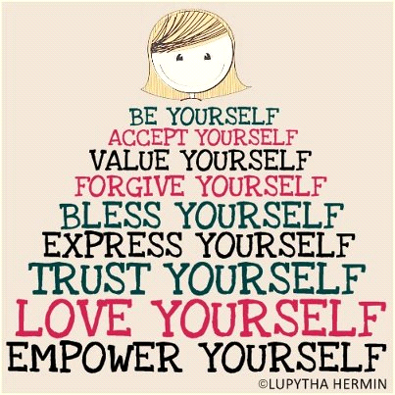

List your own list here:

Stages of Change

This is a basic model of stages of change. 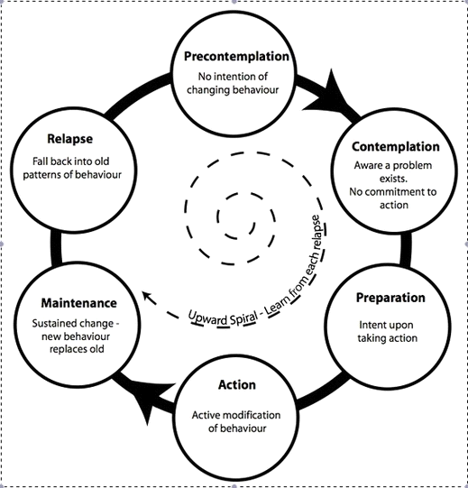

Where would you put yourself? Why?

Where were you 6 months ago? What changed? Why?

**Recovery Plan**

One way to maintain your recovery is to avoid people, places and things that could be a threat to your sobriety. Here is a contract you can use.

1. I will avoid using people. If a friend or family member shows up at my house and I don’t think they are clean, I will talk to them outside. My house will be a safe zone for myself and my family.
2. I will not allow anyone who uses, even if they are family, to stay overnight at my house.
3. If I’m feeling anxious, overwhelmed, have the funky mumps, can’t sleep, have flashbacks about past events, etc., I will seek help. If I need ideas on where to go, I can call my team.
4. I understand I have to separate myself from the using lifestyle to be clean and sober.
5. I will keep a list with me at all times of people who are safe to call if needed.
6. I will attend meetings and find a home group.
7. I will contact my sponsor at least weekly and work the steps. I will give my support people permission to call me out when needed.
8. I will prioritize my recovery and build a clean and sober lifestyle that includes a community of safe people who care about me. Parent Allies can be reached at 206.477.2566.
9. I will ask for support from my team, sponsor or others for help if I have to take any medications that could impact my recovery. I will create a safety plan.
10. I will practice HALT-don’t ever let myself get too Hungry, Angry, Lonely, or Tired without taking time to take care of myself.

**Relapse Prevention Plan**

Now that you’ve identified your triggers, make a plan. List out your triggers, ways you can avoid triggers and tools you can use if you are faced with that situation.

For example:

Trigger-Using friends

Changes I can make to avoid using friends:

***Move to a new neighborhood. Go to meetings and clean and sober events, meet new people who understand recovery and are supportive. Change my phone number. Keep a list of reasons why I like being in recovery on my phone.***

If I run into using friends, I can do this instead:

***Act like I’m on my phone. Don’t make eye contact. Call my sponsor. Get to a meeting***

Trigger-My kids just came home and the adjustment has been really stressful.

Changes I can make to help with the adjustment:

**Recognize that asking for support is not a weakness, ask my support community for support, ask my team for**

**help in getting respite care from relatives, foster parents, daycare so I can do my own self-care, ask for help with planning/scheduling, etc., ask my home group or sponsor for help in finding meetings with daycare, practice HALT, ask for regular check-ins**

If I’m feeling this way, I can do this instead:

***Call my team. Call my sponsor. Stop and take a break. Ask for a team member to check in on me.***

1. Trigger:

Changes I can make to avoid this:

If I’m faced with this situation, I can do this instead:

1. Trigger:

Changes I can make to avoid this:

If I’m faced with this situation, I can do this instead:

1. Trigger:

Changes I can make to avoid this:

If I’m faced with this situation, I can do this instead:

Please share this with your team and other support people. Make sure you practice these with team members or other support people so you are prepared for the unexpected.

**Emergency Planning**



If relapse happens, having a plan can keep it from escalating. Complete the following plan and share it with your CDP, sponsor and your team.

If I relapse, I will immediately:

1. ____________________________________________________________________________________________________________________________________________________________
2. ____________________________________________________________________________________________________________________________________________________________
3. ______________________________________________________________________________

______________________________________________________________________________