University of Washington School of Medicine

Division of Public Behavioral Health and Justice Policy

**Evaluation of the King County Family Treatment Court**

*Results of Team Member and Key Stakeholder Interviews*

Initial Results

August 12, 2008

Eric J. Bruns, Ph.D.

April Sather, M.P.H.

Ericka Wiggins, B.A.

Eric Trupin, Ph.D.

Prepared for:

King County Family Treatment Court

King County Superior Court

Prepared by:

Division of Public Behavioral Health and Justice Policy

Department of Psychiatry and Behavioral Sciences

University of Washington School of Medicine

2815 Eastlake Ave E, Suite 200

Seattle, WA 98102

(206) 685-2085

**King County Family Treatment Court Evaluation**

Initial Update from 2008 Staff and Stakeholder Interviews

King County Family Treatment Court (KCFTC) is one of a growing number of jurisdictions nationally that is looking to build on the promise of the Family Treatment Drug Court model in addressing the needs of families involved in the legal system due to child abuse and neglect charges related to parental substance abuse. As stated in the Court’s program materials, there are four primary goals of the KCFTC:

1. Ensure that children have safe and permanent homes within the permanency planning guidelines or sooner;
2. Ensure that families of color have outcomes from dependency cases similar to families not of color;
3. Ensure that parents are better able to care for themselves and their children and seek resources to do so; and
4. Reduce the cost to society of dependency cases involving substances.

In 2005-2006, the Division of Public Behavioral Health and Justice Policy at the University of Washington School of Medicine conducted an initial process evaluation of how fully these goals were being met, and success of the Court’s proposed functions and processes. We also aimed to learn about the perceived effectiveness of the Court overall from the perspective of the KCFTC team members and key stakeholders associated with the dependency court system in King County. The primary method for the process evaluation consisted of interviews with 39 team members and principal stakeholders. Respondents were asked to provide quantitative and qualitative responses to questions organized into broad areas based on the proposed theory of change for the KCFTC: (1) Success in meeting the KCFTC goals, (2) success at serving the target population, (3) eligibility and referral process, (4) process and functions, (5) adherence to best practices, (6) short-term outcomes, (7) teamwork and collaboration, and (8) overall strengths, weaknesses, and areas for improvement.

In 2007, the UW DPBHJP was again enlisted to conduct an evaluation of the KCFTC. The primary methods we are now undertaking include (1) a follow-up survey of KCFTC team members and stakeholders, (2) interviews with parents enrolled in the KCFTC, and (3) review of administrative data for KCFTC participants compared to a matched sample of parents involved in the regular dependency court process. The purpose of this brief report is to present an update from 2006, focusing on team members’ and key informants’ opinions in four broad areas:

1. Overall success of the KCFTC in achieving its proposed goals;
2. Overall success of the KCFTC compared to the regular dependency court;
3. Success serving a population that is representative of the regular dependency court process; and
4. Capacity of the KCFTC

**Results**

The 2007-2008 follow-up survey successfully completed key informant interviews for 37 of 42 (88%) identified stakeholders. This N of completed interviews is nearly identical to the N=39 interviews completed in 2005-2006, and also nearly identical to the 84% completion rate from 2005-2006. The interview we used was virtually identical to the protocol administered in 2005-2006. Respondents were similar in their role with the Court and percent time spent directly with KCFTC families or on KCFTC business, with about 50% of interviewees being stakeholders who spend less than 20% of their time with the court, and 50% being half to full-time team members. These data suggest that the sample of respondents from 2006 is similar to those interviewed in 2008; thus, we will present comparisons in the four areas above from 2006 to 2008. In a future report, we will also present comparisons for the approximately 20 stakeholders who completed the interview at both waves of data collection, as an additional test of changes in opinions from 2006 to 2008.

**Overall success.** Results are presented in graph format at the end of this report. As shown in Figure 1, results indicate that team members and stakeholders continue to view KCFTC as highly successful. Respondents perceive that KCFTC was generally successful in accomplishing its proposed goals and in serving its target population. Specifically, 70% of respondents reported that the KCFTC is “moderately” or “extremely” successful in meeting its goals. As shown in Figures 2 and 3, this is a significant increase in the percent who perceived this level of success in the 2005-2006 interviews. The percent of key informants who perceived that the KCFTC was moderately to extremely successful in meeting its goals has increased from 42% to 70% over the past two years, and the average score on this 0 – 4 rating scale has increased from 3.4 to 3.8.

|  |  |  |
| --- | --- | --- |
| **2008 Interviewees** (Total N=37) | | |
| **Respondent Type** | **N** |  |
| Advisory Group Member | 9 |  |
| DSHS Social Worker | 4 |  |
| Court Appointed Special Advocate (CASA) | 2 |  |
| Attorney (Parent or Child) | 6 |  |
| Judge | 3 |  |
| CASA Manager or Supervisor | 2 |  |
| AAG | 2 |  |
| Program Coordinator, Family Treatment Court Specialist, UW PCAP representative, Wraparound Coordinator, Social Work Supervisor, FTC Liaison, Wraparound Supervisor, Treatment Provider, Bailiff | 1 Each |  |

**Success compared to regular dependency court.** As shown in Figure 4, a vast majority (86%) of staff and advisory members perceive that KCFTC is at least a “little bit more” successful than the regular dependency court at achieving proposed outcomes for parents and children. This represents only a small increase from 2006 when 84% reported that they believed KCFTC is at least a little bit more successful. However, as shown in Figures 5 and 6, a much larger increase can be seen in the percent of respondents who believe that KCFTC is “a good deal more” or “much more” successful than the regular dependency court – from 39% to 61%. In addition, the average scores on this 1 – 7 rating scale increased from 5.0 in 2006 to 5.5 in 2008.

**Success in serving a representative population.** Respondents perceive the Court is becoming more successful in serving a diverse population that was representative of the racial composition of the general dependency system. As shown in Figure 7, 76% of respondents believe that the KCFTC is at least “somewhat” successful at serving such a diverse population. This is an increase from 52% in 2006 (see Figure 8). At the same time, it is worth noting that only 38% believe the Court has been moderately or extremely successful in this area (though this is up from 22% in 2006).

**Serving an appropriate number of families.** Finally, as shown in Figure 9, there has been a decrease in the percent of key stakeholders who perceive that the KCFTC is serving the right number of families. While in 2005-2006, 76% of respondents reported the number being served was “just about right,” in 2008, the percent has dropped to 31%, with 60% of respondents reporting that the Court is serving “too few” families.

**Conclusion and Next Steps**

These preliminary results suggest that key informants, including those working day to day with the Court as well as team members and advisors, generally feel KCFTC is achieving success in meetings its goals. There are clear trends that confidence in the Court’s ability to meet these goals and to improve outcomes over what can be accomplished by the regular dependency court process is improving over time.

We will now be analyzing the rest of the respondent data on specific areas addressed in the interviews to present a profile of strengths and needs of the KCFTC. By the end of 2008, we will also have begun analyzing responses from parent interviews and reviewing court and DSHS records, which will offer much more in-depth information about the effectiveness of the KCFTC in achieving core outcomes for parents, children, and families.

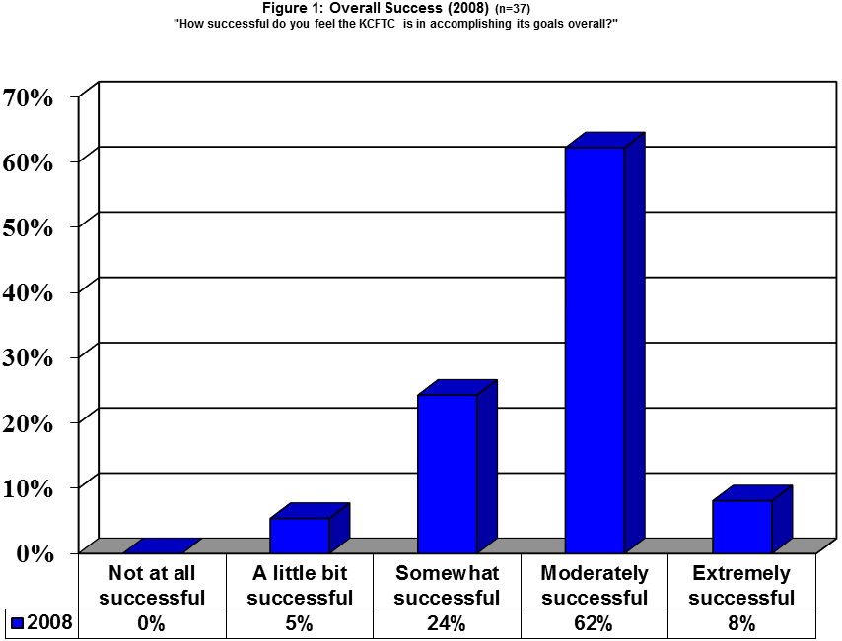

**Mean (1-5 scale)** = 3.75 **Std. Dev=** .693





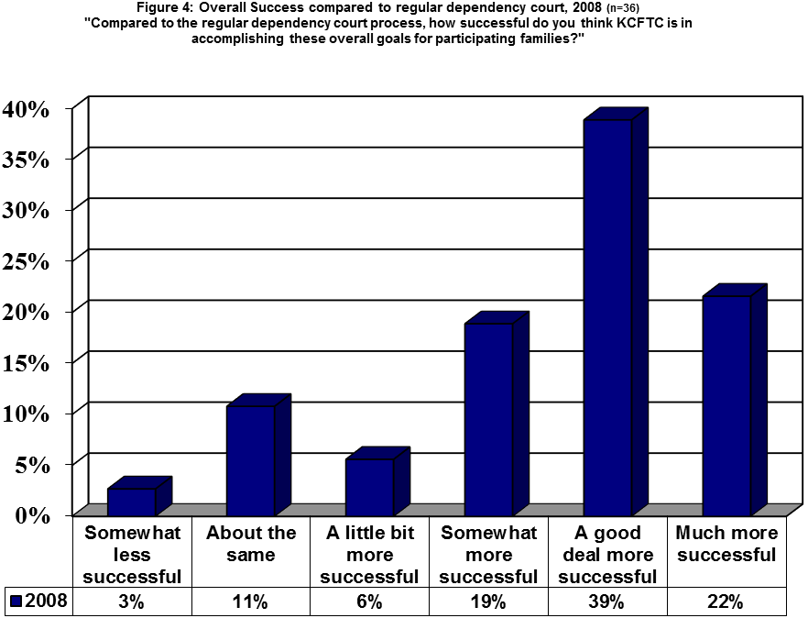

**Mean (1-7 scale)** = 5.47 **Std. Dev**= 1.36

DK/Missing (n=1)





**Mean (1-5 scale)** = 3.39 **Std. Dev**= .998

