King County Community Collaborative- KC3
Voices of Change and Empowerment
November 23,2021 5:30– 7:30 pm
Virtual Meeting

VISION
Together families, youth, systems, and communities will address the barriers to and equity for all individuals, including Black, Indigenous, Persons of Color, lesbian, gay, bisexual, transsexual, two-spirited, queer, questioning, intersex, and/or asexual individuals. We support opportunities to improve the resilience and recovery of children, youth, and families with physical, emotional or behavioral health challenges.
MISSION
Our mission is to strengthen and sustain community resources that effectively address the individual and their systems. We are allies in the support of equity for all; including Black, Indigenous, Persons of Color, lesbian, gay, bisexual, transsexual, two-spirited, queer, questioning, intersex, and/or asexual communities on multiple levels. We look to support our communities around physical health, behavioral health, social connection, practical aspects and spirituality when applicable. We extend goodwill to all individuals as we work together in a safe and supportive environment to together build a stronger King County.

As a Council of leaders of family and youth-led organizations serving families and youth with emotional and behavioral health challenges, we will represent the voices of King County families and youth at State and County policy and program decision making bodies.

Agenda
Welcome & Introductions: Facilitator: Candace Notes: LeChez
(Notes and minutes will be included in the agenda in a highlighted text)
Invite you to share your name and your role in the chat (15mins)
If this is your first time and would like to share who you are please feel free too.
Thirteen people in total participated in this month’s meeting. To track attendance, the names and roles of participants who shared in the chat are as followed:
- Candace Hunsucker, System tri lead-Community Health Plan of WA
- Jackie Berganio, King County Dept. of Community and Human Services
- Rachel Castiglia, children's behavioral health administrator with Molina Healthcare
- LeChez Bowser – KC3 Youth Tri-Lead and youth peer at VC for the WISe program
- Nelson Rascon Executive Director of Dads MOVE and Family Tri-Lead for HI-Fyve, Pierce County Fysprt
- Jenn Miller, KC3 Family Tri-Lead. Parent Partner @Sound WISe team
- Karen Kelly, Project Director for WSCC - the Statewide Family Network
- Vanessa Perez- KC Regional Case Manager, Community Health Plan of Washington
- Tajiana Ellis, Chief Program Officer, Life Enrichment Group
- CeCe Smith, Enrich Lives Coordinator, LEG
- Cole Devlin – Tri-Lead for KC3 and former Wraparound/WISe Youth Peer
- Chelsea Berg – KC3 Tri-Lead
- Kate Naeseth – System partner
Community Input and Concerns:
None were shared in this meeting and WSCC shared later on in the meeting.
WSCC

Presentation:
LEG- Tajiana M. Ellis, M.S. Chief Program Officer & CeCe, Enrich Lives Mentoring Project Coordinator (30min presentation and Q&A)

Mentorship and support for African American youth. Offers academic, vocational, and peer support.
More information on this program can be found on their website: www.lifeenrichmentgroup.org
Internship opportunities and entrepreneurial training were offered. Youth had the opportunity to make their own products and sell them (makeup, skincare, etc.)
Young Queens of Seattle/King County – Youth involved reported increase in their view of self and the world around them (over 70%), grade progression (100%), enrolled in higher education opportunities (over 70%) along with other improvements noted thanks to these services.
Provides culturally relevant care and knowledge.
To become a mentor for this program go to: https://form.jotform.com/213047014186145
Tajiana Ellis can be reached at her email address: cpo@lifeenrichmentgroup.org and slides from the presentation will be shared with KC3 Leads to include with meeting minutes

Dads Move- Nelson Rascon (20mins presentation and Q&A)

“Challenging Fathers to Become Involved in their Childs Mental Health Care”
Dads M.O.V.E = “Mentoring Others through Voices of Experience”
“Servicing families raising children with Behavioral Health concerns across Washington”
Their mission is to strengthen the father’s role in raising children with behavioral and mental health challenges
Dads MOVE was founded in July of 2011 by a core group of dedicated fathers who have worked in the child serving systems and for other family run agencies in Washington
“Family focused; Dad driven”
Various opportunities are provided by Dads MOVE to promote their mission and vision for the community
Provides ongoing cultural competency training, with diverse staff being a strength of their organization
Staff Qualifications include but are not limited to: Trained in Education Advocacy and IEP/504 plans, Mental Health First Aid Trainers, De-escalation Trainers, WRAP (Wellness Recovery Action Planning) trainers/facilitators, peer support, Wraparound/WISe facilitator, etc.
Teaching necessary skills to families and fathers to reduce stigma and promote healing
Includes LGBTQ+ Awareness and Suicide Awareness, along with Anti-Bullying trainings for families
Encourages father involvement at system levels. Mostly moms have been involved in these roles, and Dads MOVE hope to change that by increasing father involvement in these ways
Dads MOVE is currently looking for volunteers
You can learn more about Dads MOVE by visiting their website: dadsmove.org
Nelson Rascon can be contacted at his email address: nrascon@dadsmove.org

Update:
KC-SPARKS (2mins)
Changes within the organization for their staff. Continuing to recruit and expand their efforts in peer support. Hopes to have a graduate of the program provide peer support services inside New Horizons High School. Partnering with KC3 to expand their efforts within King County. Continuing to look for volunteers to promote their efforts and provide services.

WSCC (30mins)
Substance use training taking place for families and loved ones of individuals with substance use disorders. Supported by En Route to provide education for families who have a loved one involved in substance use/abuse. 16hr total over the course of four days for this training and registration links were shared.
This is a FREE TRAINING and they are currently exploring compensation options available for participants.
Families are entered for a drawing to win a gift card after completing all four days and 16hrs of this training.
WSCC has a DEI Committee (diversity, equity, and inclusion) to be intentional about bringing in all voices who may be missing from the table.
Workgroups to promote advocacy work across various agencies (inpatient and outpatient) and hoping to get others involved in these efforts. Compensation will be provided for volunteers.
Common Voice info in partner with WSCC: https://www.hca.wa.gov/about-hca/behavioral-health-recovery/center-parent-excellence-cope-project#:~:text=Support%20is%20provided%20by%20A%20Common%20Voice%2C%20a,hired%20for%20their%20lived%20experience%20as%20a%20parent%2Fcaregiver.

Workgroup recruitment conversation; Candace (3mins)
Promoting involvement for upcoming workgroups involved with KC3. Open to suggestions of workgroups that will promote our mission. Currently identifying needs for workgroups to be created around in addition to the workgroups that are already in progress.
Workgroups:
Workplan workgroup (2mins)
Creating a plan for KC3 and is currently underworks. Seeking more community involvement.
Youth Engagement TAY (3mins)
The committee is meeting again. NAMI, SPARK, TeenLink, Cities Rise, GEM, and KC3 involvement on how to support each other’s efforts in youth engagement. Collaboration to increase youth engagement in matters that are meaningful to them.

Sharing Announcements, Updates: (5mins)
Shared by Jackie Berganio:
If you work with at-risk adults or teens you won’t want to miss this insightful webinar with a panel of experts.

Tuesday, December 7 at 1:00 PM - 1:45 PM (PT)
Addressing the Fentanyl Crisis: An Evidence-Based Toolkit
https://info.rescueagency.com/king_county_laced_and_lethal?utm_medium=email&_hsmi=185892411&_hsenc=p2ANqtz-9TnTmLyNJ5VX3KMfzdQR6VP6xffu2zA0XLyMju6mHSfmACmFkDLypKdxYXmi1WKj4B6xBHEcvTLoz-Tfq5OCucQq06OLqXRu1B2ONmgsUWs5laz80&utm_content=184992845&utm_source=hs_email

Candace discussed peer integration and additional community meetings taking place where resources can be shared and found.

Agencies in need of peers for Wraparound/WISe programs across King County. Plans to follow-up in future meetings to address this need.
Thank you for attending. Be safe, stay well!

King County’s Family and Youth Council Comfort Agreement

Stay on task
No side conversations
Cell phones on silent
Safe learning environment
Be willing to give and receive feedback
Leave your agency hat at the door. Bring your experience expertise and commitment.
Remember we all bring the best intentions to our work
Value everyone’s opinion
Ask questions and check out your assumptions and thinking
Listen carefully
Let your voice be heard
Provide space to hear about immediate concerns
Seek common ground and action
Identify areas of continued debate and defer to another day
If dissenting, offer an alternative
Be clear about discussion versus decision-making
Start meetings on time
Observe time frames

King County’s Family and Youth Council FYC Regional FYSPRT

Safety Plan

If anyone during the meeting begins to feel uneasy or frustrated:
- First take a break, Leave the room if needed, and use the coping skills that are familiar to you
- Second reach out to support people in the room
- Third, Tri-leads will offer support to anyone who signals distress-emotionally or otherwise.
- Lastly, reach out to those in the room who have background n de-escalation (all Tri-leads, Convener, Mental Health Provider
FYC Tri-leads will identify exits for members and attends will know how to safely exit the room if needed
FYC members and attendees agree to be present, aware and know who in the room (i.e. Tri-leads, Metal Health Providers individuals trained in de-escalation).
FYC Tri-leads and welcome committee will offer breaks to the group and individuals if conversations get heated or someone is signaling discomfort or distressed,
If Aggressive behavior is present and you have no experience with de-escalation techniques, please find an exit and leave the room.
- IF you do have de-escalation experience you may provide support if you feel comfortable with this. If you feel unsafe or prefer to not engage with an aggressive individual, please find safe space and/or exit the room.

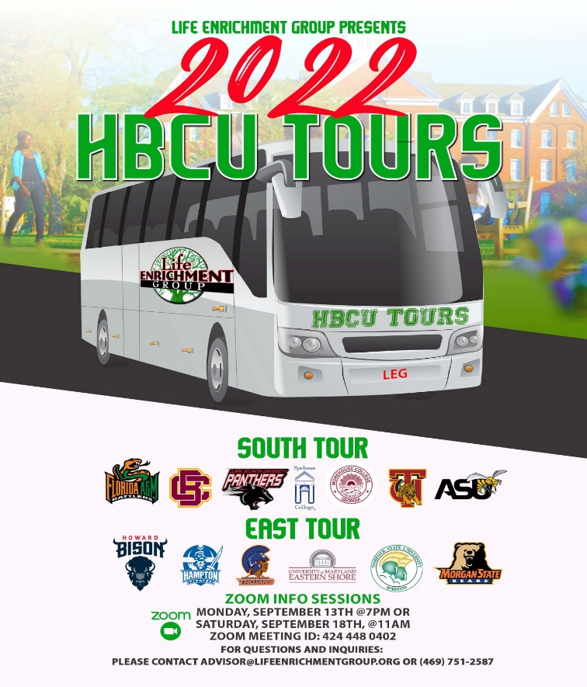

Attached you will see our flyer for our Black College Tour as well as The Scholars Project. Registration is still open for both and below are the application https://form.jotform.com/211247274215146

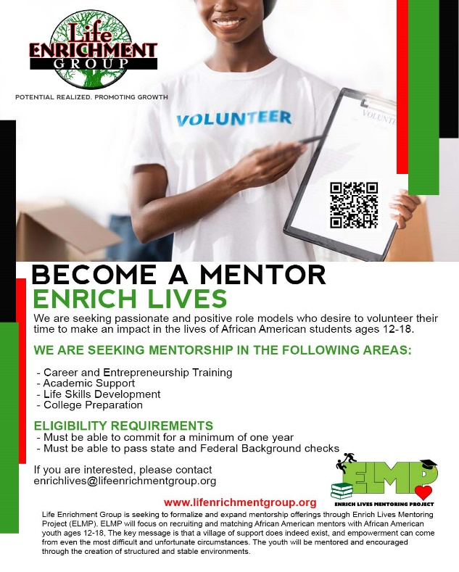

Sharing Resources and information for Families
Partner organization's events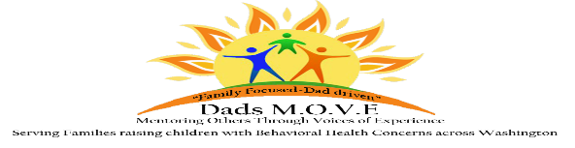

Washington state Fathers network; We do our work by connecting men with each other and with resources and information, by training men to tell their story and advocate for change, and by working to promote inclusion.
We firmly believe that:
Those who identify as male are superb resources for each other
Those who identify as male have needs of their own when they have a child in their life who has a disability or special health care need
The voice and perspective of those who identify as male need to be heard
As an organization and as individuals we need to advocate for equitable access to the community for those with disabilities or special health care needs, and their families
November 2, 2021: Maintaining Relationship Resilience While Parenting a Child with Special Need

December 7, 2021: Guardianships and Trusts

For more information click here

PAVE pave+wapave.org@ccsend.com

NAMI
https://www.nami.org/Get-Involved/Awareness-Events/Suicide-Prevention-Awareness-Month

