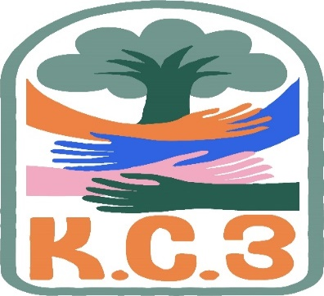
King County Community Collaborative- KC3
Meeting Notes 2/22/22
☆Community concerns
Sandy talked about WISe/MIDD
South County has openings and Seattle has about a year wait list.
CLIP -120 beds w/4 agencies (2 rivers, Tamarack, Pearl Street, CSTC) Sunstone closed
☆Erin- Regional King County working with youth for suicide prevention
☆Melody -GPS,She explained wh0o they are and what they do. They are also hiring a youth peer.
They are changing executive director’s/Hiring someone new.
They offer weekly parent support groups.
☆Karen- She would love to know if there is a resource to learn about the”Bills”?
House Bill 20/50 Looking to send a youth to prison
18% 0of families gross-charge families illness is to no longer charge for housing them in jail.
- Is there somewhere about legislation?
☆Karen from WSCC spoke about a virtual summit on Monday May 3rd, She spoke about inviting families on the wait list for WISE.
☆Candace - LaTonyas request to talk about the up coming youth summit next month 5/24
☆ Issues impact youth in King County
Behavioral health
☆Bill18/65 Lauren Davis - Noel Frame
MADE MAN
Extended juvenile jail till 25

