|  |  |
| --- | --- |
| **January 2023**  **Needs Assessment Report**  ***Survey & Data Collection***  KC3_final2 |  |

**The KC3 is a forum for families, youth, and system partners to discuss the quality of local mental health services and participate in solving identified challenges to improve the system.**

The KC3 is a part of the governing infrastructure of the Washington State Children's Behavioral Health System that supports the strengthening sustainable resources by providing community-based approaches to address the individual behavioral health needs of children, youth, and families.

**Mission**

As a council of leaders serving families and youth with emotional and behavioral health challenges, we represent the voices of King County families and youth at State and County policy and program decision making bodies. Our mission is to strengthen and sustain community resources that effectively address the individual.

**Vision**

Together families, youth, systems, and communities will address the barriers, and opportunities to improve the resilience and recovery of children and youth with severe emotional or behavioral health challenges.

**Overview**

2022 FYSPRT Workplan Overview

KC3/ King County Collaborative

Priorities & Goals

|  |  |
| --- | --- |
| **Priority 1**  Promote behavioral health supports and services in king county for youth and families with higher level of needs | |
| Goals |
| Reduce silos and increase communication across systems. |
|  |
| **Priority 2**  Advocate for effective behavioral health strategies that break the school to prison pipeline | |
| Goals |
| Increase youth participation in developing strategies that impact youth wellness and protective factors |
| Bring awareness to the behavioral health risk factors for youth to break pattern that led to the school to prison pipeline. |
|  |
| **Priority 3**  Advocate for culturally responsive and trauma-informed, individualized behavioral health services that are in line with equity and social justice principles for youth and families | |
| Goals |
| Youth and Families are informed on what effective trauma informed care looks like. |
| Identify barriers of TIC practice |
|  |
| **Priority 4**  Enhance KC3 Membership | |
| Goals |
| Increase family participation in KC3 |
| Increase youth participation in KC3 |
|  |
| **Priority 5**  Focus on Needs Assessment and Evaluations that help inform KC3 | |
| Goals |
| Ensure KC3 is better informed and makes decisions based on relevant data. |
| Gather input from KC3 on important topics |

Families everywhere were impacted by the pandemic, reports show increased anxiety, alcohol & drug use rising, violence increasing, and overall general stressed environments in our homes. For the families struggling to manage behavioral health challenges but the storm was especially harsh. Building connections is key to developing recovery and resiliency for families and Youth. The COVID-19 pandemic and the mandatory “disconnection” were not helpful to an already struggling System of Care and support for families. We are faced with an unprecedented higher need for behavioral health services compounded by the peer workforce shortage. These factors, are addressed in the KC3/FYSPRT Workplan for 2022 (See figure to right) including increasing voices of underserved families, especially youth involved in the criminal justice system and ensuring services for everyone are trauma informed and culturally responsive. The information in this assessment confirm the previously identified priorities continue to be issues for families and youth. Needs Assessment Report: This document includes highlights of a stakeholder community needs survey, compiled snapshots of significant Youth/Young adult and family data from local, state, and national dashboards, preliminary areas of importance that may impact our 2023 workplan and a summary. We have highlighted the areas of focus in the section “Survey results/ Areas of focus for 2023.” Creating this report: We successfully created and conducted a community survey, although it was brief, it and time consuming, the perspective and input is an essential component of FYSPRT! And it is important to mention just one piece of our FYSPRT process. The Next Step: Inform FYSPRT stakeholders and Update 2023 work plan strategies KC3/FYSPRT at February Meeting. KC3 is committed to prioritizing an informed planning process. Information is a key element and can help us focus on relevant action items- an otherwise overwhelming amount of information. We have briefly shared the data information and survey results at the January meeting; we will send this report. Ask for feedback to inform the 2023 planning process.

**December 2022 Needs Assessment**

**Overview**

Introduction

KCS 2022 Workplan

**Brief Community Needs Survey**

Highlights / results

**Impact on KCS 2023 Workplan**

Survey results/ Areas of focus 2023 work plan

**Significant Snapshots**

Highlights of Data review

A look back: Data snips from one year ago

**Contact Information**

FYSPRT Tri-Leads

King County

Guided Pathways Support

**Sources**

Notes on data collection process

Resources/Data links

Brief Community Needs Survey

**Who filled out the Survey ?**

|  |  |  |
| --- | --- | --- |
| **What perspectives/roles do you identify with? (Check all that apply)** | |  |
| Answer Choices | Responses | |
| Parent or caregiver with children under 18 | 36.36% | 12 |
| Parent of individuals over 18 | 48.48% | 16 |
| Youth aged 12 or younger | 6.06% | 2 |
| Youth or young adult aged 13-30 | 18.18% | 6 |
| Grandparent or kinship primary caregiver of youth/young adult | 15.15% | 5 |
| System partner | 30.30% | 10 |
|  | **Answered** | **33** |

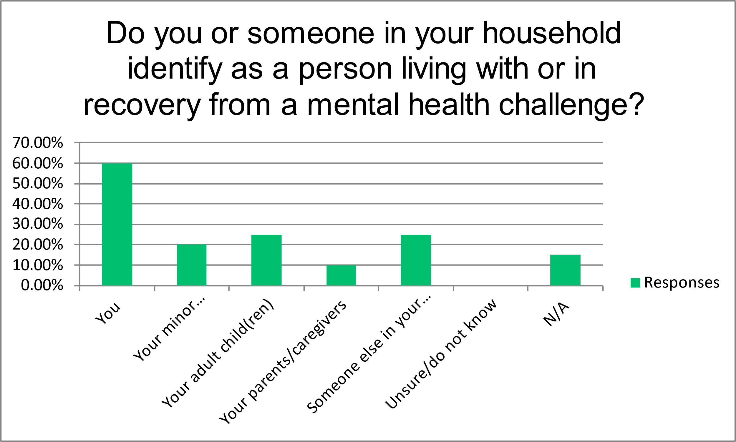

|  |  |  |
| --- | --- | --- |
| FYSPRT Community Needs Survey |  |  |
| **If you have children or other dependents under your care, what is your family situation?** | | |
| Answer Choices | Responses | |
| Single mom | 33.33% | 9 |
| Single dad | 0.00% | 0 |
| Two parents | 7.41% | 2 |
| Raising own children and children of others | 0.00% | 0 |
| Raising children of other family members (I am a grandparent, aunt, etc.) | 18.52% | 5 |
| Raising someone else's children, not family | 3.70% | 1 |
| Foster parents | 0.00% | 0 |
| Shared custody | 7.41% | 2 |
| No children, other dependents | 29.63% | 8 |
|  | **Answered** | **27** |
|  | **Skipped** | **6** |
| |  | | --- | |  | |  |  |
|  |  |  |
|  |  |  |
|  |  |  |
|  |  |  |
|  |  |  |
|  |  |  |
|  |  |  |
|  |  |  |
|  |  |  |
|  |  |  |
|  |  |  |
|  |  |  |
|  |  |  |
|  |  |  |
|  |  |  |
|  |  |  |
|  |  |  |

|  |  |  |  |  |  |  |  |  |
| --- | --- | --- | --- | --- | --- | --- | --- | --- |
| |  |  | | --- | --- | | **Are you comfortable seeking behavioral health support or services if you or someone in your family needed it? If so, can you tell us the name of at least one agency or organization you could contact?** | | | **Answered YES** | **33** | |  |  |   **Are you involved with volunteer work, leadership or advocacy through workgroups, committees, or boards with any of the following organizations?** | | |
| Answer Choices | Responses |
| KC3 (King County FYSPRT) | 15.15% | | 5 |
| GPS (Guided Pathways - Support for Youth and Families) | 9.09% | | 3 |
| WSCC (Washington State Community Connectors) | 15.15% | | 5 |
| Dad’s Move | 6.06% | | 2 |
| King County Peer Network | 21.21% | | 7 |
| None | 36.36% | | 12 |
| Other: List any relevant org you are involved with | 33.33% | | 11 |
|  | **Answered** | | **33** |

**Challenges** 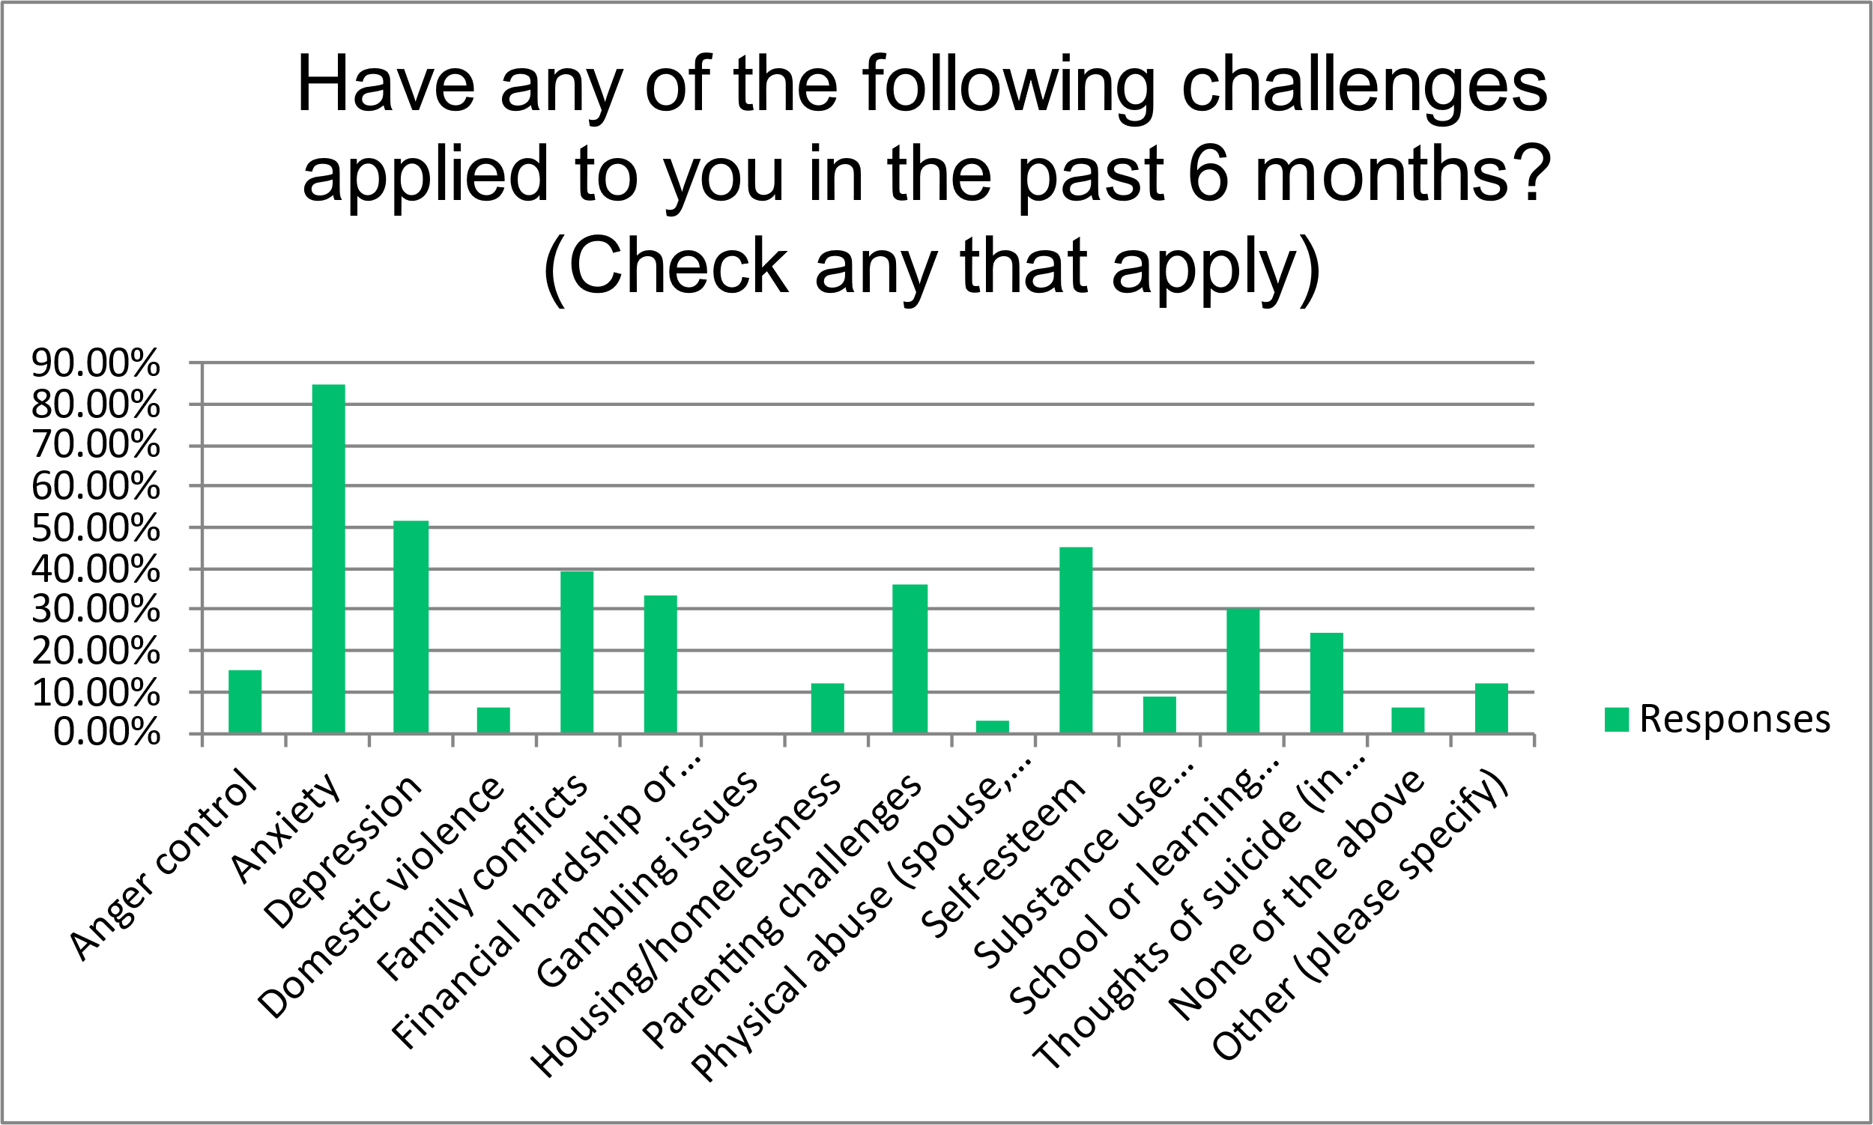

**challenges in the past 6 months**

|  |  |  |  |  |  |
| --- | --- | --- | --- | --- | --- |
| Answer Choices | Responses | | | | |
| Anger control | 15.15% | | 5 | | |
| Anxiety | 84.85% | | 28 | | |
| Depression | 51.52% | | 17 | | |
| Domestic violence | 6.06% | | 2 | | |
| Family conflicts | 39.39% | | 13 | | |
| Financial hardship or bankruptcy | 33.33% | | 11 | | |
| Gambling issues | 0.00% | | 0 | | |
| Housing/homelessness | 12.12% | | 4 | | |
| Parenting challenges | 36.36% | | 12 | | |
| Physical abuse (spouse, child, or elder) | 3.03% | | 1 | | |
| Self-esteem | 45.45% | | 15 | | |
| Substance use challenges | 9.09% | | 3 | | |
| School or learning problems | 30.30% | | 10 | | |
| Thoughts of suicide (in the past 6 months) | 24.24% | | 8 | | |
| None of the above | 6.06% | | 2 | | |
| Other (please specify) | 12.12% | | 4 | | |
|  | **Answered** | | **33** | | |
| **Final answers to the Question:**  **What supports or services are most needed to improve the behavioral health system?** | | | |  | | | | |  |
| * More workers in this field with lived experience and trauma-informed care and diversity relevancy knowledge (BIPOC, QT2SLGBTQ+, Neurodiversity, Disabled, etc) | | | | | | | |
| * More outreach to the people who need it | | | | | | |  |
| * more hours available to mid-level risk patients | | | | | | |  |
| * King County does offer many supports and services, I just don't think they're very well known to the community, so they don't know to access them. More services for transitional aged youth would be beneficial as well, as many end by time a youth is 18-21. | | | | | | | |
| * Staff | |  |  | |  | |  |
| * More housing. If people have housing it can help them get other things they need.  More peer services, resources. | | | | | | | |
| * Better school options for kids who don't fit the box of public education, reliable childcare, affordable access to care and availability of providers. The other thing is that when I have found providers for my kids, they transition so often-- my son or daughter will finally connect with someone and then they are leaving their position. | | | | | | | |
| * Respite for Caregivers and Mentors for Youth in addition to counseling, education and support groups. Certified Peers can support both of these needs. | | | | | | | |
| * Available counselors and therapist. | | | | |  | |  |
| * housing, available step-down care, quicker access to appointments, additional peer services throughout all types of care (not just MH), behavioral health practitioners who identify as BIPOC or LGBTQ | | | | | | | |
| * Single father support | | |  | |  | |  |
| * Peer Support | | |  | |  | |  |
| * access to services when needed. | | | | |  | |  |
| * Free services in the community without waitlists. | | | | | | | |
| * Infrastructure to strengthen what is already designed and would work better with the needing infrastructure (work force, dollars, beds) - this includes WISe/Wraparound, FYSPRTs, Family Orgs, Reimaging Respite, 988 program, etc... | | | | | | | |
| * Families who can take in persons for a night or two should be able to take in a kid or two for respite. We see kids and families who need respite and there are some families who could help and would help if they were paid from Medicaid to do this- this could save the ER from seeing the kids in there. Also, more youth peer ran drop-in centers for youth to go to. where youth can go and attend youth ran- peer groups. Free and low-cost sports and housing. There should be more funding flexible funding for the WISe teams not just the MIDD teams and the MCO need to cough up $$ for this. They pay for lunches for CEO's and others and can pay for families to get sensory tools. The step-down respite facilities could be a good idea as well for families coming out of CLIP- possibly a place for youth to go after they come home from CLIP and possibly a place for them to go after leaving a hospital or a place like two rivers. | | | | | | | |
| * More people of BIPOC. Education and awareness for the majority race within the current health systems. | | | | | | | |
| * More capacity within the current system. If outpatient and inpatient facilities were fully staffed with adequately trained clinicians and didn't have constant turnover, we would see better care and long-term outcomes for consumers of the behavioral health system. Increased staffing. Same-day intakes. Reduced turnover amongst behavioral health staff. Full continuum of care- steps available between outpatient services and inpatient, like an IOP | | | | | | | |
| * Groups where youths and young adults to participate | | | | | | | |
| * An increased workforce. | | |  | |  | |  |
| * More resources available | | |  | |  | |  |
| * Providing support for young black boys for single black mothers. Washinton is racist and hide behind smiles they mean our black boys no good and offer no help | | | | | | | |
| * More access to inpatient care for all ages, wraparound services for adults, supportive stepdown residential programs for adults | | | | | | | |
| * Support in getting kids behavior health needs | | | | | | |  |
| * Available qualified mental health professionals who are committed, better financial support | | | | | | | |
| * Money and resources like food and gas | | | | | | |  |

|  |  |
| --- | --- |
| GOALS | ACTION STEPS |
| Priority 1: Promote behavioral health supports and services in king county for youth and families with higher level of needs | |

|  |  |  |
| --- | --- | --- |
| **Reduce silos and increase communication across systems.** | | * Collaborate with schools and community groups to engage youth in leadership opportunities. * Invite youth and family serving programs and organizations to participate in KC3 * Share training opportunities for youth, peers, and systems |
| **GOALS** | | ACTION STEPS |
| **Priority 2: Advocate for effective behavioral health strategies that break the school to prison pipeline** | | |
| **Increase youth participation in developing strategies that impact youth wellness and protective factors** | | * Leveraging youth voice to impact community programming and service delivery * Highlight the contributions of youth and young adults in our community who promote recovery and resiliency * Offer opportunities for youth peers to share experiences and access training through SPARK, etc. |
| **Bring awareness to the behavioral health risk factors for youth to break pattern that led to the school to prison pipeline** | | * Identify opportunities for collaboration and support the work of the ZYD efforts and BSK 14 community agencies * Share various survey results as they relate to youth in our community * Discuss issues that impact youth including risk factors, behavioral health services, and access to care * Share disparities within minority communities and discuss best practices to engage culturally specific populations or access issues |
| **GOALS** | | ACTION STEPS |
| **Priority 3: Advocate for culturally responsive and trauma-informed, individualized behavioral health services that are in line with equity and social justice principles for youth and families** | | |
| **Youth and Families are informed on what effective trauma informed care looks like.** | | * Provide resources and information on trauma informed and culturally responsive care * Share DEI opportunities, trainings, and information * Invite key speakers to share info at meetings |
| **Identify barriers of TIC practice** | | * Spend time educating the FYSPRT on stigma and other issues that impact service delivery * Encourage families and systems to share concerns as they arise to educate the FYSPRT on the need for quality behavioral health services * Offer suggestions to families regarding equitable practices and resources to access TIC materials |
| **GOALS** | | ACTION STEPS |
| **Priority 4: Enhance KC3 Membership** | | |
| **Increase family participation in KC3**  **Only small percentage aware of FYSPRT** | | * Establish an engagement and outreach workgroup * Share request with WISe agencies to inform families about FYSPRT opportunities * Identify barriers to family participation * Create a flyer to share with system partners to give to clients * Encourage FYSPRT members to bring someone they know |
| **Increase youth participation in KC3** | | * Establish a youth engagement workgroup to discuss specific strategies to reach youth * Work with system partners to share information * Create roles/opportunities for youth to do things at the FYSPRT to foster meaningful participation * Create a social media blast to reach youth * Invite youth to present and bring friends to see their presentations |
| GOALS | | ACTION STEPS |
| Priority 5: Focus on Needs Assessment and Evaluations that help inform KC3 | | |
| Ensure KC3 is better informed and makes decisions based on relevant data. | * Establish an evaluation workgroup * Gather quantitative and qualitative data including family voice * Review existing needs assessments, evaluation reports and data | |
| Gather input from KC3 on important topics | * Share evaluations with FYSPRT * Elicit feedback on results and outcomes | |

***Next steps:*** *The next step is to update 2023 FYSPRT workplan: Solutions are scarce and may require us to think outside the box!*

S**ignificant Snapshots: changes in data that committee found relevant**: **Highlights of Data review national & King County**

**King County information:**

* There was a 20% increase in calls to the Behavioral Health Crisis Line in September 2022, compared to 2019. 6,845 to 7,941.
* Percent of Respondents in Households with Children in Which Any Children Seemed to Have the Following Behavior Changes:

**Feel Anxious or Clingy**

* 6/1/22-8/8/22: 19.5% 9/14/22-11/21/22: 24.3%

**Feel Sad or Depressed**

* 6/1/22-8/8/22: 10.4% 9/14/22-11/21/22: 15.1%

**Show Change in Ability to Stay Focused**

* 6/1/22-8/8/22: 9.3% 9/14/22-11/21/22: 17.9%

**Engage in Problem Behaviors**

* 6/1/22-8/8/22: 3.0% 9/14/22-11/21/22: 4.1%

Snap shot from KC dashboard December 2022

Healthy Youth Survey :

* Children Have Supportive Adults in Their Community (5 Years to 5th Grade):
  + 2017: 83.8% 2019: 85.5%
* Families Who Are Supported and Connected:
  + 2017: 75.5% 2019: 71.8% 2020: 68.1% 2021: 79.5%
* 3.1% of 8th, 10th, and 12th graders smoked cigarettes on one or more of the past 30 days compared to 1.9% in 2021.
* Vape pen use among the same group was 10.8% in 2018 and 7.6% in 2021.
* Self-Harm, Suicidal Ideation, and Suicide Attempts that Resulted in Emergency Department Visits-
  + In January 2019, there were 155 EMS incidents reported for suspected suicide attempt or self-harm, and 153 in November 2022.
  + In January 2019, there were 7, 382 Behavioral Health Crisis calls, and 8,128 in September 2022.
  + There were 261.4 per 10,000 Emergency Department visits for suicidal ideation in January 2019, compared to 219.5 per 10,000 in September 2022.
  + In January 2019, there were 39.4 per 10,000 Emergency department visits for suicide attempts and 50.3 per 10,000 in September 2022.

**A look back in time……**

Data highlights from one year ago showing the state of mental health services.

King County

**Anxiety**

**One year ago 40.65% of people aged 18-24 reported being nervous, anxious, or on edge for more than half a week. *T****hat is significantly higher than any of the other age ranges, even compared to the average* ***across*** *age ranges (****24% of people*** *for the same question and* ***16.5% average*** *for a similar question: people who reported feeling down, depressed, or hopeless for more than half a week.)*

**Percentage of King County adults who reported feeling anxious, nervous, or on edge for more than half the week.**

* 11/11/20 -11/23/20: 37%
* 12/01/21 -12/13/21: 28%
* 11/09/22-11/21/22: 31.4%

**Emergency Department (ED) visits re: suicidal ideation**



* **Racial and Ethnic demographics**

*(Highest to lowest rate per 10,000)*

449.8 American Indian/Alaska Native (AIAN)

228.5 White individuals

223.5 Black individuals

173.1Asian individuals

* **Age** (per 10,000 ED Visits)

10-19 age group (501.4)

20-39 age group (286.6)

40-59 age group (206.2)

60+ age group (60.1)

* **Gender data ED Visits for suicidal ideation vs attempts**

**Ideation:**

males (238)

females (190.2)

**Attempts:**

females (54.2)

males (36.6)

**National Data Just Released: on mental health and substance use:**

In the recent HCA/ DBHR Athena Prevention Newsletter, they highlighted the most comprehensive report on substance use and mental health indicators that SAMHSA has released to date. Link to the full report: for . The U.S. Department of Health and Human Services (HHS) Substance Abuse and Mental Health Services Administration (SAMHSA) released the results of its annual National Survey on Drug Use and Health (NSDUH), which shows how people living in America reported about their experience with mental health conditions, substance use, and pursuit of treatment in 2021.

Key findings from the 2021 report include:

* Nearly 2 in 5 young adults aged 18-25 used illicit drugs in the past year.
* 9.2 million people 12 and older misused opioids.
* 46.3 million people aged 12 or older (16.5 percent of the population) met diagnostic criteria for having a substance use disorder (SUD). Young adults aged 18-25 had the highest rate of SUD.
* 1 in 5 adolescents had a major depressive episode (MDE) in the past year. The prevalence of MDE was lower among Black and Asian adolescents. Over half of youth with an MDE did not receive treatment.
* 4 million youth aged 12 to 17 had serious thoughts of suicide, made suicide plans, or attempted suicide in the past year.
* 1 in 3 young adults aged 18-25 had a mental illness in the past year.
* 13.5 percent of young adults aged 18-25 had a co-occurring substance use disorder and mental illness in the past year.

**Results of a Brief Community Needs Survey**

Summary

We had some amazing collaborations with community partners, FYSPRT team, and involved a wider sample of stakeholder voices than in previous needs assessments. The consensus, at this point, is that this was just a starting point. We will need to develop a follow -up survey to address the challenges, gaps, and surprises noted in this report. A different strategy for collecting voices will be a priority. The stakeholder input and experiential knowledge from the process was invaluable and will be used to inform our future reports.

Future Reports: Surveying the needs of a community is a core part of the FYSPRT collaboration. The needs of each region are unique and so the ability to be creative and customized the process is both essential and challenging. In the planning and reporting process we looked at the training guidance and manuals on the HCA website. We were hoping to see templates or examples from other FYSPRT region. This type of resource may help in the future. With better tools, communities can maximize effort, reduce the time and possibly produce a better result. It is the recommendation of our workgroup to work to share best practices and collaborate, to reduce the time and effort for the local teams. It is NOT our goal to influence a rigid process, but instead leverage the experience of others, learn TIPS AND TOOLS from other regions!

* **For More Information**

**FYSPRT** **Tri-Leads**

[kingcountyfysprt@gmail.com](mailto:kingcountyfysprt@gmail.com)

Guided Pathways Support

**Pattie Marshall**, Executive Director

[pmarshall@guidedpathways.org](mailto:pmarshall@guidedpathways.org)

206-771-4405

King County

**LaTonya Rogers,***Program Manager*

[Latonya.Rogers@kingcounty.gov](mailto:Latonya.Rogers@kingcounty.gov?subject=Family%20Youth%20Council)

[206-263-8934](tel:206-263-8934)

***Many thanks to everyone involved in supporting this FYSPRT project.***

*******It was truly a community effort, and many people supported the effort. Some with patience, because we needed to extend and re-extend deadlines, others who stepped out of their comfort zones by stepping into this project, many others adjusting workloads to accommodate the effort of our committee and especially to those who held the hope and provided unbelievable grace, all the effort was important and appreciated! ~Thank you.*

The FYSPRT KC3 Survey & Data analysis was done in Partnership with the team at **Guided Pathways Support for Youth & Families (GPS)**

**A note about the Process:**

Multiple individuals with a variety of roles contributed to various parts of this process: The FYSPRT /KC3 leadership, including the Youth and Parent Tri-leads, CHPW System partner lead , and the Guided Pathways Support (GPS ) Stakeholder Data Workgroup One of the workgroups was encouraged to research and compile relevant Youth & Family data, and share any important data sources, reports or research, that was available through King County, WA State or national dashboards. Others were involved in the creation, distribution, or evaluation of the survey. Data was sourced from statewide organizations, community-based workgroups and/or other Family /Youth serving coalitions. The idea was to allow people to discover the information themselves vs. being told about data, and to allow for their interpretation of the relevance, and to contribute to the content of this report. We appreciate the effort and respect that it was relevant enough to include the data they brought back to the committee, this “choice” makes it an important piece of information. It is important to note some of the data source references were unavailable, but due to the we found the information to be credible and therefore chose to leave them in the report. We will make an effort to provide sources if any questions arise. Thank you!

For questions re: Data collection or survey please email admin@guidedpathways.org