Transition Age Youth Housing Triage Tool
**IMPORTANT** Assessors must read the following script verbatim to the client:

Completing this Housing Triage Tool allows Coordinated Entry for All (CEA) to make referrals on your behalf to Partner Agencies for housing and services. The only information shared with Partner Agencies will be for the purpose of coordinating a housing or service referral. Partner Agencies receiving a housing or service referral from CEA, whether a household consents to having their information in HMIS or not, will be provided your name and contact information. A complete list of Partner Agencies can be found in the CEA Operations Manual found on the CEA website.

*I confirm that I read the above script and the Coordinated Entry for All Privacy Statement to this client

Enter staff initials and date: _________________________________________________
_________________________________________________

Introductory Script

The Housing Triage Tool I would like to complete with you should take about 30 minutes to complete. This will help me determine if you are eligible for homeless housing through Coordinated Entry for All. This Housing Triage Tool is not used to screen you out of housing rather it is used to help figure out what you are eligible for.

Most questions only require a "yes" or "no." Some questions require a one-word answer.
You do not need to provide any additional details or information if you are not comfortable. Simply answering yes or no is okay. You may refuse to answer or skip any question. If you do not understand a question I can give you clarification, feel free to stop me and ask a question at any time. There are no ‘right’ or ‘wrong’ answers, so please be as honest as you can.

The information collected goes into a secure database, the Homeless Management Information System (HMIS) which will ensure that instead of going to agencies all over town to get on waiting lists, you will only have to fill out this paperwork one time.

If you have a case manager who is helping you apply for housing, you should still work with them once you have finished this Housing Triage Tool. I want to make sure you know that there are limited housing resources that are connected to the Housing Triage Tool, so you will not receive a housing referral today.

UNIVERSAL DATA ELEMENTS FOR CLIENT CREATION

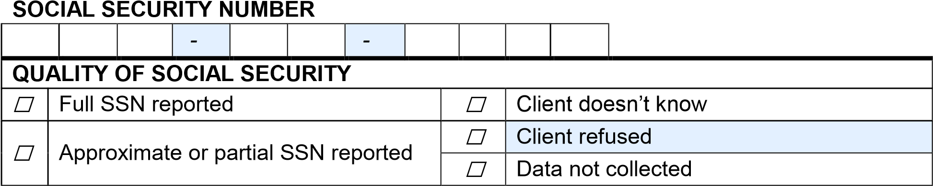

CURRENT NAME |  |  |  |  | N/A
Last
First
Middle |  |  |  |  | ☐
Suffix |  |  |  |  | ☐
Nickname |  |  |  |  | ☐
QUALITY OF CURRENT NAME
☐ | Full name reported |  | ☐ | Client doesn’t know
☐ | Partial, street name, or code name reported |  | ☐ | Client refused
 |  |  | ☐ | Data not collected

DATE OF BIRTH
 |  | - |  |  | - |  |  |  |  | Age:
Month |  |  | Day |  |  | Year
QUALITY OF DATE OF BIRTH
☐ | Full DOB reported |  |  |  |  |  |  |  |  |  | ☐ | Client doesn’t know
☐ | Approximate or partial DOB re |  |  |  |  |  | ported |  |  |  | ☐ | Client refused
 |  |  |  |  |  |  |  |  |  |  | ☐ | Data not collected

GENDER
☐ | Female |  | ☐ | Other
☐ | Male |  | ☐ | Client doesn’t know
☐ | Transgender mal | e to female | ☐ | Client refused
☐ | Transgender fem | ale to male | ☐ | Data not collected
Specify “Other”

RACE (select all that apply)
☐ | American Indian or Alaskan Native | ☐ | White/Caucasian
☐ | Asian | ☐ | Client does not know
☐ | Black/African American | ☐ | Client refused
☐ | Hawaiian or Other Pacific Islander | ☐ | Data Not Collected

ETHNICITY
☐ | Non-Hispanic/ Non-Latino | ☐ | Client doesn’t know
 |  | ☐ | Client refused
☐ | Hispanic/Latino | ☐ | Data not collected

VETERAN STATUS
☐ | No | ☐ | Client doesn’t know
☐ | Yes | ☐ | Client refused
 |  | ☐ | Data not collected
IF “YES” TO VETERAN STATUS
Year entered military service (year)
Year separated from military service (year)
Theater of Operations: World War II
☐ | No | ☐ | Client doesn’t know
☐ | Yes | ☐ | Client refused
 |  | ☐ | Data not collected
Theater of Operations: Korean War
☐ | No | ☐ | Client doesn’t know
☐ | Yes | ☐ | Client refused
 |  | ☐ | Data not collected
Theater of Operations: Vietnam War
☐ | No | ☐ | Client doesn’t know
☐ | Yes | ☐ | Client refused
 |  | ☐ | Data not collected
Theater of Operations: Persian Gulf War (Desert Storm)
☐ | No | ☐ | Client doesn’t know
☐ | Yes | ☐ | Client refused
 |  | ☐ | Data not collected
Theater of Operations: Afghanistan (Operation Enduring Freedom)
☐ | No | ☐ | Client doesn’t know
☐ | Yes | ☐ | Client refused
 |  | ☐ | Data not collected
Theater of Operations: Iraq (Operation Iraqi Freedom)
☐ | No | ☐ | Client doesn’t know
☐ | Yes | ☐ | Client refused
 |  | ☐ | Data not collected
Theater of Operations: Iraq (Operation New Dawn)
☐ | No | ☐ | Client doesn’t know
☐ | Yes | ☐ | Client refused
 |  | ☐ | Data not collected
Theater of Operations: Other peace-keeping operations or military interventions (such as Lebanon, Panama, Somalia, Bosnia, Kosovo)
☐ | No | ☐ | Client doesn’t know
☐ | Yes | ☐ | Client refused
 |  | ☐ | Data not collected
Branch of the Military
☐ | Army | ☐ | Coast Guard
☐ | Air Force | ☐ | Client doesn’t know
☐ | Navy | ☐ | Client refused
☐ | Marines | ☐ | Data not collected
Discharge Status
☐ | Honorable |  |  | ☐ | Dishonorable
☐ | General under honorable conditions |  |  | ☐ | Uncharacterized
☐ | Other than honorable conditions (OTH) |  |  | ☐ | Client doesn’t know
 |  |  |  | ☐ | Client refused
☐ | Bad Conduct |  |  | ☐ | Data not collected

CLIENT CONTACT INFORMATION | Can we leave a message for you? | Identify preferred contact method
Phone: | Yes / No | □
Alternate phone: | Yes / No | □
Text: | Yes / No | □
Email: | Yes / No | □
Other (Facebook (name/unique hyperlink), social media, etc.): | Yes / No | □
Last Permanent Zip Code:
Additional Contacts?

ON A REGULAR DAY, WHAT TIME AND PLACE IS EASIEST TO FIND YOU?
Write in ___________________________________

TOTAL MONTHLY INCOME AND PERCENT AMI
Write in Total Income from all sources_____________________
☐ | Under 30% AMI | ☐ | Client doesn’t know
☐ | 30% to 50% AMI | ☐ | Client refused
☐ | Greater than 50% | ☐ | Data not collected

DO YOU HAVE SUPPLEMENTAL SECURITY INCOME (SSI) OR SOCIAL SECURITY DISABILITY INSURANCE (SSDI)?
☐ | No | ☐ | Client doesn’t know
☐ | Yes | ☐ | Client refused
 |  | ☐ | Data not collected

WHAT TYPE OF HEALTH INSURANCE DO YOU HAVE, IF ANY?
☐ | Medicaid | ☐ | Private Insurance | ☐ | Client doesn’t know
☐ | Medicare | ☐ | No Health Insurance | ☐ | Client refused
☐ | VA medical | ☐ | Other | ☐ | Data not collected

HAVE YOU EVER BEEN IN FOSTER CARE?
☐ | No | ☐ | Client doesn’t know
☐ | Yes | ☐ | Client refused
 |  | ☐ | Data not collected

IF ‘YES’ TO HAVING EVER BEEN IN FOSTER CARE
There are some housing programs that specialize in serving those with specific life experiences or situations. Would you be interested in a housing program that specializes in serving those who have had or have the following life experiences?

☐ | Are in extended foster care | ☐ | Client doesn’t know
☐ | Aged out of foster care in WA State | ☐ | Client refused
 |  | ☐ | Data not collected

What Was Your Legal Name When You Were in Foster Care?
Last
First
Middle

Length of Time in Foster Care?
Years ____ | ☐ | Client doesn’t know
Months___ | ☐ | Client refused
 | ☐ | Data not collected

What Was Your Age upon Exit from Foster Care
Years ____ | ☐ | Client doesn’t know
Months___ | ☐ | Client refused
 | ☐ | Data not collected

What is the name of the parent or guardian you lived with before entering Foster Care?
Last
First
Middle
☐ | Client doesn’t know
☐ | Client refused
☐ | Data not collected

ARE YOU ENROLLED IN SCHOOL FULL-TIME?
☐ | No | ☐ | Client doesn’t know
☐ | Yes | ☐ | Client refused
 |  | ☐ | Data not collected

WHERE DID YOU LIVE PRIOR TO BECOMING HOMELESS?
☐ | This City | ☐ | Client doesn’t know
☐ | King County (This region) | ☐ | Client refused
☐ | Another part of the State | ☐ | Data not collected
☐ | Somewhere else

DO YOU HAVE A MEDICAL CONDITION WHICH REQUIRES TREATMENT OR
MEDICATION YOU CAN’T CURRENTLY MAINTAIN BECAUSE OF HOMELESSNESS?
☐ | No | ☐ | Client doesn’t know
☐ | Yes | ☐ | Client refused
 |  | ☐ | Data not collected

WHAT IS YOUR CURRENT LIVING SITUATION?
☐ | a. Place not meant for habitation (e.g., a  vehicle, an abandoned building, bus/train/subway station/airport or anywhere outside) | ☐ | n. Permanent housing for formerly homeless persons (such as: a CoC  project, HUD legacy programs; or  HOPWA PH)
☐ | b. Emergency shelter, including hotel or motel paid for with emergency shelter voucher | ☐ | o. Rental by client, no ongoing subsidy
☐ | c. Safe Haven | ☐ | p. Rental by client, with VASH subsidy
☐ | d. Interim Housing | ☐ | q. Rental by client, with GPD TIP subsidy
☐ | e. Foster care home or foster care group home | ☐ | r. Residential project or hallway house with no homeless criteria
☐ | f. Hospital or other residential nonpsychiatric medical facility | ☐ | s. Staying or living with a family member’s room, apartment or house
☐ | g. Jail, prison or juvenile detention facility | ☐ | t. Staying or living in a friends’ room, apartment, or house
☐ | h. Long-term care facility or nursing home | ☐ | u. Transitional housing for homeless persons
☐ | i. Psychiatric hospital or other psychiatric facility | ☐ | v. Data not collected
☐ | j. Substance abuse treatment facility or detox center | ☐ | w. Client doesn’t know
☐ | k. Hotel or motel paid for without emergency shelter voucher | ☐ | x. Client refused
☐ | l. Owned by client, no ongoing subsidy | ☐ | y. Data not collected
☐ | m. Owned by client, with ongoing subsidy

IF CURRENT LIVING SITUATION IS LITERALLY HOMELESS (ITEMS A – D), THEN
HOW LONG HAVE YOU BEEN IN YOUR CURRENT LIVING SITUATION?
☐ | One night or less | ☐ | One year or longer
☐ | Two to six nights | ☐ | Client doesn’t know
☐ | One week or more, but less than one month | ☐ | Client refused
☐ | One month or more, but less than 90 days | ☐ | Data not collected
☐ | 90 days or more, but less than one year

APPROXIMATELY WHEN DID THIS HOMELESS SITUATION BEGIN?

IN THE PAST THREE YEARS, WHAT IS THE TOTAL NUMBER OF TIMES YOU HAVE BEEN HOMELESS ON THE STREET, IN EMERGENCY SHELTER, OR SAFE HAVEN?
☐ | One time | ☐ | Client doesn’t know
☐ | Two times | ☐ | Client refused
☐ | Three times | ☐ | Data not collected
☐ | Four or more times

IN THE PAST THREE YEARS, WHAT IS THE TOTAL NUMBER OF MONTHS YOU HAVE BEEN HOMELESS ON THE STREET, IN EMERGENCY SHELTER, OR SAFE HAVEN?

__________________________________________________

IF CURRENT LIVING SITUATION IS INSTITUTIONAL (ITEMS E – J), THEN

DID YOU STAY LESS THAN 90 DAYS?
☐ | No | ☐ | Client doesn’t know
☐ | Yes | ☐ | Client refused
 |  | ☐ | Data not collected

IF STAY WAS MORE THAN 90 DAYS,

HOW LONG DID YOU STAY? ________________________________________

IF STAY WAS LESS THAN 90 DAYS,

HOW LONG DID YOU STAY?
☐ | One night or less | ☐ | One month or more, but less than 90 days
☐ | Two to six nights | ☐ | Client doesn’t know
 |  | ☐ | Client refused
☐ | One week or more, than less than one month | ☐ | Data not collected

IMMEDIATELY PRIOR TO THIS STAY, WERE YOU LIVING ON THE STREET, IN AN EMERGENCY SHELTER, OR SAFE HAVEN?
☐ | No | ☐ | Client doesn’t know
☐ | Yes | ☐ | Client refused
 |  | ☐ | Data not collected

IF YES (LIVING ON THE STREET, EMERGENCY SHELTER OR SAFE HAVEN), APPROXIMATELY WHEN DID THIS HOMELESS SITUATION BEGIN?

________________________________________________________________

IF YES (LIVING ON THE STREET, EMERGENCY SHELTER OR SAFE HAVEN),
IN THE PAST THREE YEARS, WHAT IS THE TOTAL NUMBER OF TIMES YOU
HAVE BEEN HOMELESS ON THE STREET, IN EMERGENCY SHELTER, OR SAFE HAVEN?
☐ | One time | ☐ | Client doesn’t know
☐ | Two times | ☐ | Client refused
☐ | Three times | ☐ | Data not collected
☐ | Four or more times

IF YES (LIVING ON THE STREET, EMERGENCY SHELTER OR SAFE HAVEN),
IN THE PAST THREE YEARS, WHAT IS THE TOTAL NUMBER OF MONTHS YOU HAVE BEEN HOMELESS ON THE STREET, IN EMERGENCY SHELTER, OR SAFE HAVEN?

_________________________________________________________________

IF CURRENT LIVING SITUATION IS A TRANSITIONAL OR PERMANENT HOUSING
SITUATION OR CLIENT DOESN’T KNOW OR REFUSES (ITEMS K – X), THEN

DID YOU STAY LESS THAN 7 NIGHTS?
☐ | No | ☐ | Client doesn’t know
☐ | Yes | ☐ | Client refused
 |  | ☐ | Data not collected

IF STAY WAS MORE THAN 7 NIGHTS,

HOW LONG DID YOU STAY? ________________________________________

IF STAY WAS LESS THAN 7 NIGHTS,

HOW LONG DID YOU STAY?
☐ | One night or less | ☐ | Client doesn’t know
☐ | Two to six nights | ☐ | Client refused
 |  | ☐ | Data not collected

IMMEDIATELY PRIOR TO THIS STAY, WERE YOU LIVING ON THE STREET, IN AN EMERGENCY SHELTER, OR SAFE HAVEN?
☐ | No | ☐ | Client doesn’t know
☐ | Yes | ☐ | Client refused
 |  | ☐ | Data not collected

IF YES (LIVING ON THE STREET, EMERGENCY SHELTER OR SAFE HAVEN), APPROXIMATELY WHEN DID THIS HOMELESS SITUATION BEGIN?

________________________________________________________________

IF YES (LIVING ON THE STREET, EMERGENCY SHELTER OR SAFE HAVEN),
IN THE PAST THREE YEARS, WHAT IS THE TOTAL NUMBER OF TIMES YOU HAVE BEEN HOMELESS ON THE STREET, IN EMERGENCY SHELTER, OR SAFE HAVEN?
☐ | One time | ☐ | Client doesn’t know
☐ | Two times | ☐ | Client refused
☐ | Three times | ☐ | Data not collected
☐ | Four or more times

IF YES (LIVING ON THE STREET, EMERGENCY SHELTER OR SAFE HAVEN),
IN THE PAST THREE YEARS, WHAT IS THE TOTAL NUMBER OF MONTHS YOU HAVE BEEN HOMELESS ON THE STREET, IN EMERGENCY SHELTER, OR SAFE HAVEN?

_________________________________________________________________

DISABLING CONDITION AND BARRIERS
DO YOU HAVE A DISABLING CONDITION?
☐ | No | ☐ | Client doesn’t know
☐ | Yes | ☐ | Client refused
 |  | ☐ | Data not collected

DO YOU HAVE A PHYSICAL DISABILITY?
☐ | No | ☐ | Client doesn’t know
☐ | Yes | ☐ | Client refused
 |  | ☐ | Data not collected

IF YOU HAVE A PHYSICAL DISABILITY, ARE YOU CURRENTLY RECEIVING SERVICES?
☐ | No | ☐ | Client doesn’t know
☐ | Yes | ☐ | Client refused
 |  | ☐ | Data not collected

IF YOU HAVE A PHYSICAL DISABILITY, IS IT A LONG TERM PHYSICAL DISABILITY?
☐ | No | ☐ | Client doesn’t know
☐ | Yes | ☐ | Client refused
 |  | ☐ | Data not collected

IF YOU HAVE A PHYSICAL DISABILITY, IS IT DOCUMENTED?
☐ | No
☐ | Yes

DO YOU HAVE A PERMANENT PHYSICAL DISABILITY THAT LIMITS YOUR
MOBILITY? (ie, wheelchair, amputation, unable to climb stairs?)
☐ | No | ☐ | Client doesn’t know
☐ | Yes | ☐ | Client refused
 |  | ☐ | Data not collected

DO YOU HAVE A DEVELOPMENTAL DISABILITY?
☐ | No | ☐ | Client doesn’t know
☐ | Yes | ☐ | Client refused
 |  | ☐ | Data not collected

IF YOU HAVE A DEVELOPMENTAL DISABILITY, ARE YOU CURRENTLY RECEIVING SERVICES?
☐ | No | ☐ | Client doesn’t know
☐ | Yes | ☐ | Client refused
 |  | ☐ | Data not collected

IF YOU HAVE A DEVELOPMENTAL DISABILITY, DOES IT SUBSTANTIALLY IMPAIR YOUR INDEPENDENCE?
☐ | No | ☐ | Client doesn’t know
☐ | Yes | ☐ | Client refused
 |  | ☐ | Data not collected

IF YOU HAVE A DEVELOPMENTAL DISABILITY, IS IT DOCUMENTED?
☐ | No
☐ | Yes

DO YOU HAVE A CHRONIC HEALTH CONDITION?
☐ | No | ☐ | Client doesn’t know
☐ | Yes | ☐ | Client refused
 |  | ☐ | Data not collected

IF YOU HAVE A CHRONIC HEALTH CONDITION, ARE YOU CURRENTLY RECEIVING SERVICES?
☐ | No | ☐ | Client doesn’t know
☐ | Yes | ☐ | Client refused
 |  | ☐ | Data not collected

IF YOU HAVE A CHRONIC HEALTH CONDITION, IS IT A LONG TERM CHRONIC HEALTH CONDITION?
☐ | No | ☐ | Client doesn’t know
☐ | Yes | ☐ | Client refused
 |  | ☐ | Data not collected

IF YOU HAVE A CHRONIC HEALTH CONDITION, IS IT DOCUMENTED?
☐ | No
☐ | Yes

DO YOU HAVE A MENTAL HEALTH PROBLEM?
☐ | No | ☐ | Client doesn’t know
☐ | Yes | ☐ | Client refused
 |  | ☐ | Data not collected

IF YOU HAVE A MENTAL HEALTH PROBLEM, ARE YOU CURRENTLY RECEIVING SERVICES?
☐ | No | ☐ | Client doesn’t know
☐ | Yes | ☐ | Client refused
 |  | ☐ | Data not collected

IF YOU HAVE A MENTAL HEALTH PROBLEM, IS IT A LONG TERM MENTAL HEALTH PROBLEM?
☐ | No | ☐ | Client doesn’t know
☐ | Yes | ☐ | Client refused
 |  | ☐ | Data not collected

IF YOU HAVE A MENTAL HEALTH PROBLEM, IS IT DOCUMENTED?
☐ | Yes
☐ | No

DO YOU HAVE A SUBSTANCE ABUSE PROBLEM?
☐ | No | ☐ | Yes, both alcohol and drug abuse
☐ | Yes, alcohol abuse | ☐ | Client doesn’t know
 |  | ☐ | Client refused
☐ | Yes, drug abuse | ☐ | Data not collected

IF YOU HAVE A SUBSTANCE ABUSE PROBLEM, ARE YOU CURRENTLY RECEIVING SERVICES?
☐ | Yes | ☐ | Client doesn’t know
☐ | No | ☐ | Client refused
 |  | ☐ | Data not collected

IF YOU HAVE A SUBSTANCE ABUSE PROBLEM, IS IT A LONG TERM SUBSTANCE ABUSE PROBLEM?
☐ | Yes | ☐ | Client doesn’t know
☐ | No | ☐ | Client refused
 |  | ☐ | Data not collected

IF YOU HAVE A SUBSTANCE ABUSE PROBLEM, IS IT DOCUMENTED?
☐ | Yes
☐ | No

DO YOU HAVE A CRIMINAL BACKGROUND IN ANY OF THE FOLLOWING?
☐ | Registered sex offender | ☐ | Arson | ☐ | Client doesn’t know
☐ | Meth production | ☐ | Open warrant | ☐ | Client refused
☐ | Class A felony w/in 12 mths |  |  | ☐ | Data not collected

ARE YOU INTERESTED IN BEING REFERRED TO PROGRAMS THAT SPECIALIZE IN SERVING THOSE WHO
☐ | Identify as Asian | ☐ | Identify as Black or African American
☐ | Identify as Hispanic/Latino | ☐ | Client doesn’t know
☐ | Identify as LGTBQ | ☐ | Client refused
☐ | Identify as Native American/Alaskan Native | ☐ | Data not collected
☐ | Identify as an immigrant or refugee

ARE YOU INTERESTED IN BEING REFERRED TO PROGRAMS THAT SPECIALIZE IN SERVING THOSE WHO
☐ | Are in recovery | ☐ | Client doesn’t know
☐ | Are Ex-offenders/re-entry | ☐ | Client refused
☐ | Are Deaf/hearing impaired | ☐ | Data not collected

SOME PROGRAMS REQUIRE PROOF OF A VALID SOCIAL SECURITY NUMBER AND LEGAL IMMIGRATION STATUS. ARE YOU INTERESTED IN BEING REFERRED TO ONE OF THESE PROGRAMS?
☐ | No | ☐ | Client doesn’t know
☐ | Yes | ☐ | Client refused
 |  | ☐ | Data not collected

IF ‘YES’ TO VETERAN STATUS, ARE YOU REGISTERED WITH THE VA PUGET SOUND HEALTH CARE SYSTEM?
☐ | No | ☐ | Client doesn’t know
☐ | Yes | ☐ | Client refused
 |  | ☐ | Data not collected

IF ‘YES’ TO VETERAN STATUS, DID YOU SERVE AS AN ARMY NATIONAL GUARD OR RESERVE MEMBER?
☐ | No | ☐ | Client doesn’t know
☐ | Yes | ☐ | Client refused
 |  | ☐ | Data not collected

IF ‘YES’ TO VETERAN STATUS, HAVE YOU HAD AT LEAST ONE DAY OF ACTIVE DUTY?
☐ | No | ☐ | Client doesn’t know
☐ | Yes | ☐ | Client refused
 |  | ☐ | Data not collected

IF ‘YES’ TO VETERAN STATUS, DO YOU RECEIVE ANY VA FINANCIAL BENEFITS?
☐ | No | ☐ | Client doesn’t know
☐ | Yes | ☐ | Client refused
 |  | ☐ | Data not collected

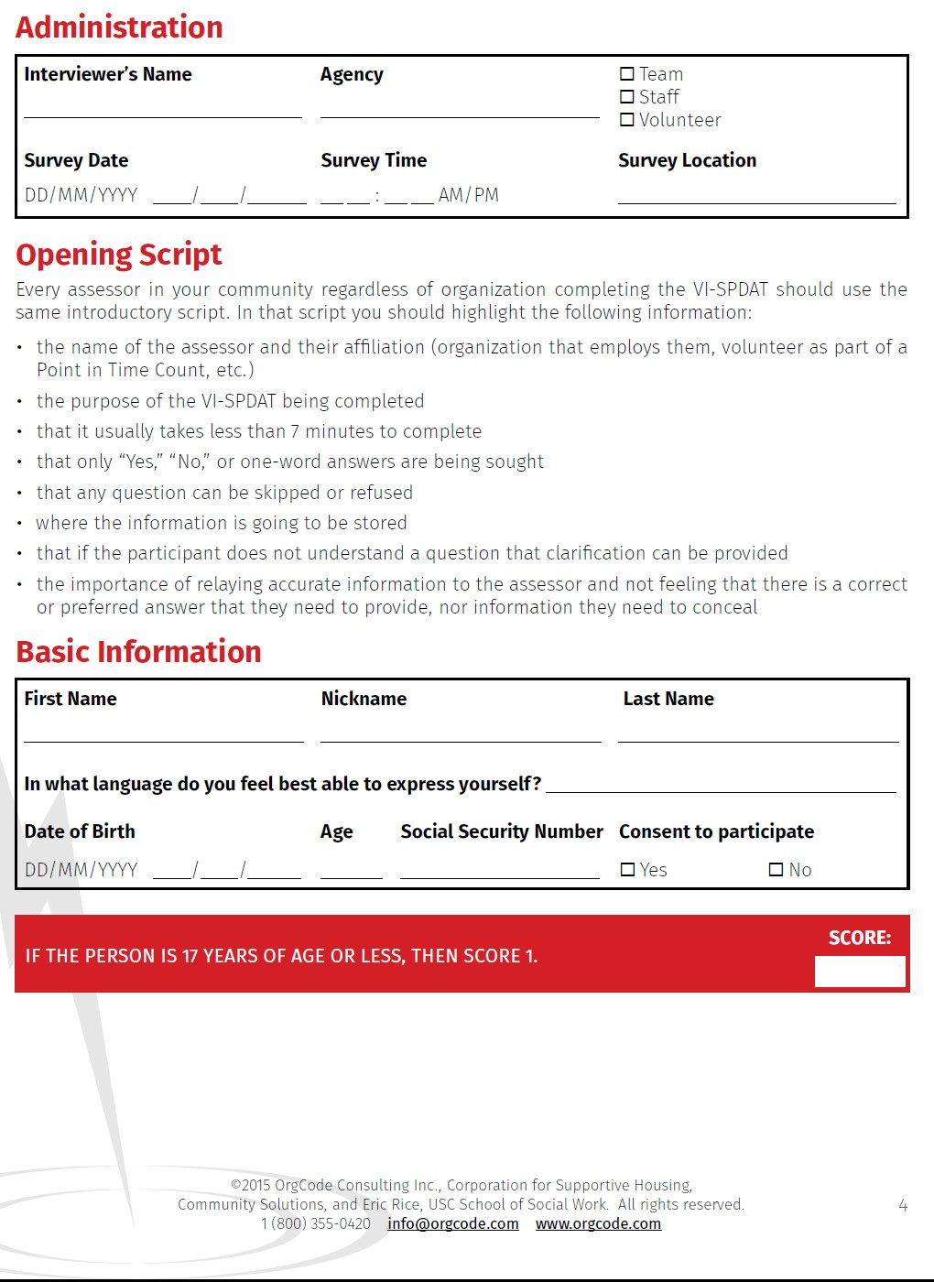

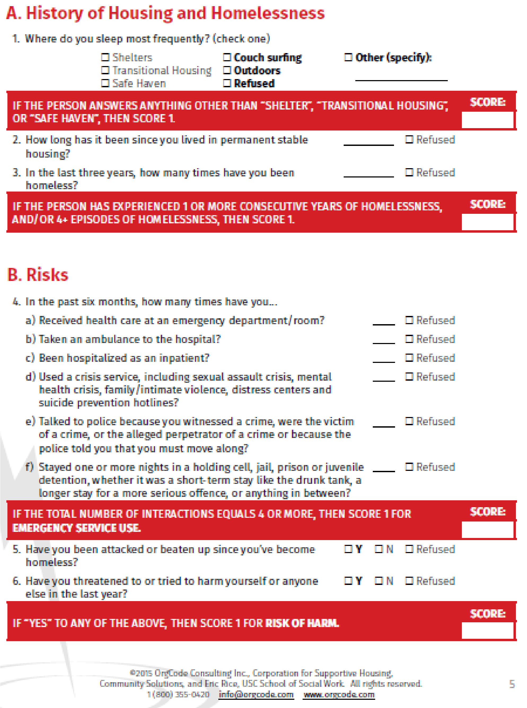

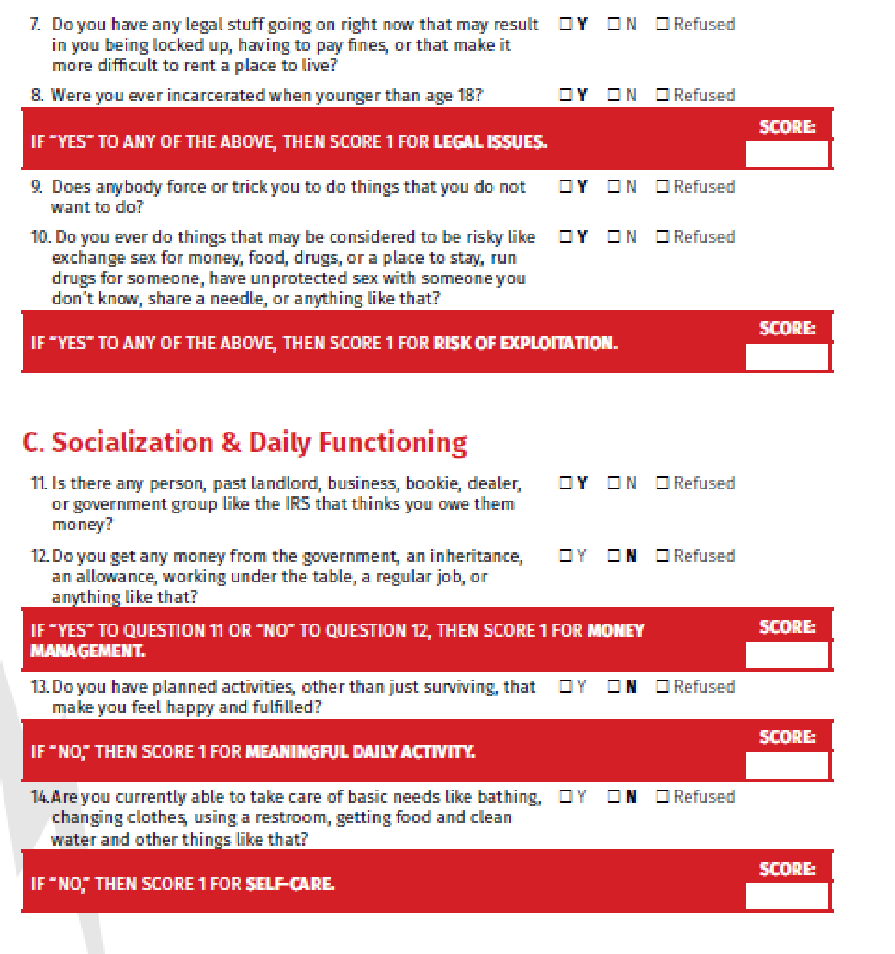

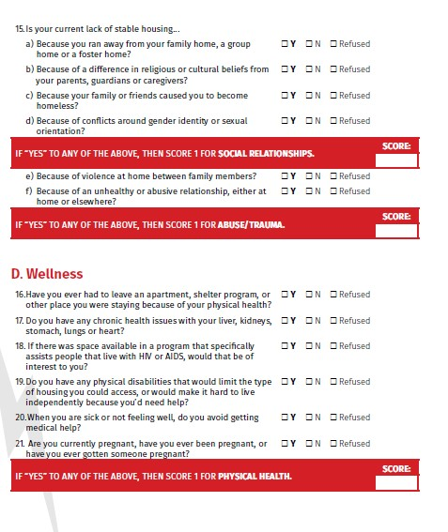

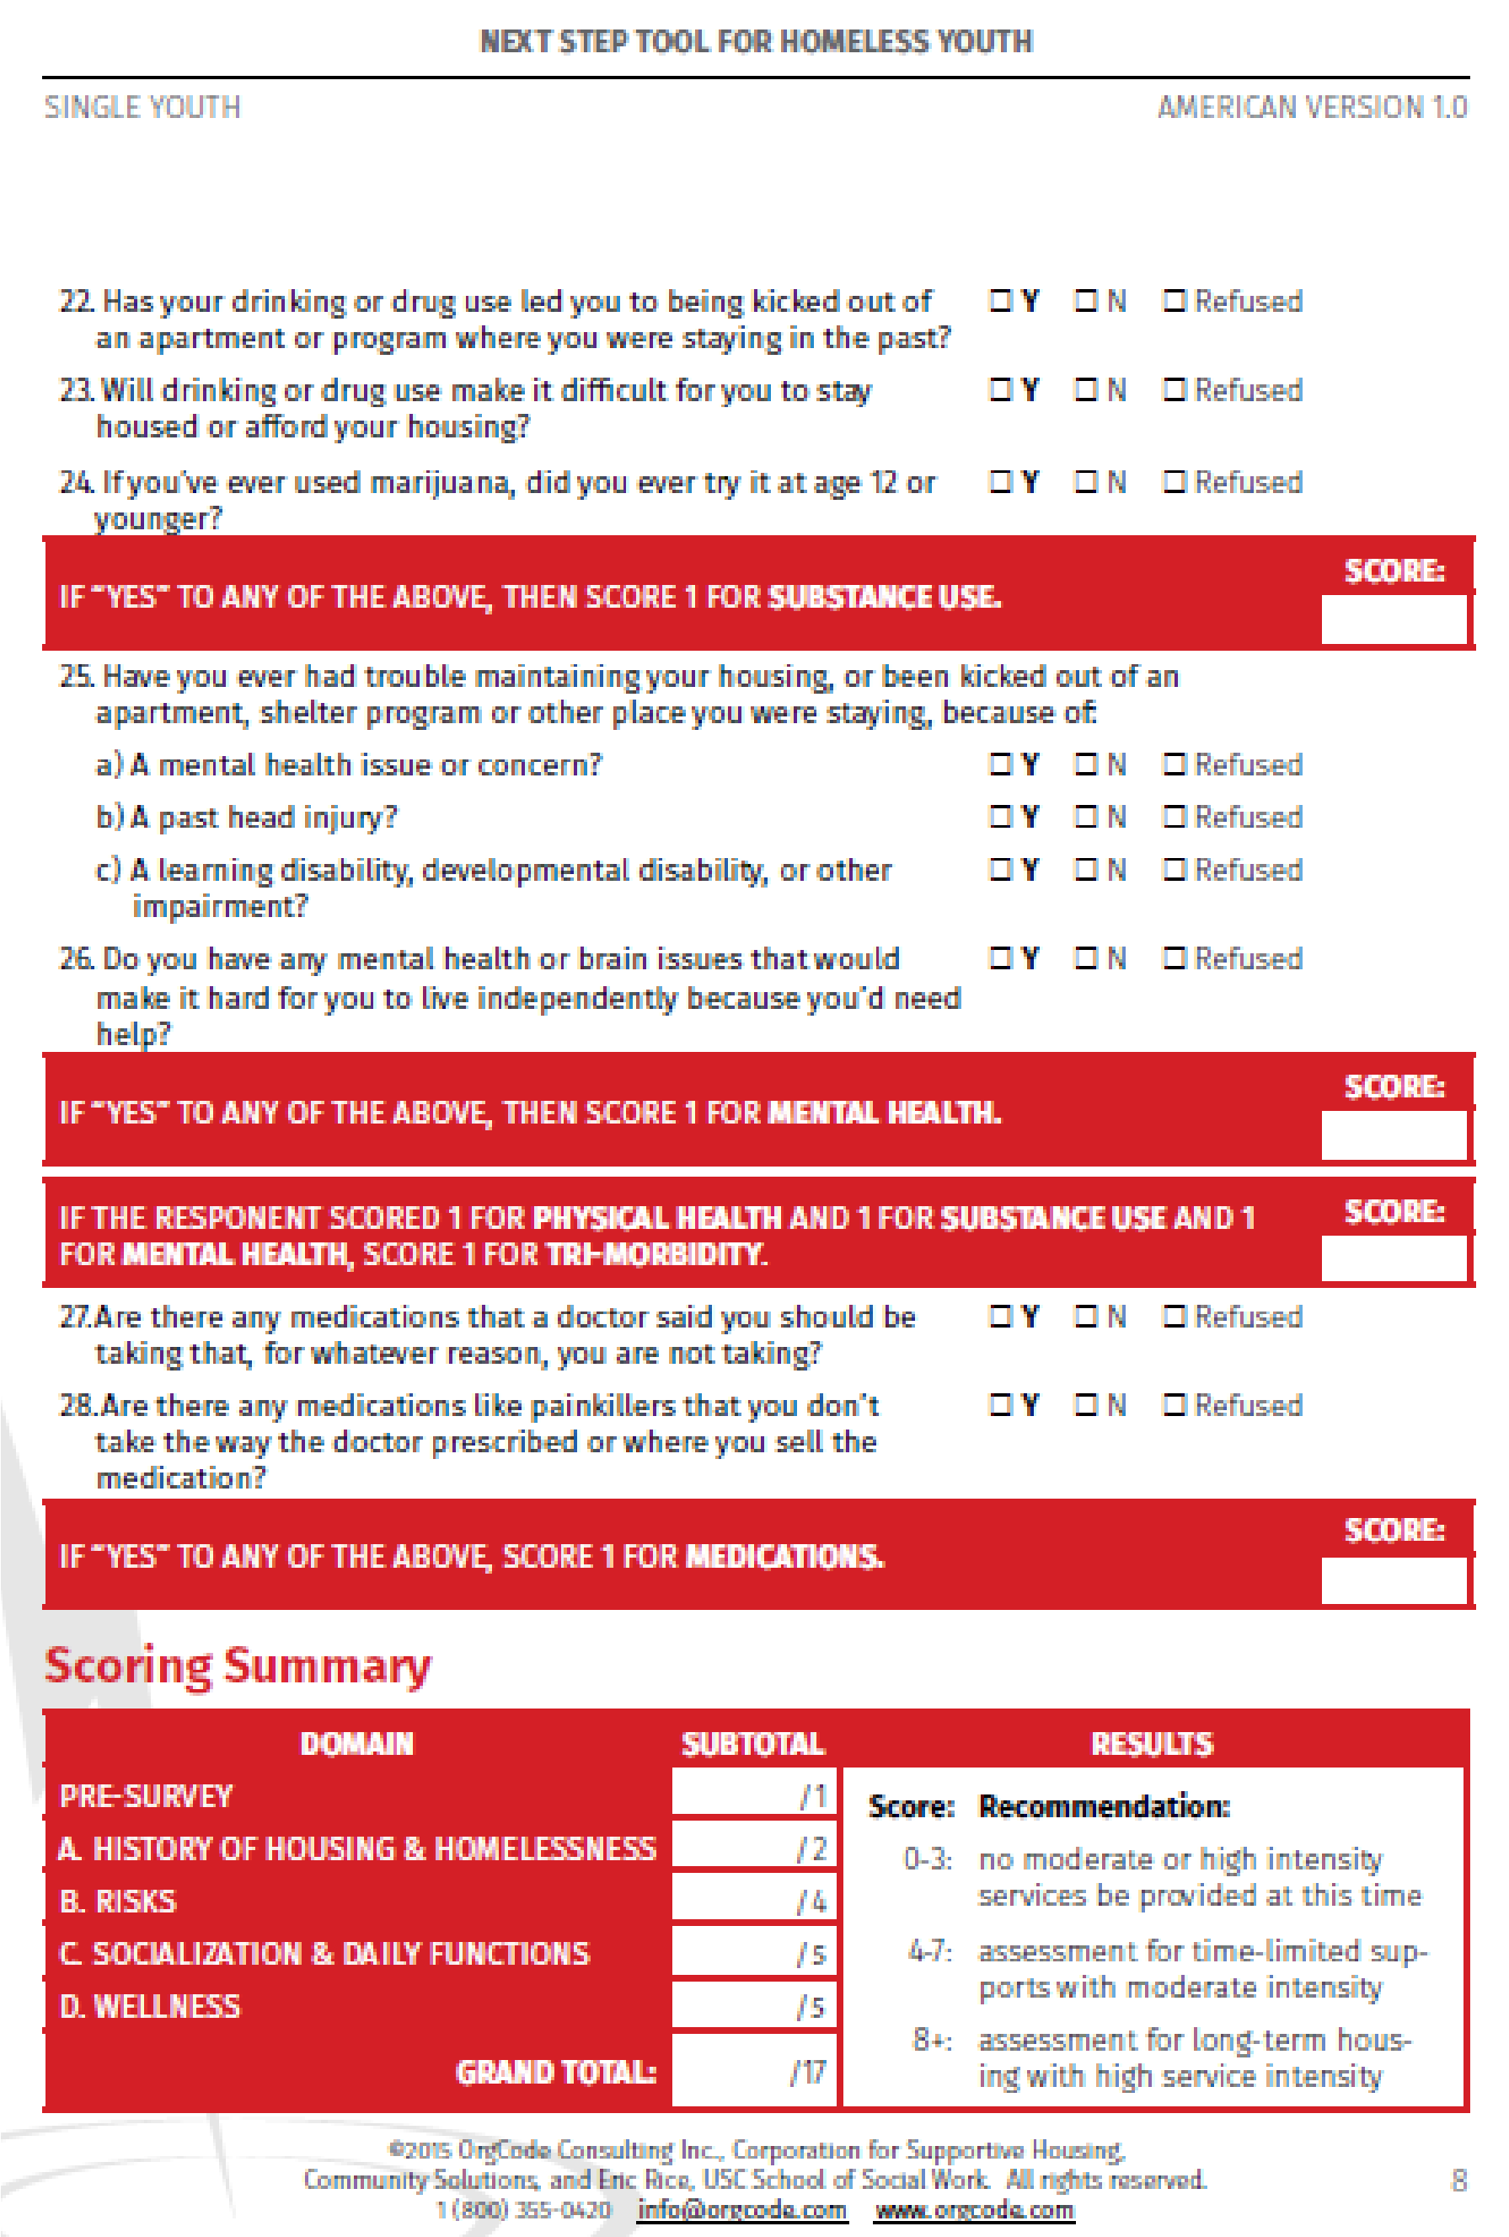
ASSESSOR – FLAG CLIENT AS UNABLE TO COMPLETE VI-SPDAT? (check if applicable)
☐ Yes, flag this Housing Triage Tool for review, due to following specific concerns. Please identify which questions you are flagging. Then include specific information and/or examples below

__________________________________________________________________
__________________________________________________________________
__________________________________________________________________
_____________________________

Was this Housing Triage Tool flagged as part of a CEA Housing Triage Tool
Disability Accommodation? (check only if applicable)
☐ Yes

HOUSING TRIAGE TOOL ADMINISTRATION INFORMATION
ASSESSOR INFORMATION

DATE HOUSING TRIAGE TOOL COMPLETED
 |  | - |  |  | -
Month Day Year

First
Last
Agency
Survey Location

Was this Housing Triage Tool completed by RAP staff?
☐ Yes, RAP staff
☐ Yes, RAP mobile staff
☐ No

If this Housing Triage Tool was completed by RAP staff, at which RAP do you work? ☐ CCS - East
☐ CCS - Seattle
☐ Solid Ground – North Seattle
☐ MSC – Federal Way
☐ YWCA - Renton

If this Housing Triage Tool was completed by RAP staff, was this a walk-in appointment or scheduled?
☐ Walk-in appointment
☐ Scheduled

If this Housing Triage Tool was completed by RAP MOBILE staff, where did the Housing Triage Tool take place?
__________________________________________________________________

I confirm that this client’s consent status (Release of Information) has been documented in HMIS under their privacy shield.

Please enter initials here: _____________

