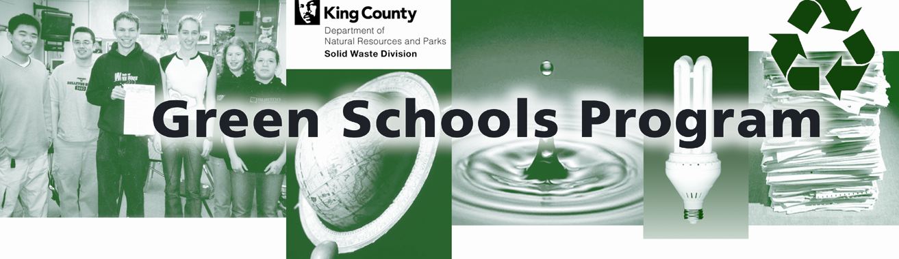
Fast Facts about Waste Reduction and Recycling

Schools can use these “fast facts” in PA announcements, emails, school newsletters and other publications to educate students and staff about the benefits of waste reduction and recycling.

RECYCLING

GENERAL RECYCLING FACTS
- Recycling, including composting, diverted 79 million tons of material away from landfills and incinerators in 2005, up from 34 million tons in 1990. – Environmental Protection Agency
- One thing that releases greenhouse gases is trash that sits at the landfill and slowly decomposes. Recycling reduces the amount of materials that are sent to the landfill. – Environmental Protection Agency
- If the US had a national recycling rate of 30 percent it could reduce greenhouse gas emissions as much as removing nearly 25 million cars from the road each year. – Recycling Revolution website
- By improving recycling throughout the school, Illahee Middle School (Federal Way School District, King County) reduced its garbage by 59 percent and saved the district over $5,000 during the 2004-2005 school year. – King County Green Schools Program

PAPER RECYCLING
- The average American uses 650 pounds of paper each year. – UCLA student recycle club
- In 2004, 16 percent of the solid waste received at the King County Cedar Hills Regional Landfill was recyclable paper. That amounts to 155,780 tons of paper thrown away. – King County Solid Waste Division
- An estimated 47 percent of school garbage is recyclable paper. – Los Angeles School Waste Composition Study
- Recycling conserves natural resources and saves energy. For example, every ton of recycled paper saves trees, electricity, and water, and results in 74 percent less air pollution, 64 percent less energy use and 50 percent less water use than manufacturing a ton of paper from virgin wood pulp. – Recycling It website
- Trees absorb carbon dioxide, one of the greenhouse gases responsible for global warming. Recycling one ton of paper saves 17 trees, which can absorb approximately 250 pounds of carbon dioxide from the air each year. - Recycling Revolution website
- A piece of paper can be recycled into new paper up to seven times before the fibers get too short for making paper. After that, it becomes toilet paper, tissue paper and paper toweling. – Washington State Recycling Association
- Every ton of paper made from recycled materials saves about 7,000 gallons of water. That means each New York Times newspaper printed on recycled newsprint saves about 3.5 gallons of water. - Washington State Recycling Association

ALUMINUM RECYCLING

- Aluminum is a metal that has to be mined from the earth. Once we have mined it all, it’s gone. – Virginia Tech, Center for Economic Education, http://susdev.agecon.vt.edu/curriculum/Natural%20Resources.pdf

- Recycling one aluminum can saves enough energy to run a TV or computer for three hours – or the equivalent of half a gallon of gasoline. – Recycling Revolution website
- Aluminum can be recycled over and over without degrading its quality. It can be recycled forever! - Recycling Revolution website
- Recycling 23 aluminum cans conserves one gallon of gasoline. – Washington State Recycling Association
- The aluminum beverage can returns to the grocer’s shelf as part of a new, filled can in as little as 90 days after collection, remelting, rolling, manufacturing and distribution. Consumers could purchase portions of the same recycled aluminum can from a grocer’s shelf 4 times a year. – Washington State Recycling Association

PLASTIC RECYCLING
- Nearly 10 percent of U.S. oil consumption - approximately 2 million barrels a day - is used to make plastic. – Metabolix Bioenergy Company study
- Supplying the plastic water bottles that American consumers purchase in one year requires more than 47 million gallons of oil, the equivalent of one billion pounds of carbon dioxide that is released into the atmosphere. – Container Recycling Institute
- According to the Beverage Marketing Corporation, Americans’ thirst for bottled water has increased dramatically. In 1997 we bought 3.3 billion bottles of water; by 2002 that number had jumped to 15 billion bottles. – Container Recycling Institute
- Recycling one ton of plastic saves the equivalent of 3.85 barrels of oil. – Washington State Recycling Association

GLASS RECYCLING
- Recycling one ton of glass saves 10 gallons of oil. – Washington State Recycling Association
- When a glass bottle is recycled, 50 percent less water pollution is produced than when a new glass bottle is made from virgin materials. – Washington State Recycling Association
- Glass can be recycled again and again with no loss in quality or purity. Glass containers go from recycling bin to store shelf in as little as 30 days—again and again. – Glass Packaging Institute
- Mining and transporting raw materials for glass produces about 385 pounds of waste for every ton of glass that is made. If recycled glass is substituted for half of the raw materials, the waste is cut by more than 80 percent. - Recycling Revolution website

Waste Reduction

FOOD WASTE

- In 2004 food scraps and compostable paper from homes and businesses made up 26 percent of the garbage sent to King County’s Cedar Hills Regional Landfill. – King County Solid Waste Division
- Food scraps make up an estimated 32 percent of school garbage in King County. Food scraps plus food soiled paper can comprise more than 50 percent of a school’s garbage. – King County Green Schools Program
- In June 2007 the King County Green Schools Program linked five school districts to Northwest Harvest and Food Lifeline to achieve the collection of over 5,000 pounds of edible food – food leftover at the end of the school year that would not keep until school reopened in September. Food that would have gone to waste instead provided 3,900 meals to hungry families in Washington at a time when donations to food banks are at their lowest. – King County Green Schools Program
- Food scraps and food soiled paper can be turned into compost, which helps build healthy soil. By building healthy soil and practicing natural yard care you can have great looking landscaping that is easier to care for and healthier for families, pets and wildlife. – King County Solid Waste Division
- Crestwood Elementary School in Covington began composting their food scraps in an Earth Tub in the spring of 2004. By June of 2005, they had composted 1,881 pounds of food waste. – King County Solid Waste Division
- The City of San Francisco Recycling Program implemented food scrap collection programs at five local schools which diverted a total of 1700 pounds of organic waste per week. Each of the schools designed a food scrap program that encompassed education, outreach, organics collection for offsite composting, and some vermi-composting. – California Integrated Waste Management Board

INFORMATION ABOUT OTHER WASTE REDUCTION PRACTICES
- During the 2005-2006 school year, Thoreau Elementary (Lake Washington School District, King County) reduced its lunchroom solid waste by 82 percent – and is keeping 47,000 Styrofoam trays out of the landfill each year -- by switching from Styrofoam to durable trays. – King County Solid Waste Division
- The Davis Joint Unified School District realized a net savings of $4,695 dollars in one year by implementing "offer versus serve" in three schools, separating food scraps for vermi-composting, and using recyclable trays. – California Integrated Waste Management Board
- Norway Public School in Toronto, Ontario implemented a litterless lunch program with excellent results. Parents reported that the Litterless Lunch program reduced the amount of packaging in their children's school lunches by about 60 percent. A similar reduction (about 50 percent) was reported in the use of "wraps and foils" at home, and an overall reduction of about 40 percent in the packaging of foods and products they purchased. – www.wastefreelunches.org
- Switching from liquid to foam soap reduces waste generation, water use, staff time and budget. Foam soap bags last 1,333 washes compared to 750 washes per liquid soap bag, due to the pre-lathered foam soap reducing the number of squirts needed per wash. – Issaquah School District, King County Green Schools Program participant
- In 1997, the Louisiana Department of Environmental Quality, Solid Waste Division, conducted a pilot locker clean out in two Baton Rouge schools, and recycled 1,750 pounds of white paper in two days. – Louisiana Department of Environmental Quality, http://www.deq.louisiana.gov/portal/tabid/2097/Default.aspx

Updated April 2008

