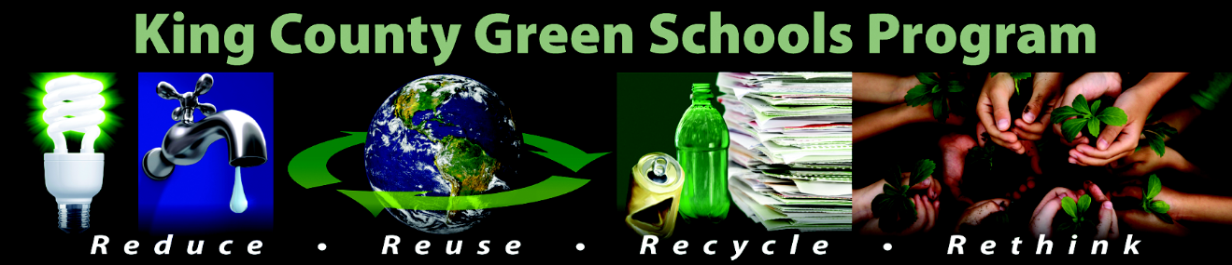

Sample announcements – Recycling kick-off

Share these announcements over the PA system, at assemblies, at lunchtime, and in classrooms. See Recycling Toolkit page for Waste Reduction and Recycling Fast Facts to add to announcements.
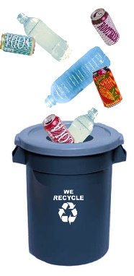
Monday

__________ (your school’s name) recycles! Today we will start to improve our recycling program! We want every student and staff member to recycle paper, bottles, cans, and milk cartons. Look for new signs on or above your classroom recycling bins showing what can be recycled. Also look for new recycling bins in the cafeteria for collecting empty bottles, cans, and milk cartons. Thank you for recycling!

Tuesday

__________ (your school’s name) recycles! Try to finish drinking your milk or other beverage. But if you have leftover milk or beverage, remember to pour out leftover liquids from your carton, bottle, or can before you place the EMPTY carton, bottle, or can in a blue recycling bin. And remember that caps and straws belong in garbage cans -- not in recycling bins. Thank you for recycling!

Wednesday

__________ (your school’s name) recycles! What happens to the materials we place in our blue recycling bins? Recycling companies sort the materials, and then the materials are used by companies to make new products. For example, plastic bottles are used to make carpets, park benches, and fleece jackets. Thank you for recycling your empty plastic bottles!

Thursday

____________ (your school’s name) recycles! Can you recycle cans? Yes you can! Aluminum cans CAN be recycled and are used to make new aluminum cans. Make sure the cans are completely empty before you place them in a recycling bin. Recycling not only reduces garbage – it also saves energy! By recycling one aluminum can, enough energy can be saved to run a computer for three hours. Thanks for recycling!

Friday

___________ (your school’s name) recycles! Question: What do candy wrappers, plastic utensils, tissues, and zip-lock or plastic bags have in common? Answer: They should not be placed in recycling bins. Place candy wrappers, plastic utensils, tissues, and plastic bags in the garbage. Only place materials that can be recycled – empty bottles, cans, and milk cartons, along with clean paper and cardboard -- in the blue recycling bins. Look for signs on or above the recycling bins. Thanks for recycling, everyone!

