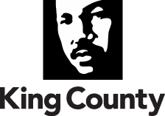

Certificate of Training:

__________________________________________________________________________
(First and Last Name – Please Print)

A member of the _____________________________________________________________
(Name of Board or Commission – Please Print)

Completed the following (Please check all that apply):

- Reviewed the Summary of the King County Code of Ethics (KC Ord. 9704)
- Records Retention & The Public Records Act Training (RCW 42.56 & 40.14)
- Open Public Meetings Act Training (RCW 42.30)

I hereby certify that the foregoing is true and correct to the best of my knowledge and belief.

Signed and dated by me this ______day of ____________, ______, at _______________, WA.
(day) (month) (year) (city)

________________________________
Signature

Please return the completed form via U.S. Post Office to (a PDF copy of the signed form is also accepted):

Rick Ybarra, Liaison for Boards & Commissions
King County Executive Office
MS: CNK-ES-0800
401 Fifth Avenue, Suite 800
Seattle, WA 98104
Direct Line: 206-263-9651
Email: Rick.Ybarra@kingcounty.gov

