

**Take pride in reducing your own carbon footprint.**

* You can’t say “carbon” without saying “car.” And the average U.S. car emits 10,383 lbs of carbon dioxide a year. 3
* If you drive to work alone you’re burning about 340 gallons of gas. At $3.50 per gallon that is $1,190. Add just one person and you can both save nearly $600 in commute costs per year. 3
* Average vehicle miles traveled (VMT) per employee at CTR affected worksites declined by 5.7% between 2007-2012, with total statewide VMT reduced by 161 million miles annually. 1
* While 2.3 billion gallons of gas are used sitting in gridlock, riding a bicycle has a carbon footprint of zero. Add that to the fact that 30 minutes of daily biking can increase your life by up to 4 years and your bike becomes one lean, mean, green machine. 3
* 710,000 pounds of petroleum and toxic chemicals flow into Puget Sound every year in the form of motor oil spill, drip, or runoff from pavement. 2

1 WSDOT 2013 Report to the Legislature

2 Transportation Choices Coalition

3 Bonneville Environmental Foundation



Take a moment to find out more about your commute options:

Find others who are interested in sharing the ride via the statewide online system:

[www.RideShareOnline.com](http://www.RideShareOnline.com)

206-625-4500 or 1-800-427-8249

Find out what transit options may work for you:

Transit Trip Planner

http://tripplanner.kingcounty.gov

206-553-3000

Community Transit

www.commtrans.org

Pierce Transit

www.piercetransit.org

Sound Transit

www.soundtransit.org

Washington State Ferries

www.wsdot.wa.gov/ferries

For more information, contact your Employee Transportation Coordinator:

Insert ETC Name, e-mail address, phone

***Consider the Alternatives to Drive-Alone Commuting and Take Off!***

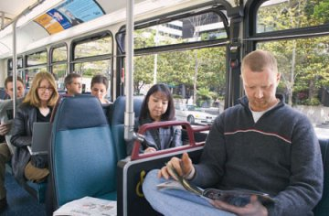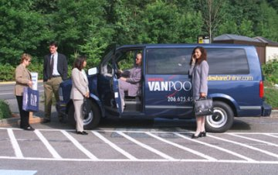

Commute Options for

Company name or logo

here



(Month and Year Here)



Take advantage of our company’s commuter benefits

Use public transit, carpool, vanpool, bike, walk, or telework from home if possible, even if just a day or two a week. You save one pound of carbon dioxide for each mile of driving you eliminate.

Include information on whether you offer discounted transit passes or a reimbursement for transit expenses. What is the amount? How do employees take advantage? What else do they need to know? Does this apply to bus, rail, light rail, vanpool, and walk-on-ferry?

Include the link to the transit trip planner here as follows:

To find your transit route(s) to work go to:

http://tripplanner.kingcounty.gov

Do you have a separate incentive or discounted parking for vanpool? If so what is it? Do you have an incentive for carpools? How about discounted or reserved parking? How much or where is the parking?

Include the link to rideshare Online here as follows:

To find find someone to share your commute with via carpool, vanpool or bike, go to:

[www.RideShareOnline.com](http://www.RideShareOnline.com)



**Take money off you commuting bill and put that money in your pocket!**

Share the ride - and the cost - with someone else!

Does your organization provide an incentive or amenities for bicyclists or walkers? What is the amount of the incentive and where are the amenities - such as secure bicycle parking or clothes lockers – located? How do employees become eligible or take advantage of them?

If you have a guaranteed ride home policy be sure to mention that your company offers this benefit and which emergencies are eligible. How do employees access this benefit? Who do they contact?

**In Washington State, more than half of our carbon dioxide comes from vehicles, so our commuting choices make a difference!**

Source: Washington State Department of Ecology



**Take time to read, chat with a friend or exercise while you commute.**

Why spend your commute time driving alone when you can use it to read or relax, Sudoku or sleep, or even exercise?

If your company offers telework or compressed work week schedule options, be sure to include it on this summary. You can indicate that employees must have manager or HR approval and that it may not be available to all positions.

Does your company allow start & quit time flexibility? If so, tie that into employees’ ability to rideshare or ride transit. Again, you can indicate that employees must have manager or HR approval and that it may not be available to all positions

Insert another photo here; either one of your own or one from our photo bank at [www.kingcounty.gov/CommuteSolutions](http://www.kingcounty.gov/CommuteSolutions)

Then click on Marketing tools and then photos.