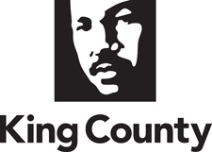

Charter Review Commission Agenda

King County Courthouse (12th floor, Southwest Conference Room)
516 3rd Ave. Seattle, WA 98104
Monday, January 13, 2020 | 2:00 p.m. – 3:00 p.m.

Purpose:
- Finalize Recommendations to the Future Charter Review Commission attachment

Agenda Topic | Lead | Time | Attachments
- Welcome and Review Agenda | Co-Chairs | 5 min
- Public Comment | Co-Chairs | As needed
- Review proposed edits received to date on draft Recommendations to the Future CRC; Live edit and finalize the Recommendations document | Facilitator | 45 min | - Draft Recommendations to the Future Charter Review Commission  - Commissioner Heller’s proposed recommendations  - Commissioner Ford’s Proposed Recommendations  - Commissioner Larson’s feedback
- Next steps | Facilitator | 5 min
- Adjourn | Co-Chairs

