ISSUE: No. 11

DATE: May 21, 2020

Period: May 10, 2020 to May 16, 2020

The Governor continued to provide additional guidance this week on the four phase “Safe Start” plan for re-opening. Additional guidance was provided for Phase 1 recreation and the restart of all medical services and for Phase 2 activities; further guidance on recreation, construction, pet grooming, fitness services and the overall criteria for which counties are able to move to Phase 2. Currently, 10 counties are in Phase 2 and 12 more are eligible. The Governor also revised guidance on the requirement that restaurants keep a log of patrons to make it voluntary.

The Governor’s risk assessment dashboard update yesterday showed generally steady or slightly improved values for the five different indicators which include Covid-19 disease activity, testing capacity and availability, case and contact investigations, risk to vulnerable populations and health care system readiness. The least favorable metric at this time continues to be testing capacity and availability.

Phase 1 continues in King County but we are still at low levels and the stay at home order remains in place, which continues to mean significant economic impacts and additional impact in coming months tied to the virus path, how fast consumer demand returns and how social distancing measures impact the economy. The state coronavirus response website indicates a minimum of three weeks is required to pass before moving to the next phase and the health metrics will have to be satisfactory before we will see statewide movement to Phase 2. A new directive from King County to wear face coverings was initiated this week.

**Significant King County Covid-19 Economic Events**

|  |  |  |
| --- | --- | --- |
| Week | Item | Notes |
| 3/22/20 | Governor announces stay home order-people to stay home, non-essential businesses to close | Essential workers: healthcare, emergency services, public works, food/ag, energy, transport/logistics, communications/IT, others (hotels, construction, rental cars), critical manufacturing, financial services, chemical |
| 4/19/20 | Governor allows re-start of low-risk construction on existing facilities | Must have a plan, social distance and monitor employees |
| 4/26/20 | Governor eases outdoor recreation and elective surgery requirements | State parks/lands open for day use, golf open, Some surgeries get the go ahead |
| 5/5/20 | Phase 1 of Re-opening Starts:  Essential businesses open  State parks open  Following activities allowed:  landscaping and lawn care vehicle/vessel sales  pet walking  retail (curb-side)  car washes | Phase 1 started 5/5/20 and will last at least three weeks. Only essential travel allowed. |
| 5/18/20 | Ban on non-critical medical and dental procedures expires | Some providers re-opened |
| ? | Phase 2-activities allowed:  Everything in phase 1 plus;  Restaurants to 50% capacity table size no larger than 5  All manufacturing open  New construction  In home/domestic services  Retail (w/restrictions)  Real estate  Office based businesses  Salons/barbers | Earliest date for Phase 2 is listed as 6/1/20 and it will last for at least three weeks. Limited non-essential travel near home allowed and socializing with up to 5 people.  -All goods production (resources, construction and manufacturing) in operation (~180K jobs)  -Majority of services operating  Currently 10 counties in Phase 2 and 12 more eligible this week |
| ? | Phase 3-activities allowed:  Everything in phase 2 plus;  Restaurants to 75% capacity table size no larger than 10  Bars <25% capacity  Indoor gyms (<50% capacity) Movie theatres(<50% capacity)  Government (telework encouraged)  Libraries/museums  All other business activities except nightclubs and events with more than 50 people | Earliest possible date for Phase 3 is 6/21/20 and it will last for at least three weeks. Non-essential travel allowed and socializing with up to 50 people. |
| ? | Phase 4-activities allowed:  Everything in phase 3 plus;  Nightclubs/concert venues  Large sporting events, Unrestricted staffing but continue social distancing and good hygiene | Earliest possible date for Phase 4 is 7/12/20. All non-essential travel allowed. |

Many auto manufacturer’s restarted this week including Daimler, BMW, Tesla, Toyota, Honda, Ford, GM and Fiat Chrysler. This is good news for the industry although they are facing major headwinds from sagging demand and covid-19 safety protocols. Already one Ford plant in Chicago had to be shut down due to positive Covid cases. Minimal Boeing news this week though Roll Royce which makes some of the engines for the 787 announced about 9,000 layoffs. Paccar.com still indicates factory closures to April 20.

Washington Employment Security released the April employment numbers for the state and metro areas. Statewide the unemployment rate increased to 15.8% with over 600,000 unemployed. In the Seattle MD (King and Snohomish counties) unemployment reached 16.3% with just over 275,000 unemployed. The highest unemployment ever reached in the great recession was 9.9% for the Seattle MD. Looking at the employment numbers by industry, Leisure and Hospitality went from 158,000 employees in March to 69,000 in April. Construction fell by 45,000 and manufacturing by 14,000 for the same months. King County numbers come out next week and are likely to be similarly discouraging.

King County had 47,136 initial claims this week which was a 25% increase over last week. Claims were up in most categories with the most claims in Healthcare & Social Assistance (5,208), Education (5,160), Professional and Business Services (4,165) and Information (3,908).

Some interesting data from Apple suggest that more people in the Seattle area are getting out in recent weeks. This data is generated by counting the number of requests made to Apple Maps for directions. Transit remains down.

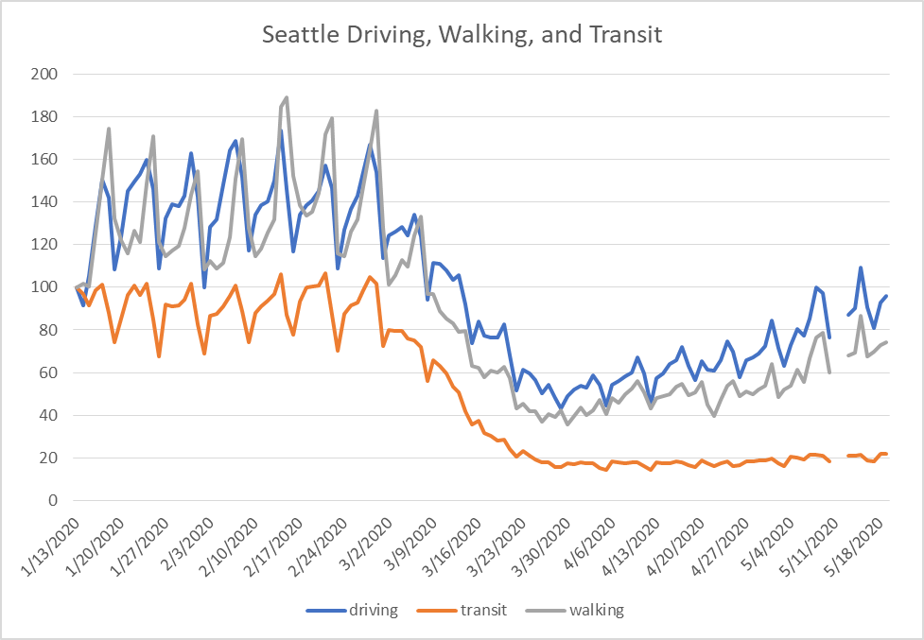

Fewer anecdotes are coming in now as most activity is shuttered and the impacts have been highlighted previously. Those listed continue to show the drastic reduction in demand and the consequent layoffs and furloughs locally. Re-opening anecdotes are highlighting the impact of social distancing measures.





**Anecdotal by Industry**

Manufacturing

•Federal Reserve’s industrial production index fell 11.2 percent in April for its largest monthly drop in the 101-year history of the index. The output of motor vehicles and parts fell more than 70 percent (<https://www.federalreserve.gov/releases/g17/current/default.htm>)

Construction

•N/A

Retail

• Earnest national spending data week ending 5/6/20; online grocers +154% (yoy), Home Improvement +73% (yoy), Delivery aggregators +127% (yoy) (Earnest, 5-14-20)

•Specialty's Café & Bakery is closing permanently. The 33-year-old chain with six locations in Seattle and one in Bellevue, said on its website that Covid-19 and shelter-in-place policies "have decimated company revenues." (PSBJ, 5-18-20)

•J.C. Penney Co. Inc. has filed for Chapter 11 bankruptcy protection, according to a news release. (PSBJ, 5-18-20)

Hotels

•N/A

Restaurants

•N/A

Tourism

•Cruise line Holland America, headquartered in Seattle, will lay off, furlough or reduce the hours or pay of all of its shoreside employees, the company announced today. Nearly 2,000 people will be laid off. (ST, 5-14-20)

•Harris Poll: in response to "major purchases planned once things return to normal," travel ranked #1 (selected by 52% of respondents), higher than buying new clothes, buying household goods or attending a concert or sporting event (Visit Seattle, 5-7-20)

•A total of 26 future citywide conventions previously booked at the Washington State Convention Center have now cancelled, representing 186,073 contracted hotel room nights and $183.4 million in lost economic impact. (Visit Seattle, 5-7-20).

•It will take until at least 2023 for the Puget Sound region hotel market to return to pre-pandemic performance levels, according to a new forecast by CBRE. (PSBJ, 5-20-20)

Airlines/Trade

•Marine cargo container shipments handled by the Northwest Seaport Alliance sank 23.5% in April, the second straight month of drops topping 20%. (PSBJ, 5-18-20)

•Seattle-Tacoma International Airport (SEA) is operating at just 10 percent of typical passenger volumes as most in our community continue to follow the guidance to avoid non-essential travel. The airport currently serves on average about 6,300 daily departing passengers. (Port of Seattle, 5-20-20)

Real Estate

•The Port of Seattle announced another round of rent relief for airport tenants this week. Dining and retail tenants at Seattle-Tacoma International Airport are eligible for four months of rent deferral on their storefronts. Sea-Tac will also extend lease terms and defer utilities charges and office and storage rent. (ST, 5-14-20)

•Greystar has begun building a $115 million, high-end multi-family project, while Trent and Hatteras Sky plan to start this summer on a large Central District project. This week Bellwether Housing and Mercy Housing Northwest broke ground on Cedar Crossing. Together the three projects will have 765 units. (PSBJ, 5-15-20)

•Amazon has leased three warehouse buildings in the South Puget Sound region and is expected to sign a deal for the largest such building on the market. Together the assets total about 2 million square feet, with the deals increasing Amazon's South Sound sorting and distribution capacity to 5.1 million square feet. (PSBJ, 5-19-20)

Employment

•University of Washington Medicine announced Monday that it is furloughing 1,500 professional and classified nonunion staff due to the financial challenges caused by the novel coronavirus. (PSBJ, 5-19-20)

•The Seattle Renaissance Hotel permanently laid off 190 people, according to a Tuesday state Worker Adjustment and Retraining Notice (WARN). (PSBJ, 5-20-20)

State/Municipal Governments

•N/A

Other

•Griffin [working on the WSCC expansion] did not know how much these measures have slowed down progress but estimated it is by 10% to 20%. (PSBJ, 5-18-20-on social distancing at the CC)

•Sound Transit will begin collecting discounted fares on light rail and Sounder commuter rail beginning June 1. (PSBJ, 5-19-20)

•Seafair is canceling all of its major events for 2020. “This has never happened in 71 years,” said Seafair President and CEO Eric Corning. (PSBJ, 5-20-20)