ISSUE: No. 4

DATE: April 2, 2020

Period: March 22, 2020 to March 28, 2020

I could probably just send this graph and leave it at that (U.S. Initial Unemployment Claims since 1967 through today’s release and the dark line to the right is not the border of the graph):

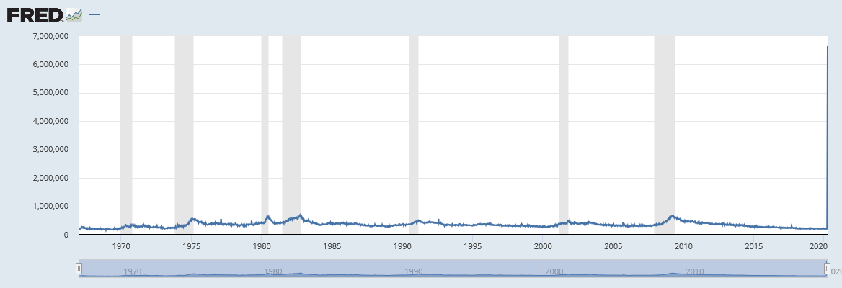

The Stay Home, Stay Healthy order remained in place for this week with the Governor issuing several clarifying orders around what is essential business, and how the rule might be enforced for those not complying. There was further guidance on construction noting that it has to be for emergencies or broad public benefit. There was also clarification around selected industries and retired workers returning to work (waiving work limitations). The current order is set to expire on April 8, but the Governor has suggested several times it might have to be extended.

The week continued to indicate the spread of the virus and the associated economic impacts. Car manufacturers including Ford, Fiat Chrysler, and Toyota of North America, among others, have announced they will remain closed until at least mid-April. Our major local manufacturers are largely shuttered for now also and Paccar announced just yesterday it will be closed until April 20 though they are still providing after-market support. I would assume Boeing will also extend the shutdown but have not seen anything or heard if they will continue to pay line workers. Food manufacturing which employs about 12K in King County is an essential business and so is likely continuing at places like Kirkland brands.

The Governor provided further guidance on construction on March 25th that indicated most construction is not considered essential except those to “further a public purpose”, and those related to emergency repairs. Per media reports, work continued on the Key Arena remodel, the Convention Center expansion and various Sound Transit projects in the area. Most private construction is likely stopped.

All the anecdotes we’ve received regarding retail continue to indicate huge reductions in revenue and non-essential businesses are closed. One national report noted that Ecommerce sales were up 24% in the first half of March. Revenues at the hotels that are still open remain down about 90% (see the anecdotes section). Restaurants that remain open are open for takeout only.

The Governor also released clarifying guidance on real estate transactions on March 28 that affirmed that real estate activities and mortgage lending are essential activities but also limited in-person meetings, open houses, how appraisals and other tasks are accomplished and requiring that new listings be facilitated remotely. The Case-Shiller index for January came out on Tuesday (3/31) indicating year over year growth of 5.1%, but recent anecdotes suggest things have change significantly. The Multiple Listing Service (MLS) indicates that new listings in the three county area fell 58% in the two days after the stay home order was issued (Seattle Times, 3-31-20). We get some key real estate data next week as the MLS will release March sales numbers and countywide REET data for March comes available.

Other indicators for last week showed the impact of the massive drop in revenues and business that is now leading to furloughs and unemployment. The 3,300% increase in claims in King County last week was followed by a 3,900% increase this last week (yoy, week ending 3/28). The impact has been especially large in accommodation and food service up 7,150% this week (yoy, statewide values) after a 13,600% increase last week. Transportation indicators continued to show the impact of people staying home with Metro ridership down about 70% and the suspension of ORCA readers on Sound Transit entities.

National unemployment claims went up by over 100% also showing the impact on labor market (as shown on the first page). One national economic forecast now has 2020 third quarter unemployment coming in near 15 percent (14.7%). County level unemployment values for February came out on Tuesday and unemployment was at 2.5%. This shows the B.C. world with an amazingly strong labor market (e.g. December, 2019 unemployment hit 2.1%). The March unemployment for the county will be out April 21 (April 15th for the MSA) but these values reflect a survey the week around March 12th and so are likely to have just caught the leading edge of the lay-offs. We’re looking for a value around 4%-4.5%, but the April value will be significantly higher.

Phase 3 of the federal stimulus program was signed by the President on Friday, March 30. The $2 trillion dollar legislation will provide much needed assistance to many. The bill provisions include forgivable loans to small businesses (those of 500 employees or less with additional help for those in food service and accommodation), industry relief which appears to be partially targeted towards Boeing, additional loan facilities, state fiscal aid and additional federal spending and taxpayer payments and tax relief (extended filing deadline and additional loss provisions). The tax payments are set at $1,200 for individuals ($2,400 for those married and filing jointly) with incomes $75,000 ($150,000 for married filing jointly) with a reduced payment for increasing incomes. Using IRS data we estimate that about 2/3 of county filers will be eligible for the full payment and that this will amount to $1.1b in county stimulus not including the partial payments for higher earners and $500 payments for children.

Anecdotal information continues to be made available by you (thanks!) and via media outlets and largely continues to show the drastic reduction in demand and now the consequent layoffs and furloughs locally.



**Anecdotal by Industry**

Manufacturing

•Boeing offers buyouts to eligible workers (Seattle Times 4-2-20)

•Paccar extends plant closure until 4-20-20 (Businesswire, 4-1-20)

•Superfeet, Flowbuilt and Pioneer Aerofab switch to producing respirator masks (PSBJ, 3-31-20)

Construction

•Some construction projects working including Key Arena, WSCC, and Sound Transit work. WSDOT not working and construction on NHL center at Northgate stopped (PSBJ, 3-30-20)

Retail

•All non-essential retail stores now closed in Washington State

•Emanuel which owns/operates 34 gas stations says sales down 60% yoy (Seattle Times, 4-1-20)

•Ecommerce sales up 24% Mar 1-Mar 17 (WSJ, 4-1-20)

•Commons Mall in Federal Way is now closed (City of Federal Way, 4-1-20)

Hotels

•Kirkland hotel occupancy on 3-27-20: WoodMark (2% today), Courtyard (32% today), Heathman (5%-11% this week), La Quinta (8% this week), (City of Kirkland, (3-27-20)

•Seattle area hotels owe $1.59b spread among 114 hotel properties (PSBJ, 3-31-20)

•Red Lion in Federal Way closing, other hotels reporting “significant” lay-offs (City of Federal Way, 4-1-20)

•National hotel occupancy rate was 22.6% for week of March 22, down 67.5% form same time last year (CNN, 4-1-20)

•The information below is from Visit Seattle on 4-1-20:

Seattle Downtown:

* 25 hotels with 5,280 combined guest rooms affected
* 10 have suspended operations or closed until April 15
* 5 have suspended or closed through May 31

Eastside:

* 5 hotels with 659 combined guest rooms affected
* 3 hotels have suspended operations or closed until May 1

Restaurants

•All restaurants are only offering food for take-out or delivery

Tourism

•86% drop in Sea-Tac passenger traffic (PSBJ, 3-30-20)

•Survey of Travelers indicates 84% are changing plans for travel for the next 6 months, but 72% are still planning a trip in the next six months (Visit Seattle, 4-1-20)

Airlines/Trade

•Almost 90% of foreign carriers have stopped flying into Sea-Tac (Port of Seattle, 4-1-20)

Real Estate

•N/A

Employment

•17 employers reported layoffs to ESD via WARN notices about 2,100 WA employees including hotels, food distributors, multiple car dealerships, restaurants and others (PSBJ, 4-1-20)

•More than half of dining and retail employees at Sea-Tac have been furloughed (Port of Seattle, 4-1-20)

Municipal Governments

•Federal Way increased funding of the Multi-Service Center’s food bank and is deploying parks personnel to help distribute food to those unable to leave their homes. (City of Federal Way, 4-1-20)

•The City of Tukwila is considering wage cuts for city employees to offset a revenue shortfall of more than $6 million (KOMO News, 4-1-20)

Other

•The disparate effects of COVID-19 can be seen by examining how the prices of certain stocks changed between December 31, 2019 and March 27, 2020 (Dively, D. 4-1-20)

|  |  |  |
| --- | --- | --- |
| **Company** | **Industry** | **% Price Change 12-31-19**  **to 3-27-20** |
|
| Netflix | Home entertainment | 10.2% |
| Amazon | Remote sales, computing, etc. | 2.8% |
| Kroger | Grocery stores | 0.5% |
| Costco | Wholesale groceries, etc. | -3.4% |
| Microsoft | Technology | -12.1% |
| Apple | Technology | -15.6% |
| Google | Technology | -17.1% |
| Johnson & Johnson | Pharmaceuticals, health, etc. | -17.3% |
| IBM | Technology | -19.4% |
| Fed Ex | Package delivery | -20.3% |
| Nucor | Steelmaking | -40.7% |
| Delta Airlines | Airline | -49.5% |
| Boeing | Aerospace | -50.3% |
| Alaska Air | Airline | -55.9% |
| Nordstrom | Retail clothing, etc. | -60.9% |
| Carnival | Cruise lines | -71.7% |