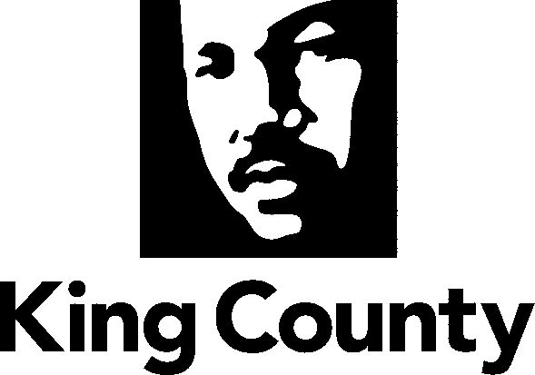
Foomka Codsashada Diwaanka Dadweynaha
Waaxda Fulinta Adeegyada
Xafiiska Maaraynta Khatarta Adeegyada
King Street Center
201 South Jackson Street, #320
Seattle, WA 98104
Talefoon: 206-263-2250
TTY: 800-833-6388
8:30am - 4:30pm
Isniin – Jimce
kingcounty.gov/pra
Taariikhda Maanta: ___________________________
Macluumaadka Codsadaha
Magaca: ________________________________________________
Cinwaanka iimaylka: __________________________________________
Lambarka talefoon ee la doorbidayo: ________________________________________
Iimaylku waa habka ay door biday degmada King ee lagu wada xiriiro iyo habka ugu dhaqsaha badan ee adeega.
Sideed jeclaan lahayd inaanu kula xiriirno? £ Iimayl £ Boostada Maraykanka ☐ Talefoon
Sideed jeclaan lahayd inaad hesho diiwaannada? ku
£ Iimayl £ Boostada Maraykanka £ Ka Qaadashada King Street Center £ Ku Baaritaanka King Street Center
Haddii aad xulatay Boostada Maraykanka, fadlan na sii cinwaankaaga deegaan ahaaneed:
Cinwaanka Boostada lagu dirayo:
Cinwaanka deegaanka ee wada - Magaalada - Gobalka - Lambarka Boostada
Luuqada la doorbidayo (Hadaysan ahayn Ingiriis): _____________________________________________________
Codsashada Guud ahaaneed ee Diwaano
Fadlan noo sheeg diwaanada aad rabto. _________________________________________________
______________________________________________________________________________
______________________________________________________________________________
______________________________________________________________________________
______________________________________________________________________________
Macluumaadka naga caawinaya inaan raadino diwaanada
Nooca Diwaanka: £ RUqsado£ Qandaraasyo £ Iimayk £ Fiidyaw
Mudada u dhaxeysa taariikhaha: _______________________________________________________
Taariikhaha dhacdada: _____________________________________________________________
Baska, gaari bas ah, ama lambarka wadada: ______________________________________________
Lambarka Ruqsada: _______________________________________________________________
Erayo ama Jumlado: _______________________________________________________________
Magacyada Shaqalaha la rabo: _____________________________________________________
Diiwaanada ku saabsan shakhsi xiran waa maxay BA/CCN/JCN? __________________________

